Week | Monday | Tuesday | Wednesday | Thursday | Friday
Week 1 | Beans on toast plus fruit yoghurt  Fruit | Fill your own Pitta  Fruit | Tomato pasta and garlic bread  Fruit | Cheese and tomato Pizza and veg/salad  Fruit | Jacket potato – tuna / cheese  Fruit
Week 2 | Cheesy Pasta  Fruit | Vegetable stir fry and noodles  Fruit | Build your own wraps plus fruit yoghurt  Fruit | Cheese and tomato Pizza and veg/salad  Fruit | Soup and a bread roll  Fruit
Week 3 | Vegetable stir fry and noodles  Fruit | Spaghetti on toast  Fruit | Tomato pasta and garlic bread  Fruit | Cheese and tomato Pizza and veg/salad  Fruit | Vegetable curry and Chapatti  Fruit
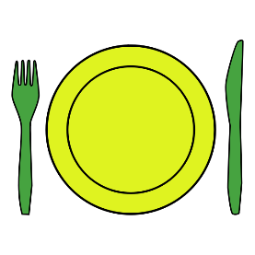
When you eat food with your family and friends, it always tastes better!

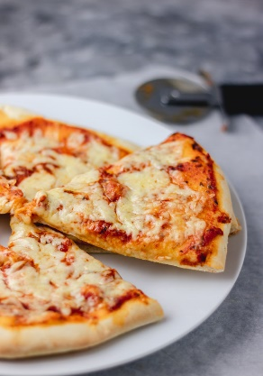
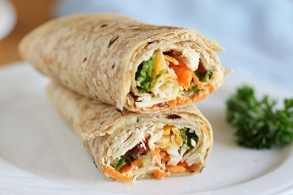
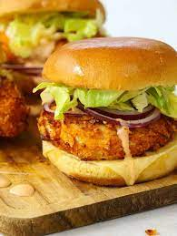
Milk and water available daily

