Term 1 Autum 1
Coding Unit 5.1
This unit consists of six lessons that assume children have followed the Coding Scheme of Work in Years 1 to 4. If most of the class have not, use the Coding Catch-Up unit instead of this unit.

Prior Knowledge | Prior Skills:
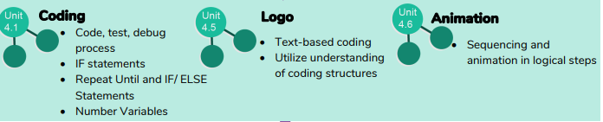
Planned outcomes:
To be able to begin to code efficiently.
To programme a simulation using 2Code.
To use decomposition to plan a real-life situation.
To understand how to use friction in code.
To understand how to create a string and how to use Text Variables and Concatenation.
Learning Journey – small steps in learning to meet the planned outcome  Coding Efficiently  To begin to be able to simplify code  Children can use simplified code to make their programming more efficient. To use variables in their code.  To create a simple playable game.  Simulating a Physical System  To program a simulation using 2Code  To plan an algorithm modelling the sequence of traffic lights.  To select the right images to reflect the simulation they are making.  To use their plan to program the simulation to work in 2Code.  Decomposition and Abstraction  To use decomposition to plan of a real-life situation  To know what decomposition and abstraction are in Computer Science.  To take a real-life situation, decompose it and think about the level of abstraction.  To make good attempts to break down their task into smaller achievable steps.  To recognise the need to start coding at a basic level of abstraction to remove superfluous details from their program that do not contribute to the aim of the task.  Friction and Functions  To understand how to use friction in code  To begin to understand what a function is and how functions work in code.  To create a program which represents a physical system.  To create and use functions in their code to make their programming more efficient.  Introducing Strings  To understand how to create a string  To understand what the different variable types are and how they are used differently.  To create and use strings in programming.  To set/change variable values appropriately.  To know some ways that text variables can be used in coding.  Text Variables and Concatenation  To begin to explore text variables when coding.  To understand what concatenation is and how it works.  To create a string and use it in their program.  To use strings to produce a range of outputs in their program. | Tiered Vocabulary  3  2  1  1  1  Concatenation Decomposition  Function Event Nesting Abstraction  Output System Sequence  Physical System  Simplify  Selection
Scaffolds | Oracy Activities
Small group work  Modelling by teacher 1:1 or in small groups | Vocabulary clarification  Sentence stems

