Reading Policy

“Once you learn to read, you will be forever free.” – Frederick Douglass

Curriculum Intent:
The main purposes of this policy are:
- to establish the entitlement for pupils in line with government guidance
- to provide guidance on how the subject is taught at EP Collier
- to support parents and carers’ understanding of the curriculum

At EP Collier, we believe that the ability to read is fundamental to pupils’ development as independent, life-long learners and recognise the relationship between a child’s reading ability and their future opportunities. The National Curriculum (2014) singles Reading out as having extreme importance in children’s ability to understand and access the whole curriculum. Reading underpins learning for all subjects. When children learn to read, they can read to learn. We aim to have our pupils leave us with: a genuine love and appreciation for reading; the ability to read fluently; and the skills and confidence necessary to be able to understand the texts that they will encounter in the future.

Research, such as The Simple View of Reading, separates reading into two main processes:
• word reading/recognition - the ability to recognise, decode and understand the meaning of individual written words
• comprehension (both listening and reading) – a process used to access the underlying meaning of spoken and written language.
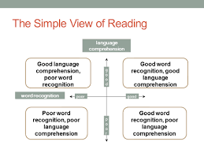

However, each of these two main processes can be broken down further, as demonstrated by Scarborough’s Reading Rope, making reading an extremely complicated act.

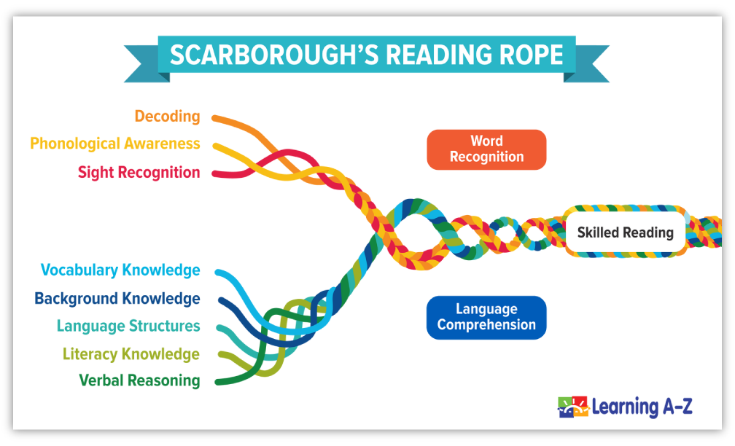

Implementation
At EP Collier, word reading/recognition is taught through daily phonics sessions, 1:1 and group reading sessions as required (please see our phonics policy for further information). We prioritise building a secure foundation of phonics knowledge because, without it, pupils cannot become skilled readers.

Ultimately, we want children to comprehend what they have read. We use VIPERS, which is an acronym for the key areas (content domains) that we teach, based on the National Curriculum, in order to improve their comprehension of texts. In Key Stage One, the S stands for sequence and in Key Stage Two, it stands for summarise. Lessons are focused on teaching these key skills at progressively more challenging levels based on children’s age and reading ability.
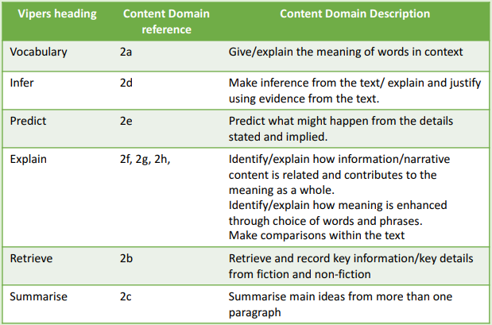
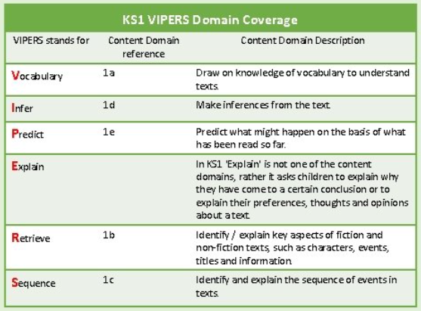

Text Selection
We ensure that pupils are exposed to a wide range of high quality, diverse and representative texts in which to practise the skills taught in lessons. These texts are carefully selected and cover the “5 Plagues of Reading”, as categorised by Doug Lemov, and promote a love of reading. We also select texts that link to other areas of the curriculum where possible. The 5 plagues are 5 types of texts that children need to be given experience of and taught to navigate in order to help them access the challenging texts that they will encounter in secondary school and beyond. The “5 plagues” are texts that are:
- archaic – have vocabulary or syntax that is not used nowadays
- narratively complex – have an unreliable, multiple or non-human narrator which often creates multiple plot-lines or alternative view points;
- non-linear – have timelines that can be complex to follow as the events are not written in order;
- figurative/symbolic – have language that often conveys a moral or political message
- resistant - texts that deliberately resist easy meaning-making by readers such as poetry.

Throughout the year, the level of challenge the texts the children are exposed to increases and this may be through the amount the children are expected to read, the language used or skills required to comprehend what they are reading. This is the same across year groups.

Early Years Foundation Stage (EYFS) – Nursery and Reception_
In the foundation stage, the focus is on building early reading behaviours such as developing curiosity and enthusiasm about the written word, recognising signs and symbols, how to hold a book the right way up and follow the text from left to right. This is so children understand that texts convey meaning. Pupils will read and have read to them a range of fiction, non-fiction, poetry and rhymes which they will have opportunities to discuss with the teacher and others as well as retelling narratives themselves. There will also be a focus on word reading/recognition through daily phonics sessions (please see our phonics policy for further information). We aim to have children demonstrating curiosity and enjoyment of books and using their phonics knowledge to help them read words, phrases and simple sentences and books by the end of Reception, including some common exception words.

Key Stage One (KS1) – Year 1 and 2
In Key Stage One, the pupils build on the reading behaviours learnt in the foundation stage and there is a greater focus on developing children’s word reading/recognition. Pupils are supported with this during daily phonics lessons (please see our phonics policy for more information) and 1:1 and guided reading sessions where children read books that are matched to their phonic knowledge. Comprehension is taught through class novels and short extracts. The class novel reading sessions involve discussions and activities that deepen children’s vocabulary and understanding and are focused on the VIPERS skills. Children in year 2 who have completed the phonics programme read an extract of text and answer questions on this. By the end of KS1, children should be able to fluently (quickly and accurately) read words that include the phonics sounds they’ve learned, common exception words and common suffixes. They should be able to check that texts makes sense to them, correct any inaccurate reading, answer questions and make some inferences and explain what has happened so far in what they have read.

Lower Key Stage Two (LKS2) – Year 3 and 4
When pupils transition into KS2, the focus shifts from word reading/recognition to comprehension as they should have sufficient phonic knowledge and strategies to be able to read most words they come across fluently. Comprehension is taught during 5 whole class guided reading lessons per week. We use VIPERS as the focus for lessons and to support questioning to check understanding. These lessons last for approximately 30 minutes and follow this format:

- Day 1: Vocabulary – pre-teaching of the vocabulary that the pupils will encounter in the upcoming section of text they will be reading
- Day 2: Reading Fluency – pupils will hear good models of reading fluency and then practice reading a shorter section of the text to develop their own fluency skills
- Day 3: Reading Skills Lesson – pupils focus on and will be explicitly taught one of the other reading skills and demonstrate their understanding through activities which may be recorded in their reading books
- Day 4: Reading Skills Lesson – pupils focus on and will be explicitly taught one of the other reading skills and demonstrate their understanding through activities which may be recorded in their reading books
- Day 5: VIPERS – the pupils answer questions based on the reading skills taught that week

Upper Key Stage Two (UKS2) – Year 5 and 6
In UKS2, pupils continue to develop their comprehension skills during whole class guided reading sessions. There are 5 sessions per week that last for approximately 45mins, following the same structure as LKS2. This increase from the 30 minute sessions in LKS2 is because pupils need to develop their stamina for reading. It is important that they can read for a sustained amount of time to prepare them for future learning that requires this. The whole class guided reading sessions follow this format:

- Day 1: Vocabulary – pre-teaching of the vocabulary that the pupils will encounter in the upcoming section of text they will be reading
- Day 2: Reading Fluency – pupils will hear good models of reading fluency and then practice reading a shorter section of the text to develop their own fluency skills
- Day 3: Reading Skills Lesson – pupils focus on and will be explicitly taught one of the other reading skills and demonstrate their understanding through activities which may be recorded in their reading books
- Day 4: Reading Skills Lesson – pupils focus on and will be explicitly taught one of the other reading skills and demonstrate their understanding through activities which may be recorded in their reading books
- Day 5: VIPERS – the pupils answer questions based on the reading skills taught that week

Pupils may also complete an optional task from Comprehension Ninja once a week to practise these skills further, in a different context.

Reading for Pleasure
At EP Collier, the teachers and other adults play an important role in fostering a love of reading in pupils. This is rooted in the adults being readers themselves and having a good knowledge of children’s literature. It is our view that extensive exposure to and reading of a wide range of texts makes a vital contribution to every child’s educational achievement and future.

We therefore promote reading for pleasure by providing pupils with access to a wide range of quality literature through a range of engaging activities. The texts the pupils study as part of the curriculum are carefully selected and there are frequent opportunities to discuss the books they are currently reading and get recommendations of others. Pupils have a class novel that the teacher/adult reads to them every day, which links to their learning for that term. This creates a positive reading experience for the children where they can listen to stories purely for enjoyment as well as hearing a good model reading with enthusiasm, expression and intonation. Pupils have regular time slots planned in to the day to read self-chosen books silently, which we call ERIC (Everyone Reads In Class). This allows them to build their stamina for reading and become lost in a book as they begin to develop their own tastes and interests. Pupils also have time to look at the books in the school library and take out books that capture their interest. Children in Key Stage Two (Years 3-6) will have a reading journal in which they complete a variety of reading activities of their choice, based on the book that they are reading.

How We Support Reading at Home
We realise how important it is for school and home to work together in order to give your children the best start. A positive link between home and school allows for children to understand the value of reading outside of the classroom. It is also a form of learning as well as fun and relaxation. We deliver workshops that inform parents of how we teach reading at school as well as providing strategies and ideas on different ways that they can support their children at home. Parents also receive feedback from teachers about the strengths and areas for development in regards to their child’s reading.

Impact
As we believe that reading is the key to all learning, the impact of our reading curriculum goes beyond the result of statutory assessments. We aim to have our pupils becoming fluent, confident and able readers, who can access a range of texts for pleasure and enjoyment, as well as use their reading skills to unlock learning and all areas of the curriculum.

Assessment
Staff regularly assess children’s reading in order to provide feedback and inform them of the next steps in learning to ensure that children are continuing to make progress. They do this in two different ways.
Formative Assessment: Pupils’ reading is assessed regularly throughout the day, not just in reading lessons. During lessons, they are questioned to check their understanding and performance during independent activities is monitored. They are given precise feedback about strengths and areas for development. These assessments help to inform planning.

Summative Assessment: Please see the school’s phonics policy for information about when and how children who are learning to read through phonics are assessed. Pupils from Year 1-6 will sit the Rising Stars PIRA paper at the end of each full term (3 times a year) while Year 6 pupils will sit past papers.

Support for Children with Additional Needs
While we aim to have all of our pupils reading in line with national expectations, we do understand that there are some children with particular needs meaning that this is not possible. In these instances, we ensure that gaps are identified and aim to have these pupils making at least good progress.

For children in KS2 who are learning to word read, they will receive daily phonics intervention and progress will be assessed termly with the aim of moving children through the phonics programme. For those who have completed the phonics programme but are not yet fluent, they are placed in an intervention that focuses on developing their reading fluency and comprehension.

