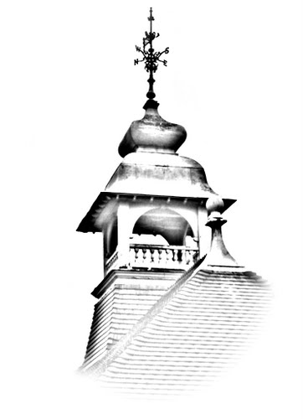

Helping handwriting at EP Collier

A booklet of tips!

Handwriting

Children are taught to form single letters with their leads in and out as seen below:

The alphabet

a b c d e f g h i

j k l m n o p q r

s t u v w x y z

Capitalised Letters

A B C D E F G H I

J K L M N O P R

S T U V W X Y Z

Each letter belongs to a ‘letter family’ according to how it should be formed. These are:

Tortoise letters (letters that are the same size and sit on the line)

a c e i m n o r s u v w x z

Giraffe letters (letters that sit on the line then ascend tall)

b d h k l t

Monkey letters (letters that descend below the line)

f g j p q y

Children are then taught to combine letters from each family together. These are taught in no particular order, instead when children learn new spellings, high frequency words or as required.

Tortoise to tortoise:

e.g ee ae ie ai ou ui oo

Giraffe to giraffe

e.g ll ht tt

Monkey to monkey

e.g py jy fy

Tortoise to monkey/ monkey to tortoise

e.g ey ag ip ey go ye je fu

Tortoise to giraffe/ giraffe to tortoise

e.g eh al it et hi to be lu

Giraffe to monkey/ monkey to giraffe

e.g gh hy ly pt gh yb pl

