Welcome to EP Collier

Early Years Team

[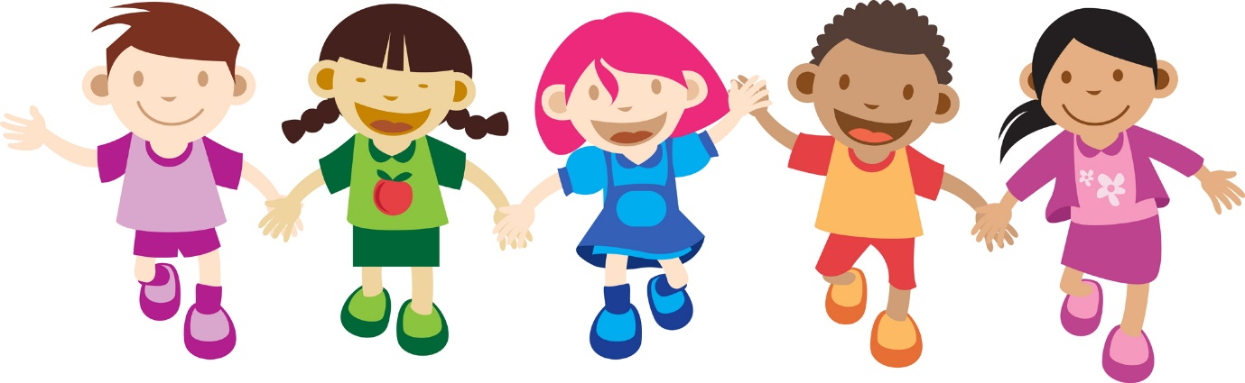](http://www.google.co.uk/url?sa=i&rct=j&q=&esrc=s&source=images&cd=&cad=rja&uact=8&ved=0CAcQjRw&url=http://cliparts.co/cartoon-pictures-for-children&ei=p8qGVZyMK-ip7AbF55PQBA&bvm=bv.96339352,d.ZGU&psig=AFQjCNFCe6tBMBRzT-PtEcnFvVhiFc7slA&ust=1434983362173479)

We hope you will be very happy at

EP Collier School

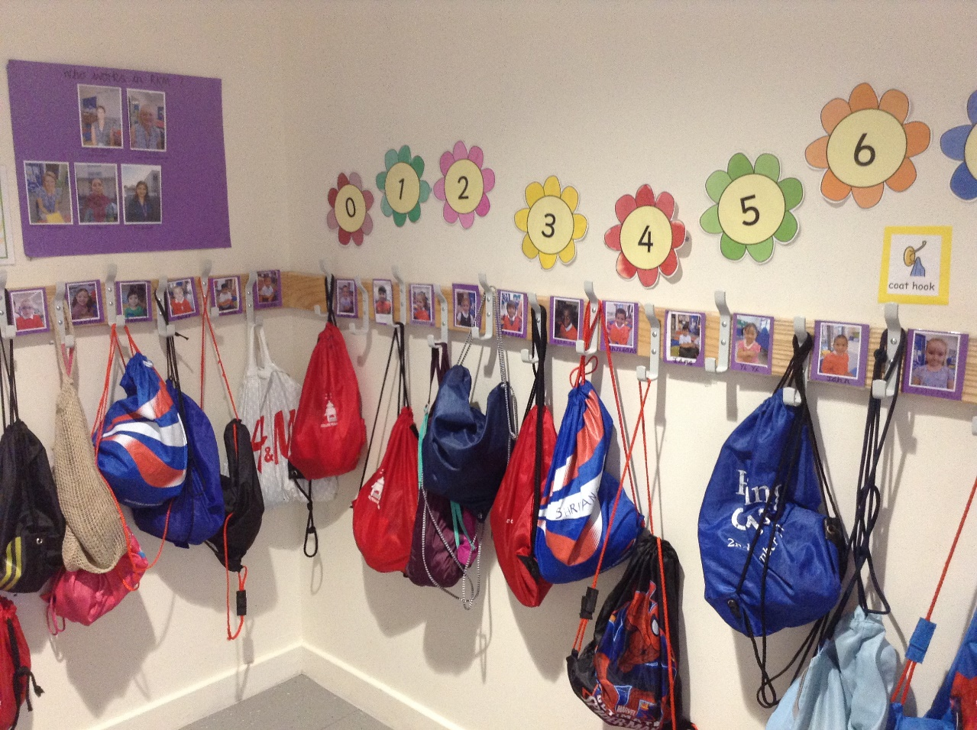Here is the cloakroom where I hang my coat, bag and PE kit.

My peg has my name on it.

I have my name on my drawer.

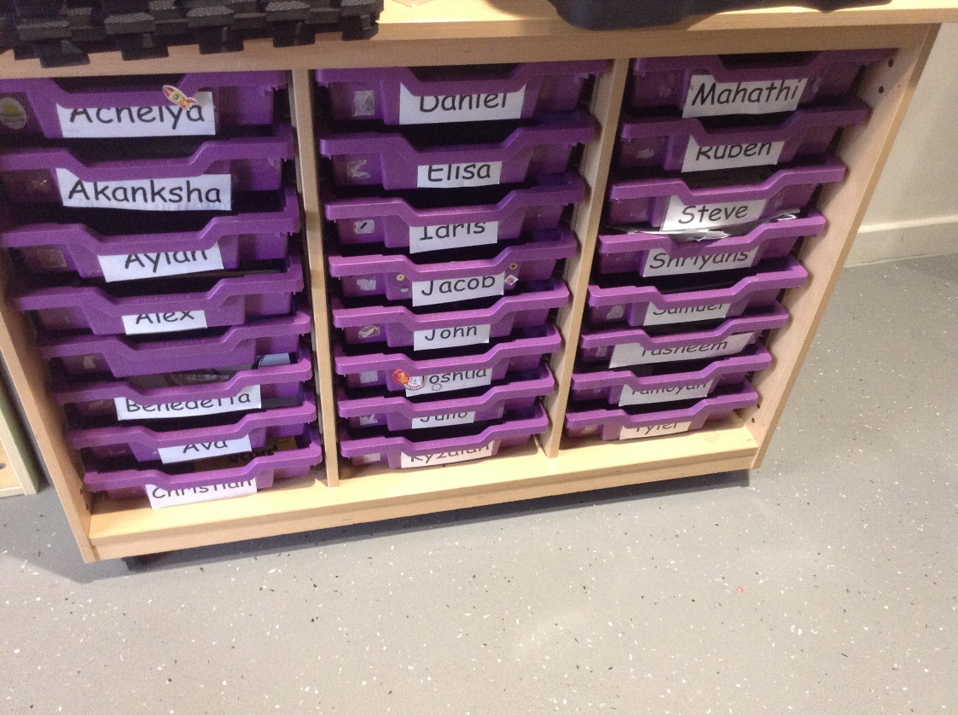

Here is one of my classrooms.

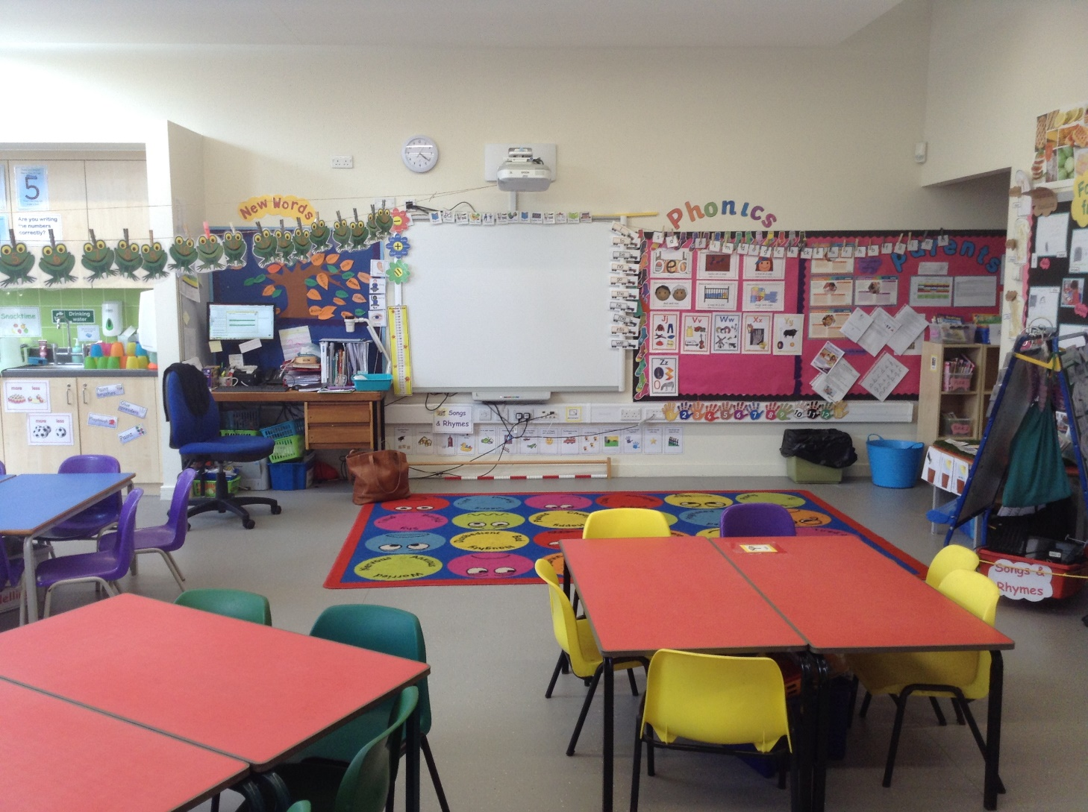

I can paint, draw, read stories, and play with my friends. The teachers at school help us.

The teacher will give me a book to keep in my book bag.

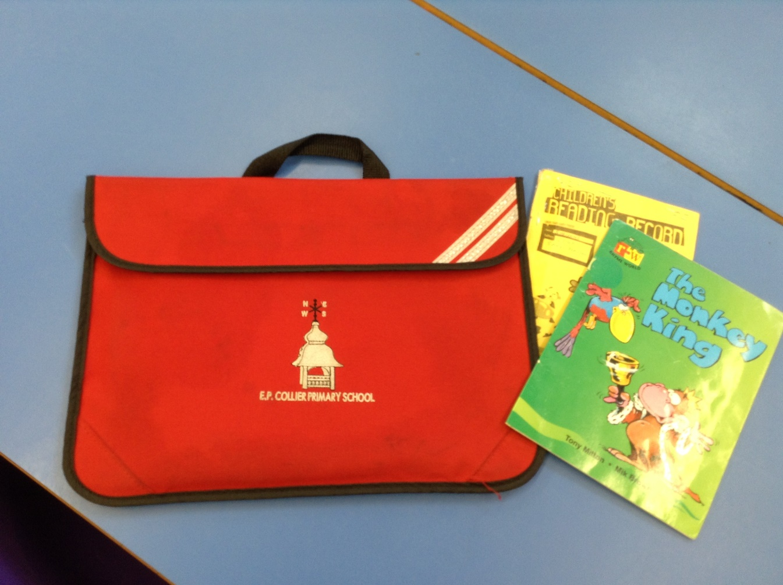I can take it home to read with my family.

Here are the toilets.

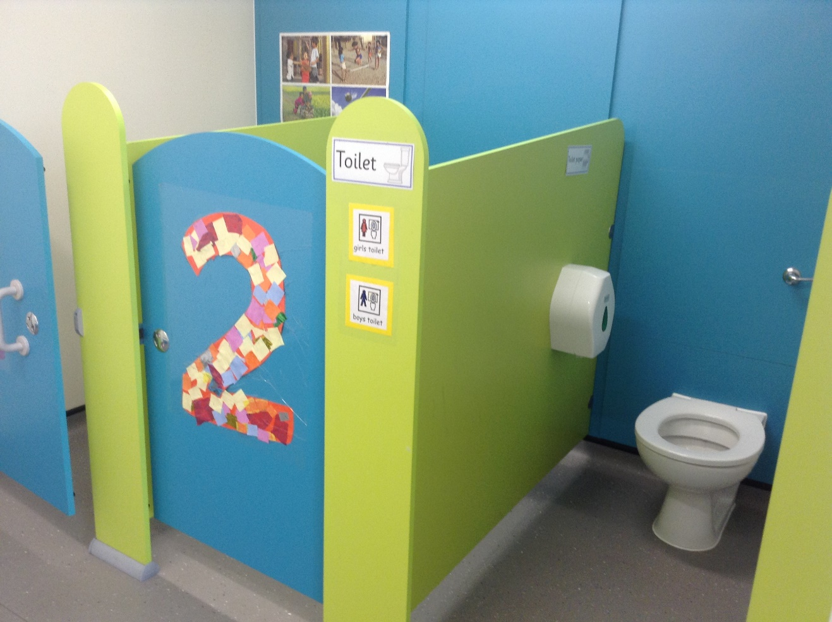

I can ask an adult if I need some help.

I wash my hands at the sinks.

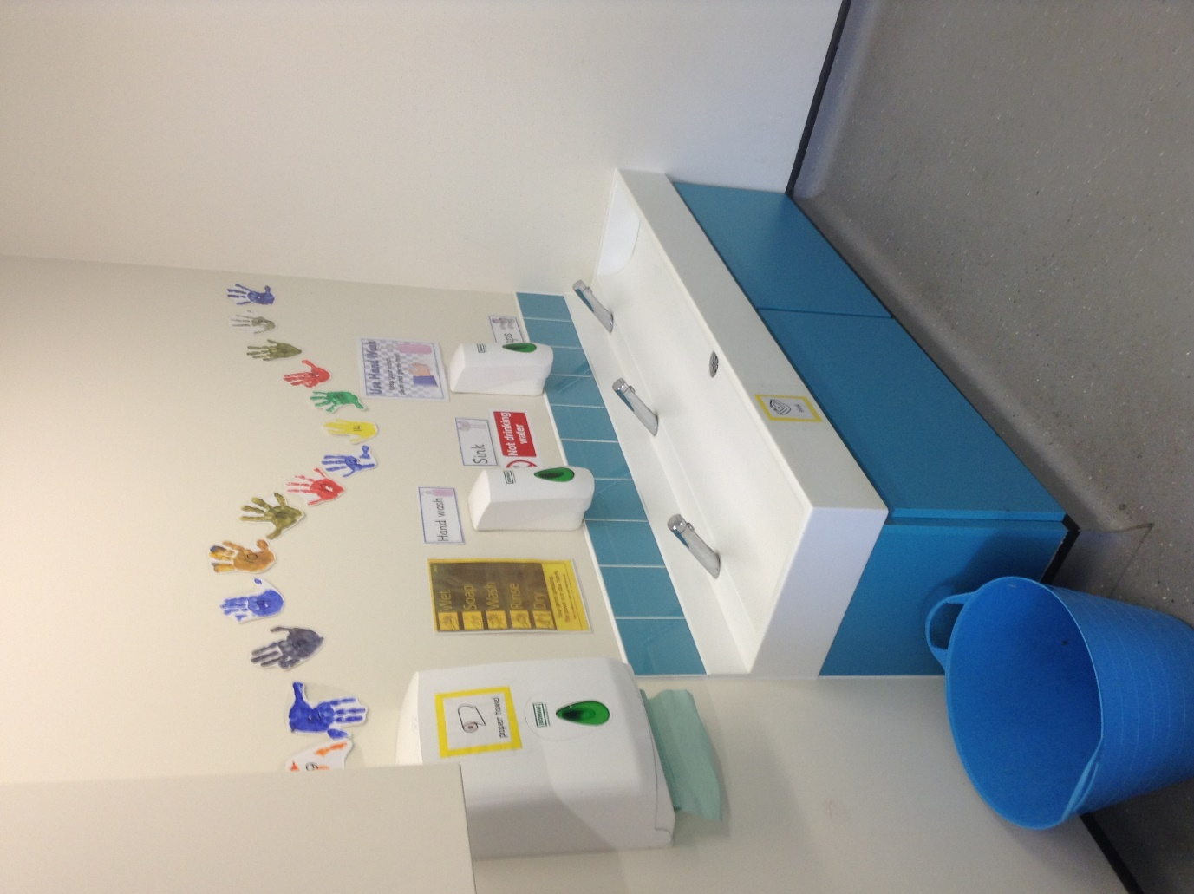

Here is the school hall where we do physical activities (PE).

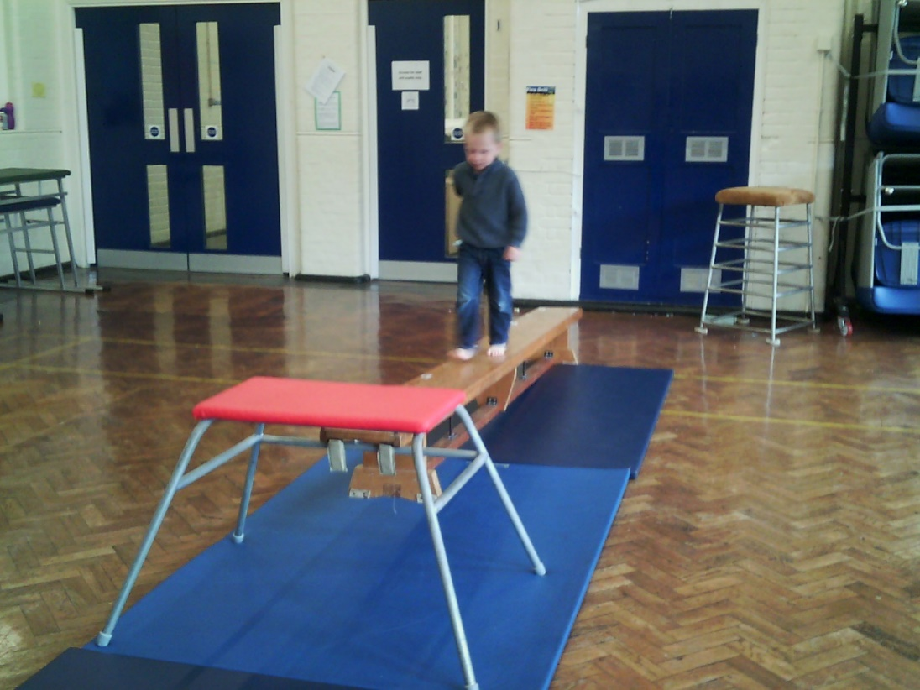

I can choose a school dinner

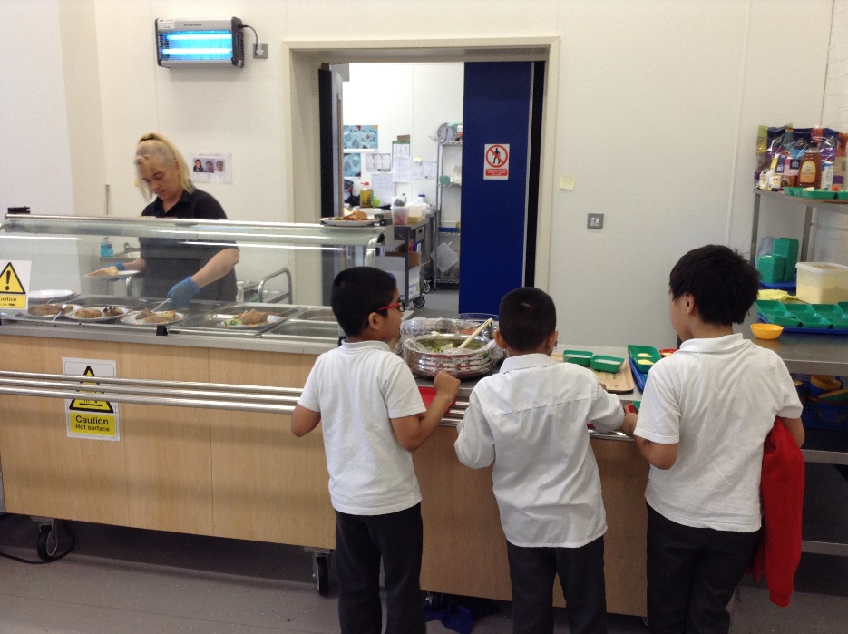

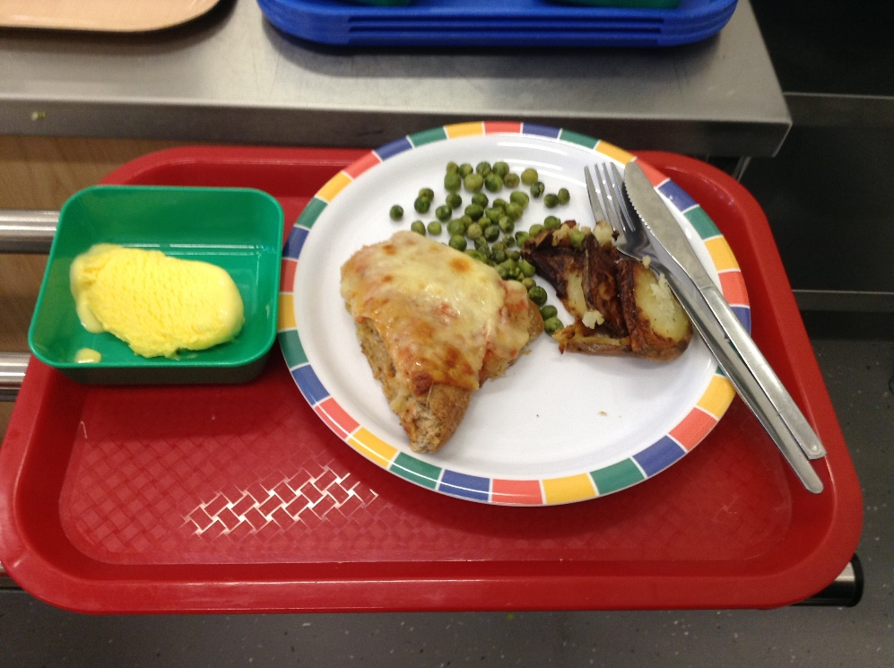

or I can bring a packed lunch from home.

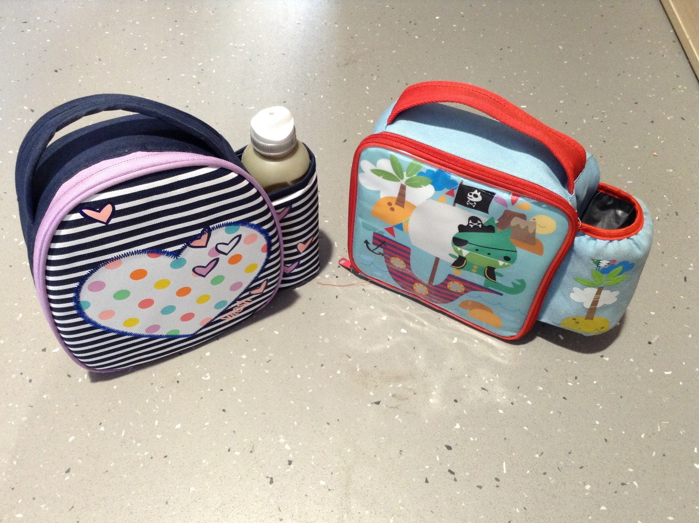

I get changed for physical activity, games and dance (P.E). I put my things in a basket.

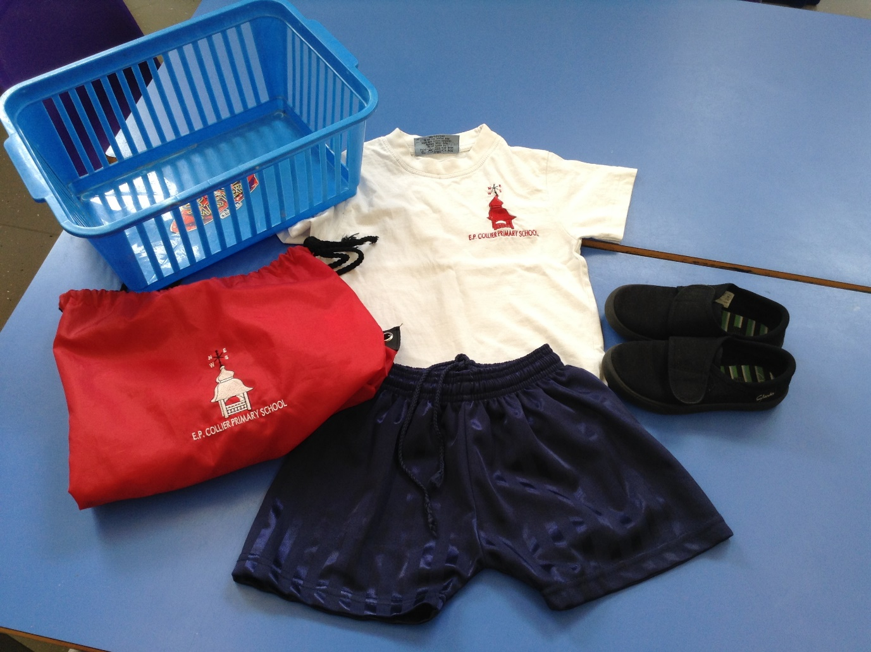

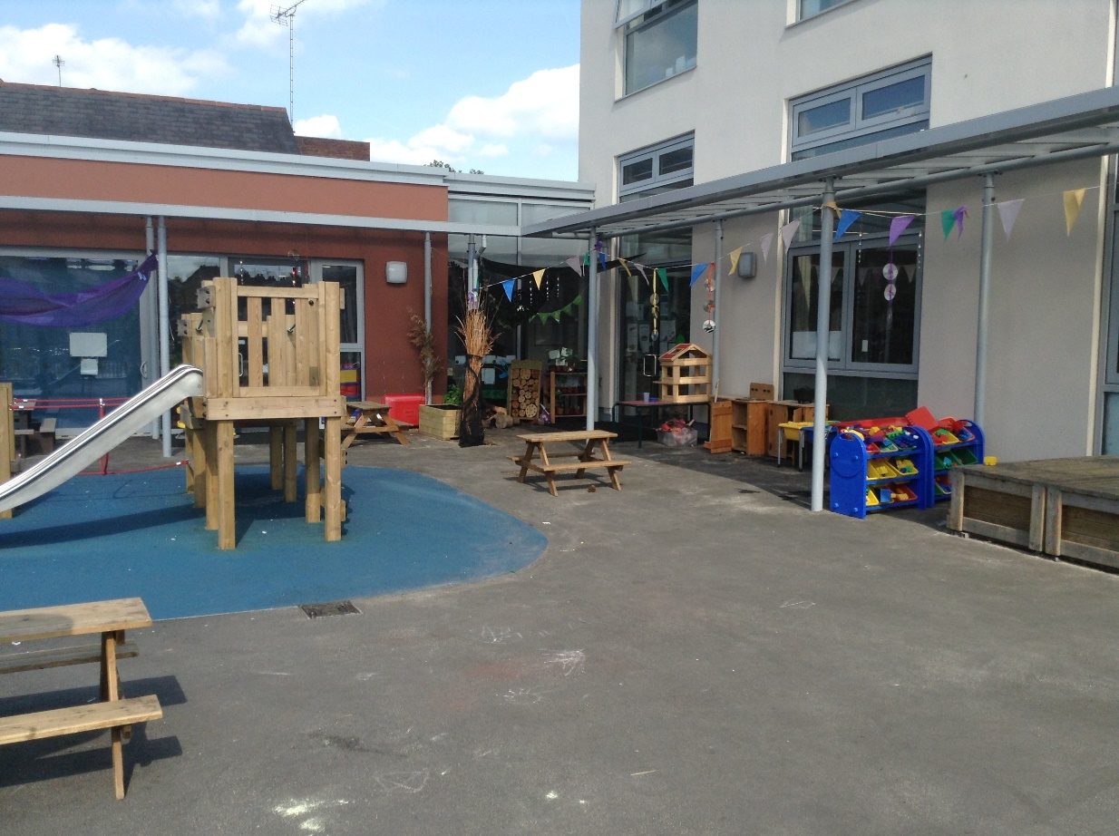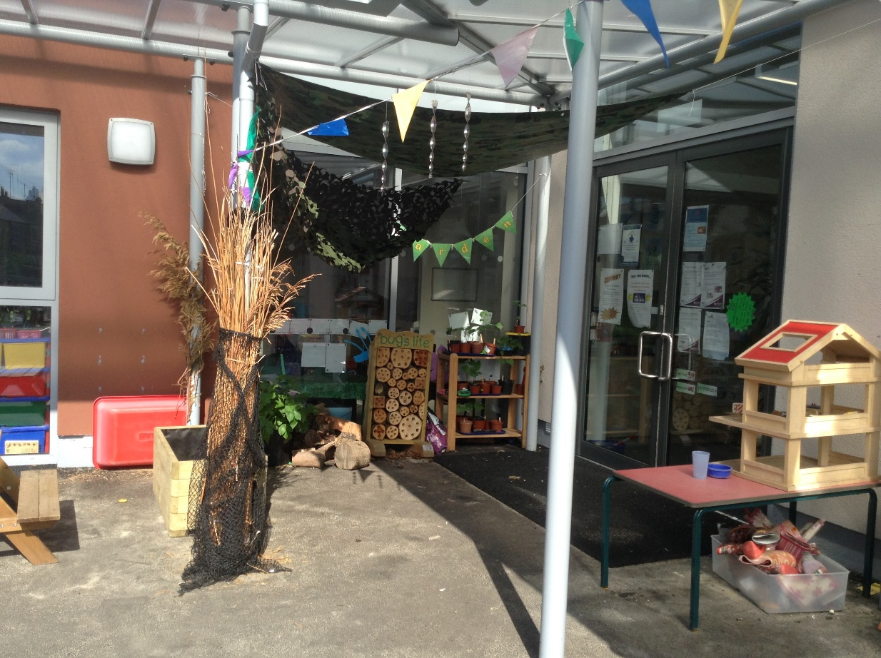Sometimes I play outside.

I go home at the end of the day, when somebody I know comes to collect me.



I am going to have fun at school and everybody is looking forward to meeting me!

Updated June 2022