Autumn Term 1 – Year 6 Geography
Change for the better
North East and North West of England, Yorkshire and the Humber and Scotland - counties, cities, hills, mountains, coasts, rivers and land use patterns – have these changed over time?
Prior Knowledge | Prior Skills:
Locate cities on a map  Names of rivers in the south of England.  Topology natural features of an area such as rivers, hills, coasts and understand how they have changed over time.  Recognise land use on the coast of South of England and | Describe the location of features and routes on a map.  Map skills. How to use an atlas. Locating a region/city in the UK and understanding how far and near a place.  How big and small a town/city is.  Use world maps, atlases and globes  Identify the United Kingdom and its countries( south of England), as well as the countries, continents and oceans
Planned outcome:
• Explore maps of the North East and North West of England, Yorkshire and the Humber and Scotland and learn which counties make up each area
• Explore the human and physical characteristics of each region including topological features
• Find out the cities in each area and locate on a map
• Explore the land use in each area and whether this has changed over time
• Develop their range of map skills
• Choose a specific area from the localities studied to create a detailed labelled map identifying patterns such as land use, climate zones, populations densities, height of land
Learning Journey – small steps in learning to meet the planned outcome  Step 1:  Identify North east and north west of England  Identify counties in North East of England and Scotland  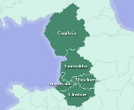  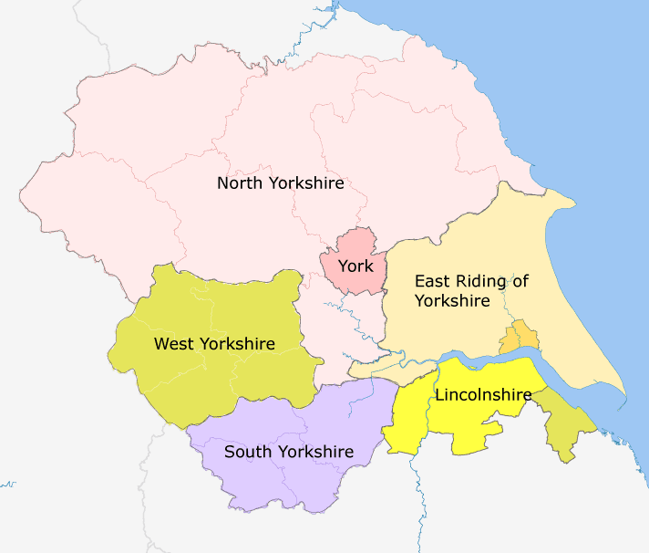  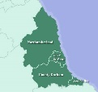  Step 2:  Identify Scotland, including it’s counties  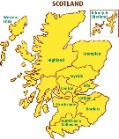  Step 3 : North east of England  ♦ The counties  ♦ There are three cities in the region: Newcastle Upon Tyne, Sunderland and Durham  ♦ Rivers: Tyne, Tees, Wear  ♦ All the counties have coastal areas  Step 4: North east of England  ♦ The region is generally hilly and sparsely populated in the north and west and urban and arable in the East and South  ♦ North East England has an oceanic climate with narrower temperature ranges than the south of England. Summers and winters are mild rather than extremely hot or cold, due to the strong maritime influence of the North Atlantic Current of the Gulf Stream.  ♦ The Pennine Hills separate North East England from the North West of England.  Step 5 North West of England  ♦ The counties  ♦ It is the third-most-populated region in the United Kingdom after the South East and Greater London.  ♦ Cities: Cities: Liverpool, Chester, Manchester, Lancaster, Preston  ♦ Rivers: Mersey, Ribble, Lune and Eden  ♦ Cumbria, Merseyside and Lancashire all have coastal areas.  Step 6 North West of England  ♦ The North West is generally regarded as having the most average weather in the UK. Temperatures are generally close to the national average. Cumbria usually experiences the most severe weather, with high precipitation in the mountainous regions of the Lake District and Pennines.  ♦ The North West contains parts of three national parks: all of the lake District and small parts of the Peak District and the Yorkshire Dales. Most mountains and highlands are located in the North West of England  Step 7 Yorkshire and the H umber  ♦ The counties  ♦ Cities: Leeds, Sheffield, York, Bradford, Kingston Upon Hull, Ripon, Wakefield  ♦ Leeds is the biggest conurbation in Yorkshire and The Humber region  ♦ Rivers: Ouse, Tees, Esk, Trent  ♦ This region of England generally has cool summers and relatively mild winters, with the upland areas of the North York Moors and the Pennines experiencing the coolest weather and the Vale of York the warmest. Weather conditions vary from day to day as well as from season to season. The latitude of the area means that it is influenced by predominantly westerly winds with depressions and their associated fronts, bringing with them unsettled and windy weather, particularly in winter  Step 8: Scotland  ♦ The counties  ♦ Cities: Edinburgh( Capital City of Scotland) , Glasgow, Dundee, Aberdeen, Inverness, Perth and Sterling  ♦ Rivers: Spey, Clyde and Tweed  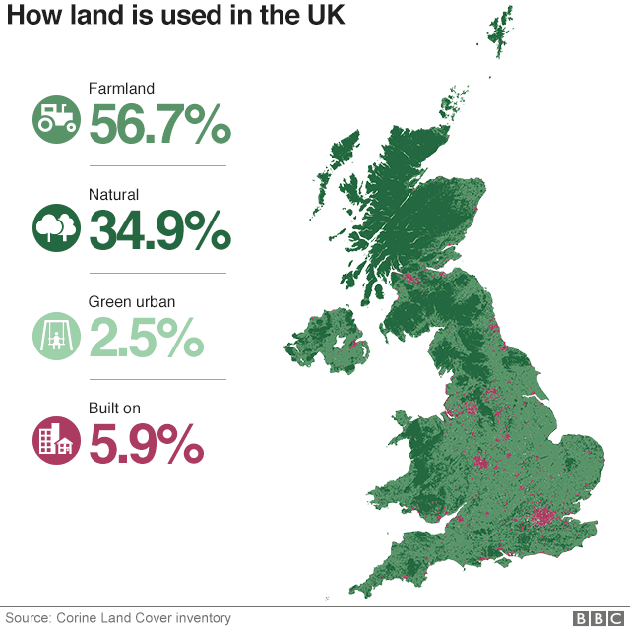  Step 9: How land is used in the UK and population densities UK | Tiered Vocabulary  Topology, city, population  Conurbation , arable  3  2  1  County , hill, mountain , coast, river, moor, climate
Scaffolds | Oracy Activities

