# Year 6

**Coastlines**

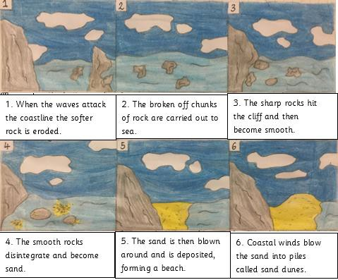

**What is a coast?** It is where the land meets the sea.

**Types of coast:** Cliff, beach, sand dune, mudflat, salt-marsh, estuary, artificial/manmade.

**Managed beach:** A beach where humans are attempting to control coastal erosion by using sea defences such as rock armour, sea wall, rip rap, groynes.

**Unmanaged beach:** A beach which has been left to the natural processes of coastal erosion, caused by longshore drift and the weather.

**Humans use the coast for:** leisure, tourism, trade and transportation. This has a negative effect by causing pollution, speeding up the process of erosion and affecting the economy of the area.

**Human life is affected when:** living near the coast due to coastal erosion. Many livelihoods have been lost due to the eroding coastline. One example of this is making it impossible to sell your house.

# Important Vocabulary

**Coastline:** The outline of a coast where the land meets the sea.

**Deposition:** When material being transported by the sea is dropped due to the sea losing energy.

**Transportation:** The movement of eroded material up and down, and along the coast.

**Erosion:** The gradual destruction of land by the sea. **Groyne: Gabion** A low wall or sturdy barrier built out into the sea from a beach to prevent longshore drift.

**Headland:** A narrow part of the coast that juts out into the sea.

**Sediment:** The name given to material that is broken down by erosion. E.g. rocks, pebbles, sand.

**Tides:** The regular rise and fall of sea levels.

**Undercut:** Where the lower part of a cliff is eroded often causing the cliff to collapse.

**Longshore drift:** The transportation of sand and pebbles along the coast by waves.

**Swash:** The movement of a wave up a shore. **Backwash:** The movement of a wave down a shore. **Sea defence:** Measures put in place to prevent coastal erosion and longshore drift.

**Tourism:** the business of encouraging and supporting people visiting places where they do not live.

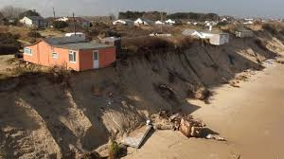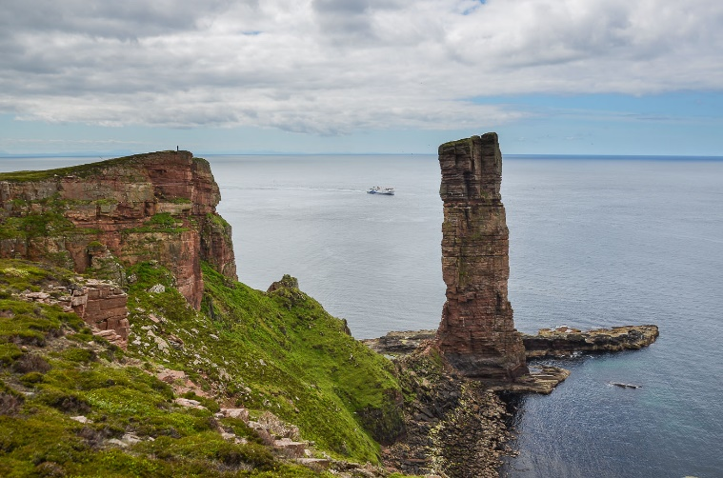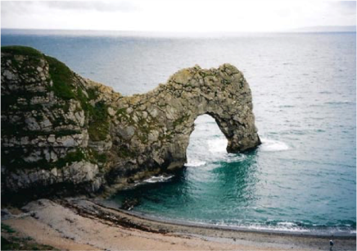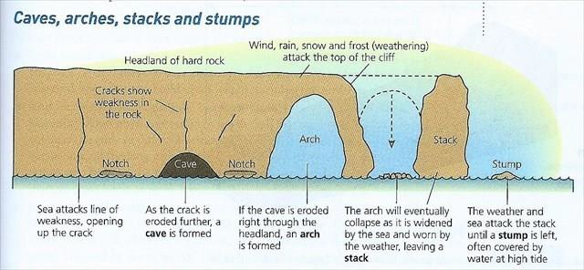

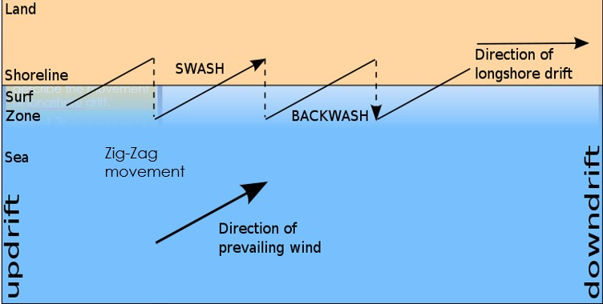

**Longshore drift** is a process where sediment is transported down the coast. Waves can approach the coast at an angle because of the direction of the prevailing wind. The swash of the waves carries material up the beach at an angle. The backwash then flows back to the sea in a straight line at 90°. This movement of material is called longshore drift and occurs in a zigzag moving sediment and often forming new land.