22nd November 2024

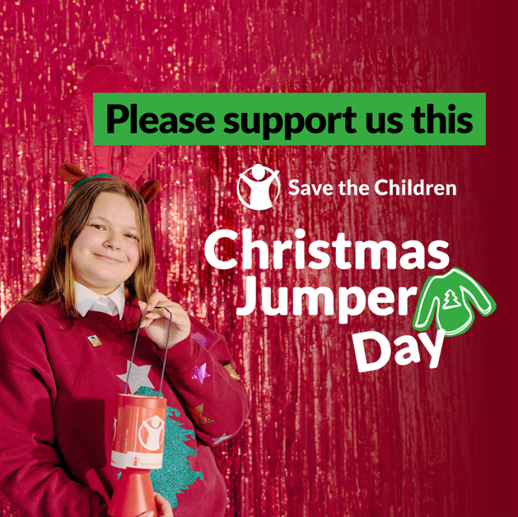

Dear Parents / Carers,

On Thursday 12th December, which is our Christmas dinner day, we will be supporting a Christmas Jumper Day to raise money for the National charity Save the Children. The children can wear their festive knitwear, t-shirts or accessories to school for the day, and are asked to bring a donation.

EP Collier have a unique Just Giving link for you to make your donations directly
https://christmas.savethechildren.org.uk/fundraising/CJD240014141
Alternatively, you can just bring a donation on the day – the charity suggests a £2 donation but anything you can contribute is great!

We have chosen this charity because we believe improving the quality of life for all children is important.

For further information Save the Children, see https://www.savethechildren.org.uk/

Yours sincerely

Ms Barnett
Deputy Head

