

**Times Tables Workshop**

By the end of the workshop you will:

* Know the times tables curriculum expectations



* Know why it is important for your child to learn the times tables
* Understand the teaching techniques we use in school
* Know how you can support your child in learning the times tables at home

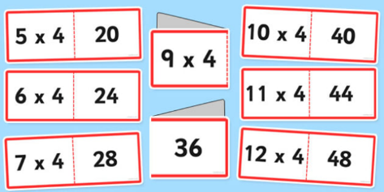

**Thursday 22nd November**

**2.00-3.00 pm at School**

Everyone Welcome………………….Contact the school office to book a space. No cost.