Welcome to EP Collier

Nursery

[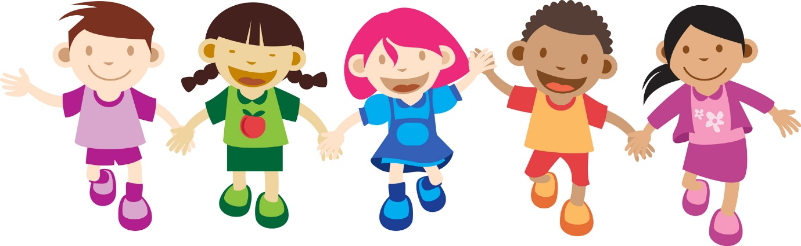](http://www.google.co.uk/url?sa=i&rct=j&q=&esrc=s&source=images&cd=&cad=rja&uact=8&ved=0CAcQjRw&url=http://cliparts.co/cartoon-pictures-for-children&ei=p8qGVZyMK-ip7AbF55PQBA&bvm=bv.96339352,d.ZGU&psig=AFQjCNFCe6tBMBRzT-PtEcnFvVhiFc7slA&ust=1434983362173479)

We hope you will be very happy at

EP Collier School!

I will hang my coat and bag on my peg.

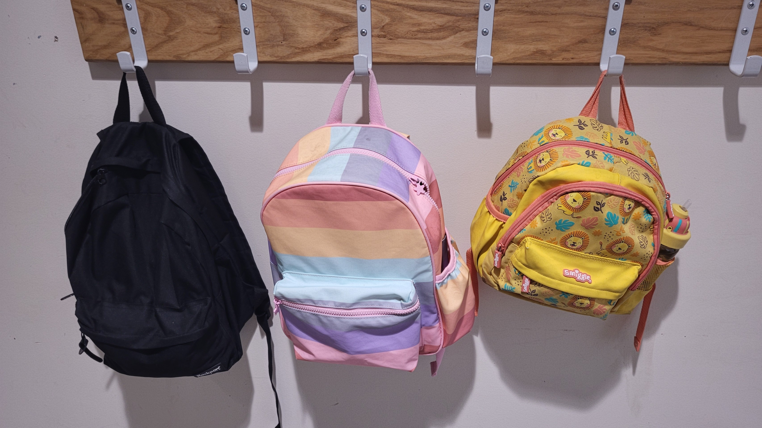

My peg has my name on it.

Here is my classroom.

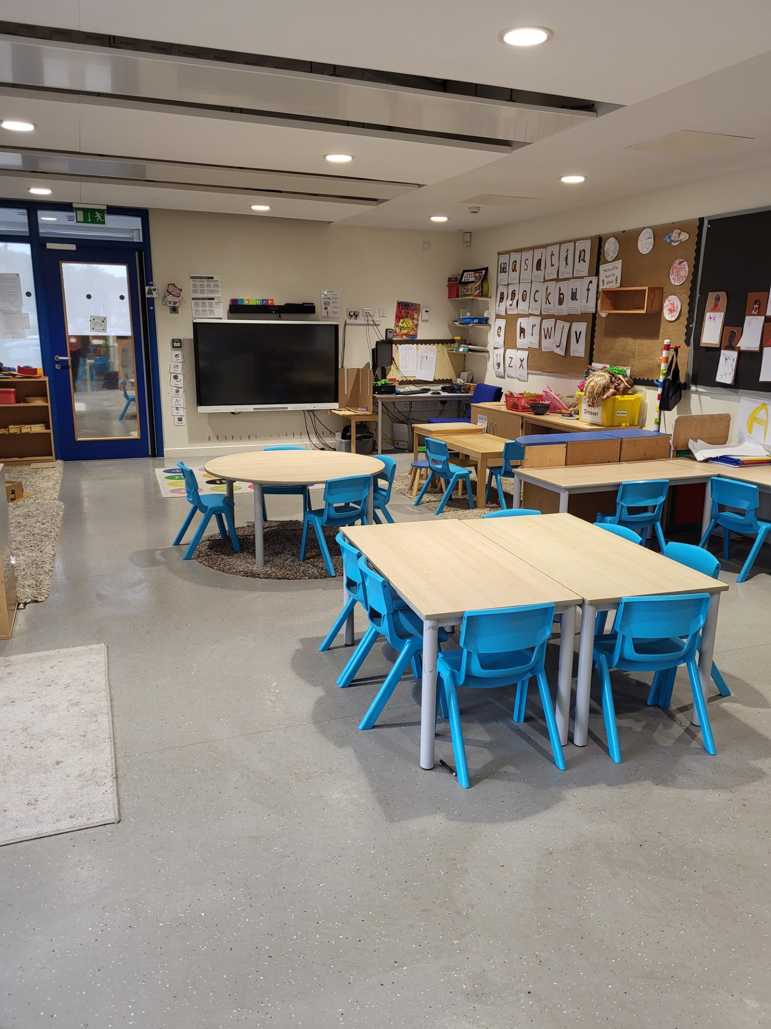

Here are the toilets.

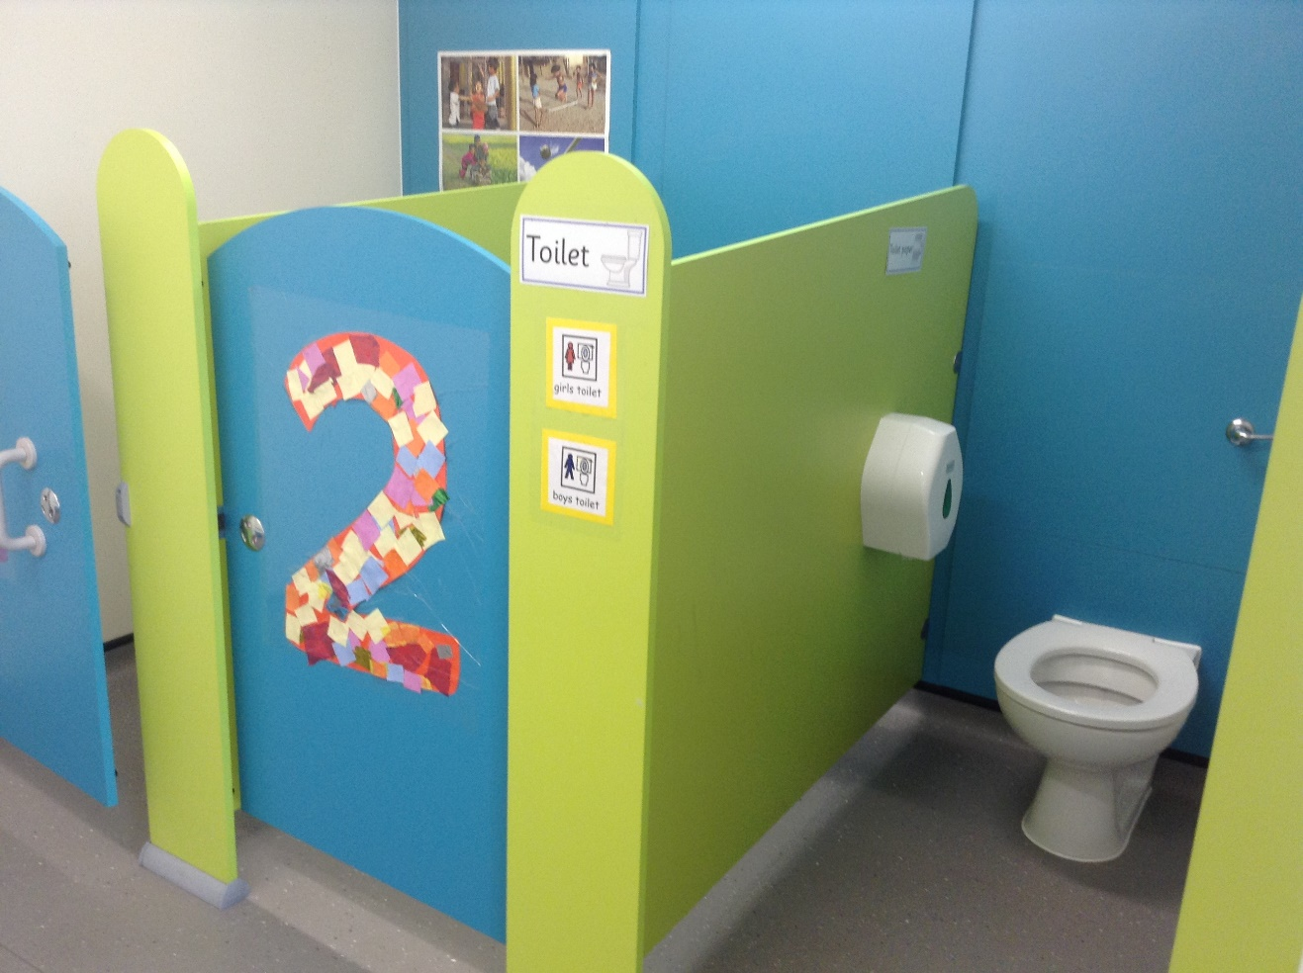

I can ask an adult if I need some help.

I wash my hands at the sinks.

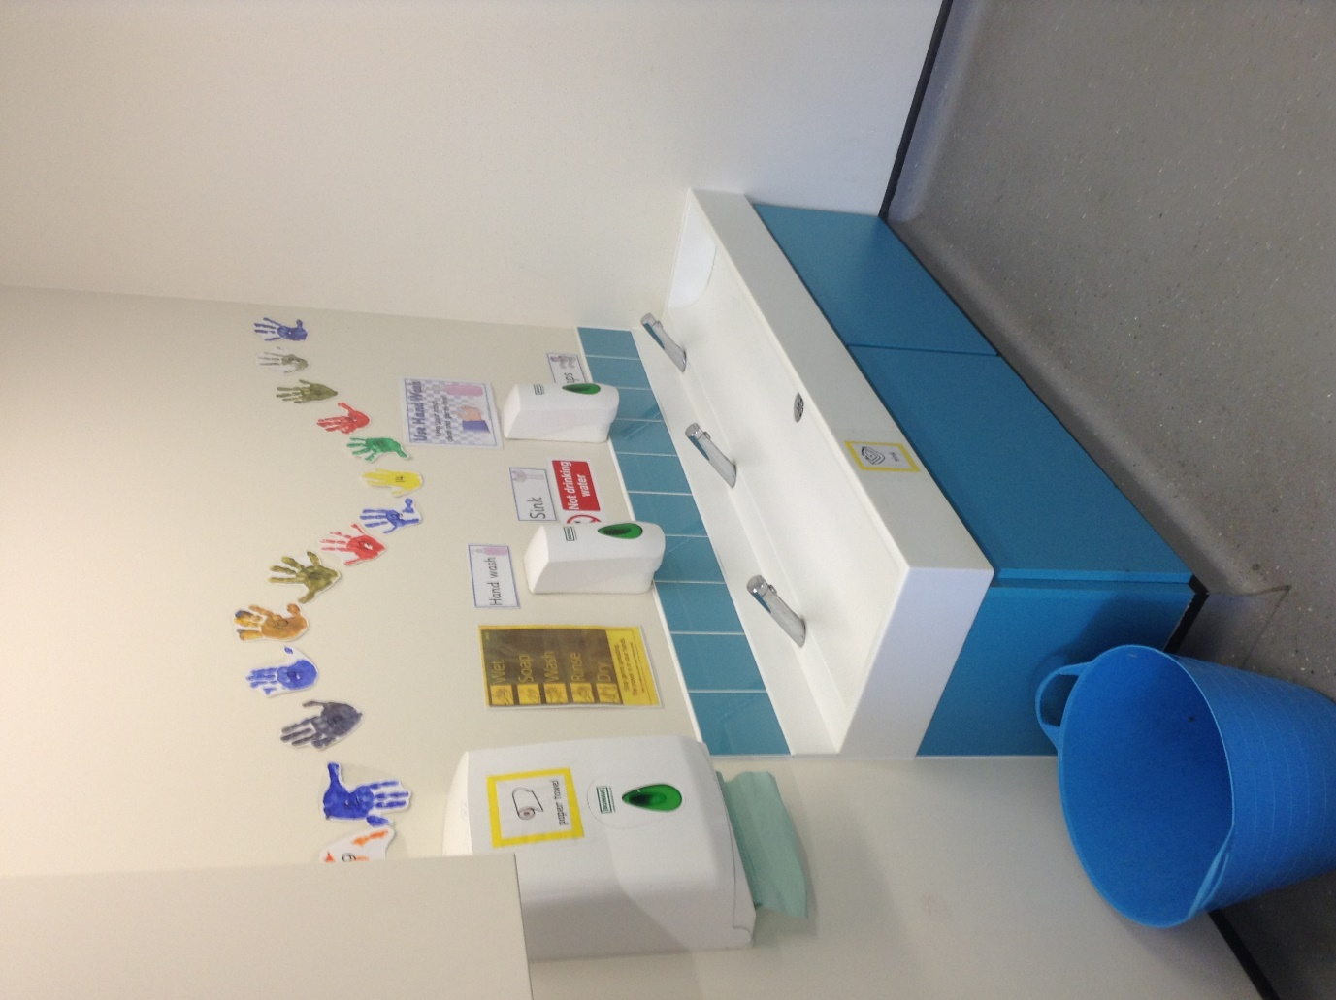

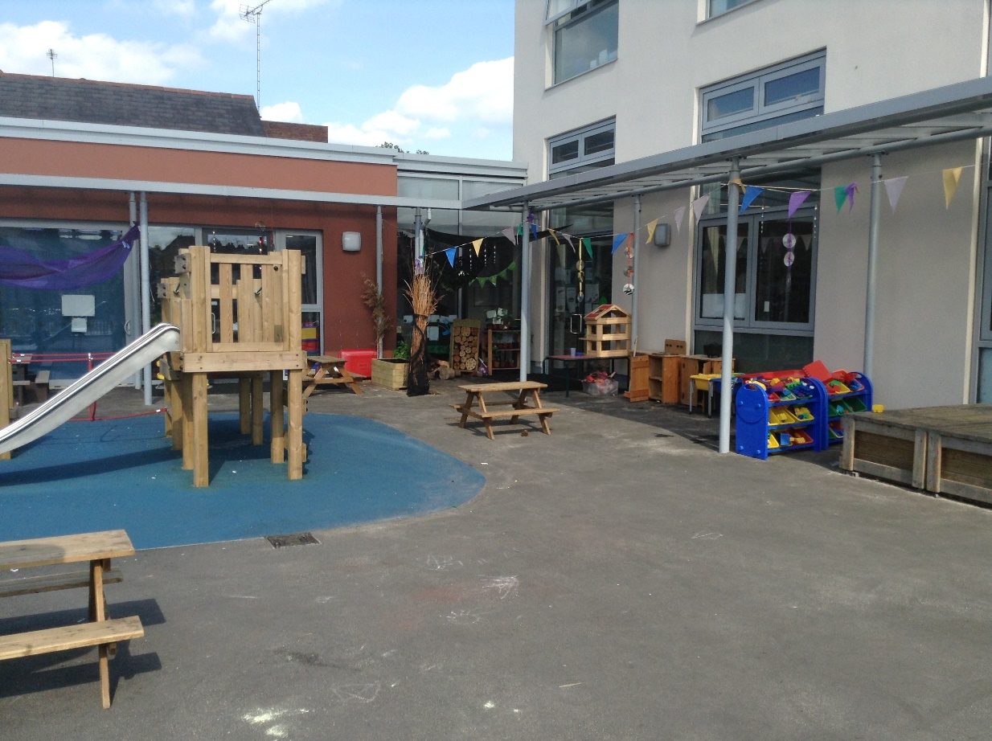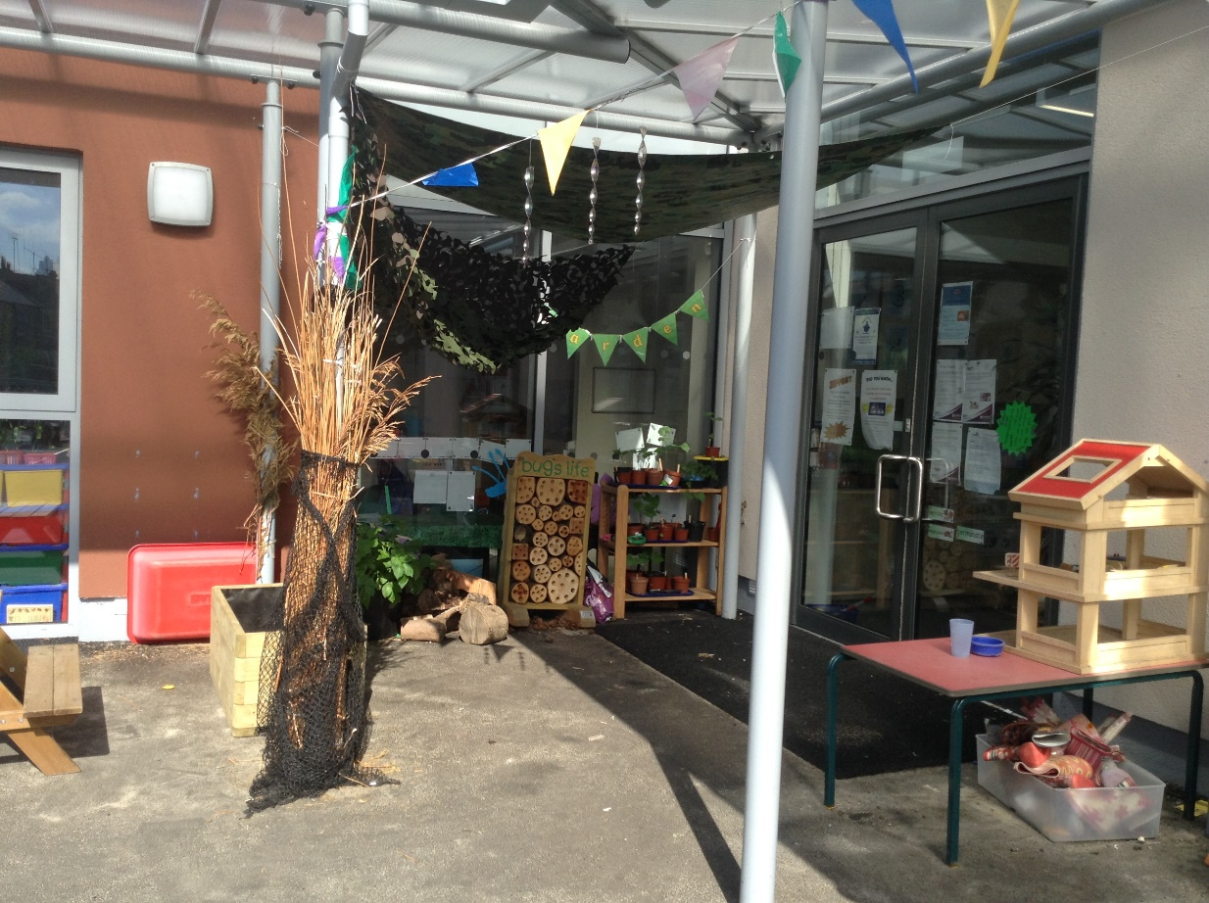This is the outside area. I can paint, draw, read stories and play with my friends. The teachers at school help us.

I go home at the end of the day, when somebody I know comes to collect me.



I am going to have fun at school and everybody is looking forward to meeting me!

Updated July 2023