Fish Story

One, two, three, four, five   
Once I caught a fish alive.  
Six, seven, eight, nine, ten   
Then I let it go again.  
Why did you let it go?  
Because it bit my finger so.  
Which finger did it bite  
This little finger on my right.





C:\Documents and Settings\Steve\Local Settings\Temporary Internet Files\Content.IE5\A7F5YVBJ\MC900058267[1].wmf

Five fat sausages

Five fat sausages sizzling in a pan  
one went pop the other went bang.

Four fat sausages sizzling in a pan  
one went pop the other went bang.

Three fat sausages sizzling in a pan  
one went pop the other went bang.

Two fat sausages sizzling in a pan  
one went pop the other went bang.

One fat sausage sizzling in a pan  
one went pop the other went bang.

C:\Documents and Settings\Steve\Local Settings\Temporary Internet Files\Content.IE5\T7BDI0WV\MC900264338[1].wmf No fat sausages sizzling in a pan.

C:\Documents and Settings\Steve\Local Settings\Temporary Internet Files\Content.IE5\A7F5YVBJ\MC900138283[1].wmf

Five little ducks

Five little ducks  
Went out one day  
Over the hill and far away  
Mother duck said  
"Quack, quack, quack, quack."  
But only four little ducks came back.

Four/Three/Two/One….. little ducks  
Went out one day…

C:\Documents and Settings\Steve\Local Settings\Temporary Internet Files\Content.IE5\T7BDI0WV\MC900355057[1].wmfSad mother duck  
Went out one day  
Over the hill and far away  
Sad mother duck said  
"Quack, quack, quack."  
And all of the five little ducks came back.

C:\Documents and Settings\Steve\Local Settings\Temporary Internet Files\Content.IE5\T7BDI0WV\MC900434613[1].wmf

C:\Documents and Settings\Steve\Local Settings\Temporary Internet Files\Content.IE5\A7F5YVBJ\MC900438131[1].wmfFive little monkeys jumping on the bed

C:\Documents and Settings\Steve\Local Settings\Temporary Internet Files\Content.IE5\T7BDI0WV\MC900434613[1].wmfFive little monkeys jumping on the bed,  
One fell off and he bumped his head.  
Mama called the Doctor and the Doctor said,  
"No more monkeys jumping on the bed!"

Four little monkeys jumping on the bed,  
One fell off and she bumped her head.  
Papa called the Doctor and the Doctor said,  
"No more monkeys jumping on the bed!"

C:\Documents and Settings\Steve\Local Settings\Temporary Internet Files\Content.IE5\T7BDI0WV\MC900434613[1].wmfThree little monkeys jumping on the bed,  
One fell off and he bumped his head.  
Mama called the Doctor and the Doctor said,  
"No more monkeys jumping on the bed!"

Two little monkeys jumping on the bed,  
One fell off and she bumped her head.  
Papa called the Doctor and the Doctor said,  
"No more monkeys jumping on the bed!"

C:\Documents and Settings\Steve\Local Settings\Temporary Internet Files\Content.IE5\T7BDI0WV\MC900434613[1].wmfC:\Documents and Settings\Steve\Local Settings\Temporary Internet Files\Content.IE5\T7BDI0WV\MC900434613[1].wmfOne little monkey jumping on the bed,  
He fell off and he bumped his head.  
Mama called the Doctor and the Doctor said,  
"Put those monkeys straight to bed!"

C:\Documents and Settings\Steve\Local Settings\Temporary Internet Files\Content.IE5\T7BDI0WV\MC900290203[1].wmfFive currant buns in a baker's shop

Five currant buns in a baker's shop.

Big and round with a cherry on the top,  
 Along came a boy with a penny one day,  
 Bought a currant bun and took it away.

C:\Documents and Settings\Steve\Local Settings\Temporary Internet Files\Content.IE5\A7F5YVBJ\MC900112734[1].wmfFour currant buns in a baker's shop.  
Big and round with a cherry on the top,  
Along came a girl with a penny one day,  
Bought a currant bun and took it away.

Three currant buns in a baker's shop.  
Big and round with a cherry on the top,  
Along came a boy with a penny one day,  
Bought a currant bun and took it away.

Two currant buns in a baker's shop.  
Big and round with a cherry on the top,  
Along came a girl with a penny one day,  
Bought a currant bun and took it away.

C:\Documents and Settings\Steve\Local Settings\Temporary Internet Files\Content.IE5\T7BDI0WV\MC900290203[1].wmfOne currant bun in a baker's shop.  
Big and round with a cherry on the top,  
Along came a boy with a penny one day,  
Bought the currant bun and took it away.

C:\Documents and Settings\Steve\Local Settings\Temporary Internet Files\Content.IE5\SU0U23IW\MC900237629[1].wmf

I'm a little teapot

I'm a little teapot  
Short and stout  
Here is my handle  
Here is my spout

When the kettle’s boiling  
Hear me shout  
"Tip me up  
and pour me out!"

C:\Documents and Settings\Steve\Local Settings\Temporary Internet Files\Content.IE5\TP7XI3XF\MC900030279[1].wmf



Incy Wincy Spider

Incy Wincy spider  
Climbed up the waterspout

Down came the rain  
And washed the spider out.

Out came the sunshine  
And dried up all the rain

So Incy Wincy spider  
Climbed up the spout again!

C:\Documents and Settings\Steve\Local Settings\Temporary Internet Files\Content.IE5\T7BDI0WV\MC900252225[1].wmf



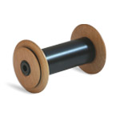

Wind the bobbin up

Wind the bobbin up, Wind the bobbin up  
Pull, Pull, Clap, Clap Clap.  
Wind the bobbin up, Wind the bobbin up  
Pull, Pull, Clap, Clap Clap.

Point to the ceiling, Point to the floor  
Point to the windows and point to the door

Clap your hands together, One, Two, Three  
Then put your hands upon your knees

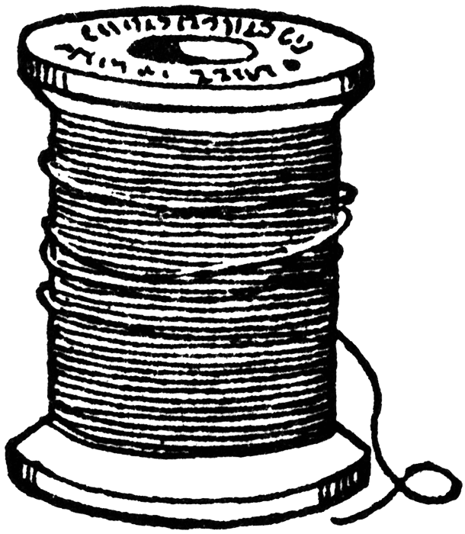



If you're happy and you know it…

If you're happy and you know it clap your hands.  
(clap clap)  
If you're happy and you know it clap your hands.  
(clap clap)  
If you're happy and you know it and you really want to show it.  
If you're happy and you know it clap your hands.  
(clap clap)

Repeat with…nod your head/shake your hands/wiggle your toes etc

C:\Documents and Settings\xyz\Local Settings\Temporary Internet Files\Content.IE5\0KE0G23D\MC900383592[1].wmf

**C:\Documents and Settings\xyz\Local Settings\Temporary Internet Files\Content.IE5\06HOUFRS\MC900241615[1].wmfRow, row, row your boat**

Row, row, row your boat  
Gently down the stream.  
Merrily, merrily, merrily, merrily,  
Life is but a dream.

Row, row, row your boat  
Gently down the stream.  
If you see the crocodile  
Don’t forget to scream!

C:\Documents and Settings\xyz\Local Settings\Temporary Internet Files\Content.IE5\7V2JV2IA\MC900192165[1].wmf Rock, rock, rock your boat  
Gently to the shore  
If you see the lion there  
 Don’t forget to Roar!

C:\Documents and Settings\xyz\Local Settings\Temporary Internet Files\Content.IE5\3R2RPZZ1\MC900445164[1].wmf

C:\Documents and Settings\xyz\Local Settings\Temporary Internet Files\Content.IE5\3R2RPZZ1\MC900330291[1].wmf

**Baa, baa black sheep**

Baa, baa black sheep  
Have you any wool  
Yes sir, yes sir  
Three bags full.

One for my master  
And one for my dame  
And one for the little boy  
Who lives down the lane.

C:\Documents and Settings\xyz\Local Settings\Temporary Internet Files\Content.IE5\06HOUFRS\MC900215945[1].wmfC:\Documents and Settings\xyz\Local Settings\Temporary Internet Files\Content.IE5\06HOUFRS\MC900215945[1].wmfC:\Documents and Settings\xyz\Local Settings\Temporary Internet Files\Content.IE5\06HOUFRS\MC900215945[1].wmf

C:\Documents and Settings\xyz\Local Settings\Temporary Internet Files\Content.IE5\7V2JV2IA\MC900351524[1].wmf

Hickory dickory dock

Hickory dickory dock,

The mouse ran up the clock.

C:\Documents and Settings\xyz\Local Settings\Temporary Internet Files\Content.IE5\7V2JV2IA\MC900446060[1].wmfThe clock struck one,  
The mouse ran down,  
Hickory dickory dock.

Hickory dickory dock,  
The mouse ran up the clock.  
The clock struck two,  
The mouse said “BOO”  
Hickory dickory dock.

Hickory dickory dock,  
The mouse ran up the clock.  
The clock struck three,  
The mouse went “Weeeeeee”  
Hickory dickory dock.

C:\Documents and Settings\xyz\Local Settings\Temporary Internet Files\Content.IE5\0KE0G23D\MC900091113[1].wmfHickory dickory dock,  
The mouse ran up the clock.  
The clock struck four,  
The mouse said “No more!”  
Hickory dickory dock.

C:\Documents and Settings\xyz\Local Settings\Temporary Internet Files\Content.IE5\3R2RPZZ1\MC900232108[1].wmf

Miss Polly had a dolly

Miss Polly had a dolly who was sick, sick, sick.  
She called for the doctor to come quick, quick, quick.  
The doctor came with his bag and hat,  
And knocked at the door with a rat tat tat.

He looked at the dolly and shook his head,  
He said "Miss Polly put her straight to bed."  
He wrote on some paper for a pill, pill, pill.  
I'll be back in the morning with my bill, bill, bill.

C:\Documents and Settings\xyz\Local Settings\Temporary Internet Files\Content.IE5\0KE0G23D\MC900277242[1].wmf

C:\Documents and Settings\xyz\Local Settings\Temporary Internet Files\Content.IE5\0KE0G23D\MM900354469[1].gif

**Twinkle, twinkle, little star**

Twinkle, twinkle, little star,  
How I wonder what you are!  
Up above the world so high,  
Like a diamond in the sky.  
Twinkle, twinkle, little star,  
How I wonder what you are!

C:\Documents and Settings\xyz\Local Settings\Temporary Internet Files\Content.IE5\0KE0G23D\MM900354469[1].gif



**Humpty Dumpty**

Humpty Dumpty sat on a wall,  
Humpty Dumpty had a great fall;  
All the King's horses and all the King's men,  
Couldn't put Humpty together again.

C:\Documents and Settings\xyz\Local Settings\Temporary Internet Files\Content.IE5\3R2RPZZ1\MC900116092[1].wmf

C:\Documents and Settings\xyz\Local Settings\Temporary Internet Files\Content.IE5\3R2RPZZ1\MC900410847[1].wmfC:\Documents and Settings\xyz\Local Settings\Temporary Internet Files\Content.IE5\3R2RPZZ1\MC900410847[1].wmfC:\Documents and Settings\xyz\Local Settings\Temporary Internet Files\Content.IE5\3R2RPZZ1\MC900410847[1].wmfC:\Documents and Settings\xyz\Local Settings\Temporary Internet Files\Content.IE5\3R2RPZZ1\MC900410847[1].wmfC:\Documents and Settings\xyz\Local Settings\Temporary Internet Files\Content.IE5\3R2RPZZ1\MC900410847[1].wmf

**Head, shoulders, knees and toes**

Head, shoulders, knees and toes, knees and toes  
Head, shoulders, knees and toes, knees and toes  
And eyes and ears and mouth and nose  
Head, shoulders, knees and toes, knees and toes  
(Repeat, getting faster each time or missing out the words)

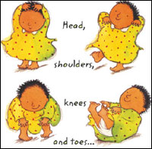

**The music man**

C:\Documents and Settings\xyz\Local Settings\Temporary Internet Files\Content.IE5\06HOUFRS\MC900057671[1].wmfI am the music man  
I come from down your way  
And I can play...  
What can you play?  
 I play the piano

pia-pia-piano  
 piano piano  
 pia-pia-piano  
 pia-piano

I play the big drum….big bass, big bass, big bass drum



I play the trumpet….tooty, tooty, tooty toot!

C:\Documents and Settings\xyz\Local Settings\Temporary Internet Files\Content.IE5\06HOUFRS\MC900446240[1].wmf

**The Grand old Duke of York**

The Grand old Duke of York,  
He had ten thousand men,  
He marched them up to the top of the hill,  
And he marched them down again.

And when they were up, they were up,  
And when they were down, they were down,  
And when they were only halfway up,  
They were neither up nor down.

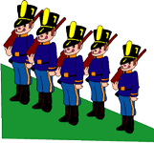

**One, two, buckle my shoe**

C:\Documents and Settings\xyz\Local Settings\Temporary Internet Files\Content.IE5\06HOUFRS\MC900215240[1].wmf One, two,  
 Buckle my shoe;

C:\Documents and Settings\xyz\Local Settings\Temporary Internet Files\Content.IE5\0KE0G23D\MC900088992[1].wmf

Three, four,  
 Knock at the door;

C:\Documents and Settings\xyz\Local Settings\Temporary Internet Files\Content.IE5\7V2JV2IA\MC900014754[1].wmfFive, six,  
Pick up sticks;

Seven, eight,  
Lay them straight;

C:\Documents and Settings\xyz\Local Settings\Temporary Internet Files\Content.IE5\0KE0G23D\MC900026900[1].wmf

Nine, ten,  
A big, fat hen.