Parents as Partners in Learning
Areas Of learning:  Communication & Language  Understanding the World | Topic/Theme:  Autumn | Date: October 2017
What are we learning at school?  - That the seasons change throughout the year.  - That we can sort objects by size, colour and shape.  - To use new vocabulary for objects that we find and come across. |   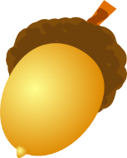  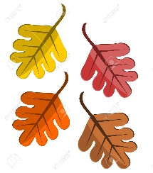  
Learning at Home:

- Take an Autumn Walk together. Go to the river, the park, the woods or your garden
- How many signs of Autumn can you spot? Look for colours, berries, leaves and seeds
- Can you collect 5 different Autumn objects? (Leaves, conkers, seeds, acorns, twigs etc)
- Can you bring them in for our Autumn table?
Other Ideas

- Bring in a photo of you on your walk
- Paint/draw an Autumn picture, what colours do we see in the Autumn?
- How many conkers/leaves etc can you collect? Can you fill a container and count them all?
- Can you sort them by shape or order them by size?
- Talk about the dangers of eating berries with your child.
Child & Parent’s Comments:
(Please comment on your child’s response to this activity)

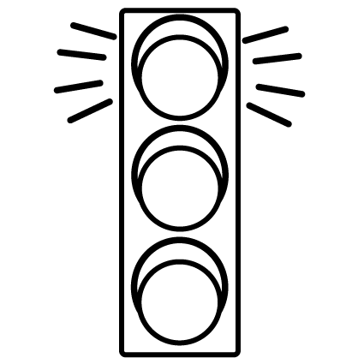
You may prefer to colour the traffic light…

Red: This was tricky, my child found this hard.
Orange: My child was happy to have a go.
Green: We enjoyed this activity and found it valuable.

