Parents as Partners in Learning
Areas Of learning:  Personal, Social & Emotional Development  Communication & Language  Understanding the World | Topic/Theme:  Ourselves | Date: September 2016
What are we learning at school?  - What it is that makes us special  - Who is in our family  - Where we all come from  - What makes us all different | 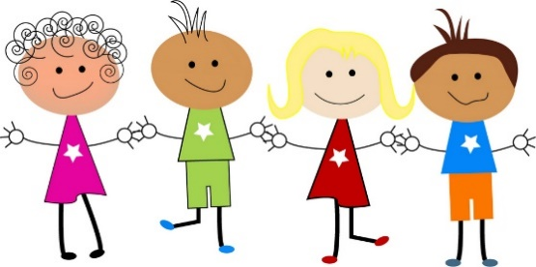
Learning at Home:

- Spend some time looking through photos of family and friends. Does your child know the names of the people in their family? How are they related to each other and what do they know about them? Can they remember a special event or visit that included people from their family?
Other Ideas
- Bring in a photo to talk about at school
- Draw a picture of your family
- Where are you from? Can you find something to show your friends that tells us about your home country.
Child & Parent’s Comments:
(Please comment on your child’s response to this activity)


You may prefer to colour the traffic light…

Red: This was tricky, my child found this hard.
Orange: My child was happy to have a go.
Green: We enjoyed this activity and found it valuable.

