Parents as Partners in Learning
Areas Of learning:  Communication & Language  Understanding the World | Topic/Theme:  Winter | Date: January 2019  You may need to wait for some Wintery weather before completing this!
What are we learning at school?  - That the seasons change throughout the year.  - The characteristics of winter and winter weather & the language to describe it.  - How to use Non Fiction books to find out new information.  - Ways of keeping ourselves warm and healthy. | 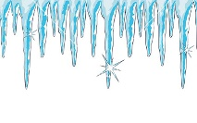    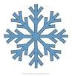  
Learning at Home:

- Take a walk on a cold frosty morning. What do you need to wear?
- What can you see? What can you feel? What do you notice about the trees and plants?
- Can you make marks in the frost/ice? Could you collect some snow/ice to bring home? What happens to it? Why?

Other Ideas
- How many words can you think of to describe winter weather?
- Can you find a non fiction book in your house or at the library? Find the contents page and the page numbers. Can you find out 3 things you did n’t know before?
- Can you make some ice? How fast can you make it melt? Where could you put it?
- Maybe you make a wintery picture or a photo collage to show your friends?
Child & Parent’s Comments:
(Please comment on your child’s response to this activity)


You may prefer to colour the traffic light…

Red: This was tricky, my child found this hard.
Orange: My child was happy to have a go.
Green: We enjoyed this activity and found it valuable.

