**JMA Year 5 & 6 Football League**

**Tuesday 16th October 2018**

On Tuesday 16th October 2018, Mr Gardner took seven Year 5 & 6 children to John Madejski Academy to compete in the first of many Reading Sports Partnership football matches. These children were chosen as they have worked incredibly hard in all aspects of their education and shown an interest to become sports ambassadors for E.P. Collier Primary School.

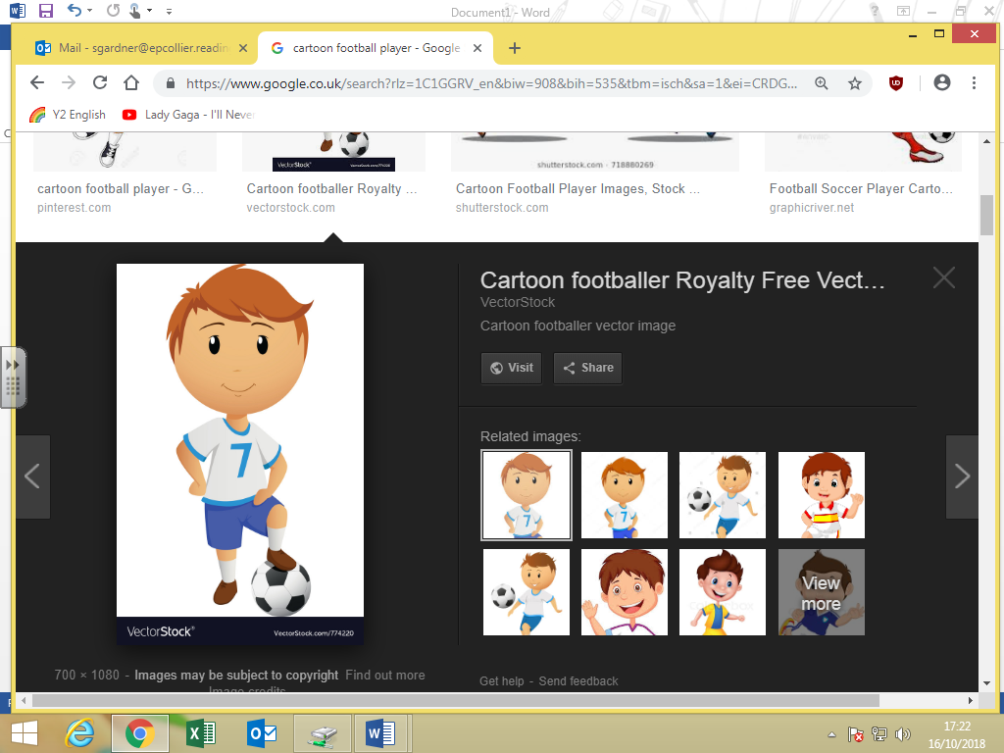After a 10 minute warm-up led by Mr Gardner, the E.P. Collier Football team were focused and limber for their first game against George Palmer. George Palmer showed a strong front and scored within the first few minutes of our game. Samita gave a valiant effort as our goalkeeper in this game and gave some amazing kicks to clear the ball out of play. Harleigh and Riccardo showed great teamwork up front and Brian had the crowds shouting words of praise from the side-lines to recognise his amazing defensive efforts. Unfortunately, E.P. Collier lost 4 – 0 to George Palmer. However, the whole team showed amazing sportsmanship by shaking the opposition’s hands and giving constructive feedback to their team mates ready for our next gave against Caversham Primary.

Within minutes of starting our second game, we knew that Caversham Primary would be a tough opponent for our school football team. With our strong defence from Samita and Karolina and Isra in goal, there was no way that E.P. Collier would concede a goal in this game. Kiril gave a brilliant performance when playing at mid-field and when throwing the ball in from the side lines for the first time. A special mention has to go to Harleigh for scoring two goals with some amazing support seen by Riccardo.

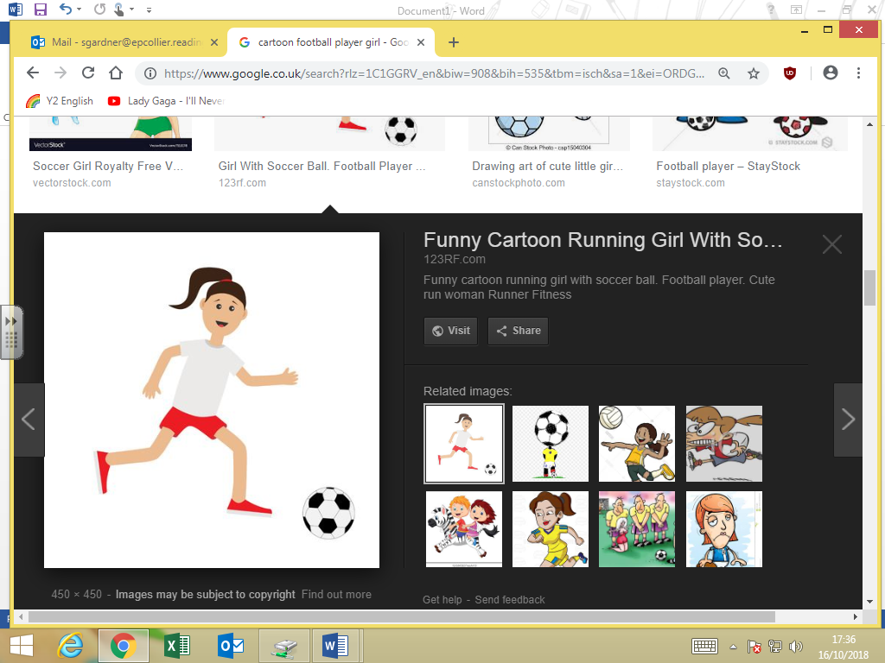

Player of the match was Brian for the amazing support he gave his team mates on the and off the pitch and for the incredible improvements he has made in a competitive game of football. All children played incredibly well and were super excited to tell their parents the result of our first football league.

Could you be the next sports ambassadors for E.P. Collier Primary? Mr Gardner is looking forward to taking even more children out to competitive sports events. **Mr Gardner 16.10.2018**