EP Collier P.E. & Sports Premium Report 2017 - 2018

Sam Gardner and Amanda Walcott-Barnett

School Background

E.P. Collier is a dynamic and innovative school providing exciting opportunities for all children to achieve outstanding outcomes. Strong Values create a safe environment where everyone is nurtured, respected and celebrated. We have 6 core school values that are at the centre of learning and community at E.P. Collier (Respect, Equity, Honesty, Care, Empathy and Courage).

At E.P. Collier, we believe an active lifestyle is vital to a child’s wellbeing. We have high expectations of the children in all aspects of PE. To achieve this, we introduce all children to a wide range of physical activities and experiences. Children will be taught to develop their fundamental physical skills of agility, balance and co-ordination. We also place great importance on the development of children’s co-operative and social interaction skills. Our aim is to deliver lessons that are both challenging and fun. We are also currently working with Get Active to offer a wider variety of sporting opportunities (November 2017).

At E.P. Collier, we are faced by the challenge of having no green space and have had to think creatively around how best to make our P.E. and sport vision successful. This P.E. Impact Report is going to outline how we are going to increase participation and competition opportunities for the school community. Furthermore, how we are going to use the Sport Premium money to instil a love of P.E and leading an active & healthy lifestyle.

Context

This year, we have successfully worked as a team to lead curriculum PE and extra curriculum PE. There have been many advantages to this approach including; logistic, work load demands and increased output.

The sports premium money was used to invest in new sports equipment, specialised sports leaders for playtimes, additional playground marking and wall displays to motivate pupils to enjoy participation in a greater range of self-initiated sports games. We have replenished and updated the sports equipment for both PE lessons and break times. All pupils experience two high quality PE sessions each week and results from pupils feedback show pupils have demonstrate high levels of motivation and engagement.

This year we have continued to offer a variety of extra-curricular sports clubs, these included; football, multi-skills, gymnastics, yoga and rounders. These clubs have proved popular and were well attended. The Year 5 and 6 children have had to opportunity to take part in bikeability, which develops their cycling proficiency and Year 4 pupils have taken part in swimming lessons.

Headline Data and Impact

|  |  |  |
| --- | --- | --- |
| Objectives of spending the PE grant:   * Increase pupil participation in competitions, interschool sport and events. * Instil in pupils a love of sport and physical activity. * Improve resources to support PE, including transport and equipment. * Broaden the sporting opportunity available to pupils. * Train sports coach / class teachers to develop sporting skill in pupils. | | |
|  | | |
| Objective: | Activities | Impact: |
| To increase pupil participation in competitions, interschool sport and events. | Pupils have taken part in a number of  sporting competitions with other schools, Year 6 residential trip and Sports day | We have joined the School Sport Partnership and  Pupils have represented the school at a number of sporting events some of the events included, Change4Life Festival (JMA – February 2018), New Age- Kurling & Boccia (JMA – March 2018), Year2 Multi-Sports and Sports Relief.   * 76 children have had access to sporting competitions * 16 Extra Hours of sport and competition preparation with (SG) * 5 Extra Sports Clubs (SG) * Attended 9 Sports Competitions * Active Sports, Koosa Kids, Teacher Led Extra-Curricular Activities   (Data collected in February 2018)  This has raised the profile of sports and pupils achievements have been celebrated in assemblies.  Subsidising Year 6 residential, which provides the children with a range of outdoor sporting opportunities. Thus maximising the wide range of sports opportunities available to the pupils.  This provided the school with a venue to hold sport day encouraging the children to take part in competitive sports. |
| To instil in pupils a love of sport and physical activity. | Adult led sports activities at lunchtime | All pupils have a regular opportunity to take part in specialised sports activities during lunchtime breaks. |
| To improve resources to support PE, including transport and equipment. | Replenish PE equipment stock | An excellent range and availability of PE equipment so all pupils actively participate in every lesson. Updated and new sports resources for play and break times. Break time observations show pupils are using the equipment purposefully and engaging in self-initiated sports activities. This term we have placed mirrors in the studio to encourage the pupils to provide pupils with immediate visual feedback. |
| To broaden the sporting opportunity available to pupils. | Cycling proficiency  After School Sports clubs | Data from Year 4 swimming  44% achieved the 25m in all 4 strokes  A further 18% achieved 25m in backstroke  100% children achieved 5/10m with a swimming aid  Data from Year 5 and 6 Bikeability  96% got level one or above  32% got level two  After school sports clubs are provide three days a week and these are well attended. |
| Train sports coach / class teachers to develop sporting skill in pupils. | Class teachers PE CPD | Subject Leaders staff meeting for PE provided some focus on Greater Depth and use of questioning in PE.  SG attended School Games P.E. CPD & additional CPD provided by Rebecca Anderson |

Qualitative evidence from pupil questionnaires indicate high levels of enjoyment and engagement, good use of subject specific vocabulary and clear progression.

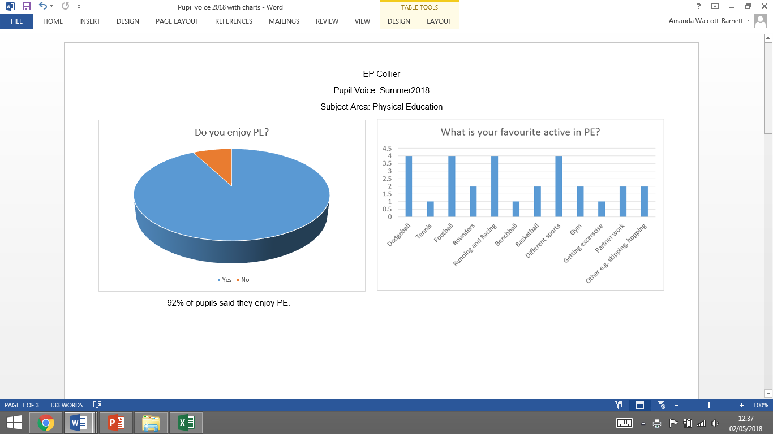

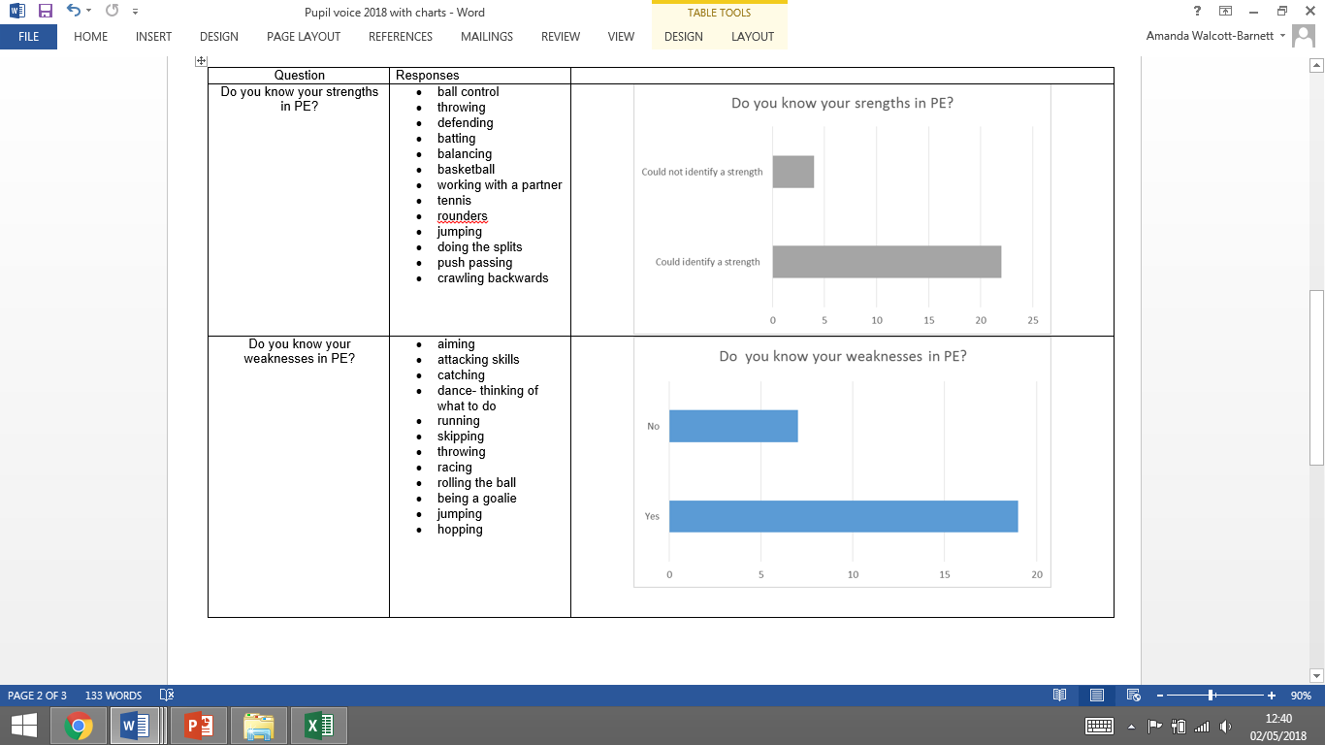

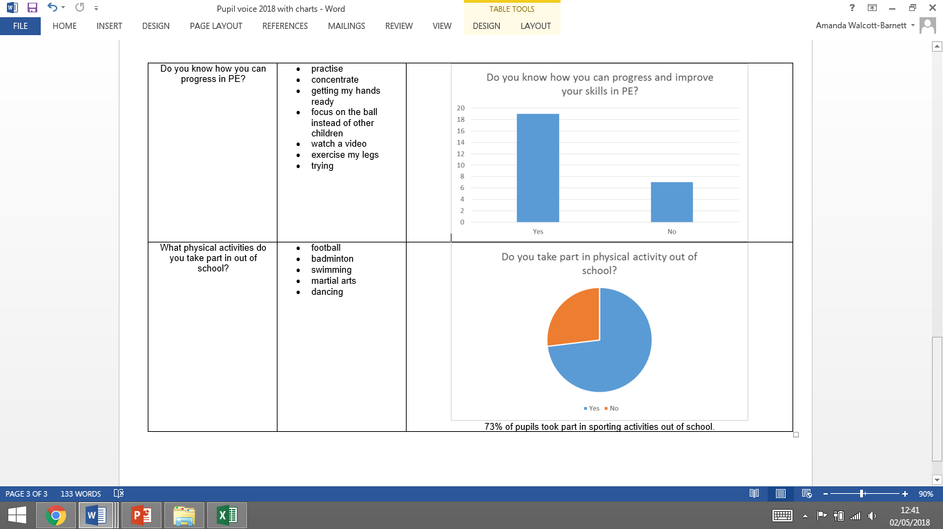

Successes

* A greater number in children attending intra & Inter sports competitions
* A wider range of sports being made available for children in the extra-curricular timetable
* Noticeable positive behaviour changes at break and lunch times, with children using the play equipment appropriately and with respect (feedback from the class teachers)
* A well-established link with Kingfisher coaches and local companies to help us provide good extra-curricular sports provision
* Winning both Development league competitions (New-Age Kurling & Boccia and Indoor Athletics) and gaining recognition from the school games partnership for allowing many children with additional needs to take part in these activities
* A wide range of sports covered on Sports Day, with a suitable level of challenge for KS2 to reflect the demands from the National Curriculum to provide challenge that will prepare KS2 children for their secondary transition. KS1 also had a good level of challenge and a wider range of activities. Reading Football Club also came and delivered extra provision.

Challenges

* Time pressures and priorities means most class have not lead a class sporting activities with other schools.
* Identifying most able pupils in sports and ensure they have sufficient support and opportunity to pursue extra-curricular training in their area of talent.

Other

Next Steps:

* More opportunities for sporting activities with other schools – being part of the School Sports Partnership will help with this
* Staff to look for opportunities for enable the pupils to develop greater depth in PE
* CPD- opportunities in PE – SG & AB to email teachers with CPD opportunities
* SG to meet with specialist in Impact reports – Term 1 (September 2018) to understand how to record progress and impact further on our Impact Report

