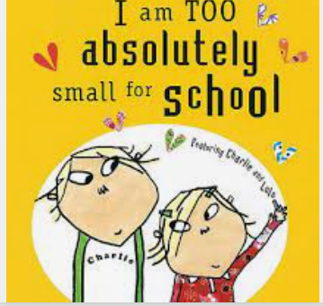

Term 1:1

Starting School-Settling in

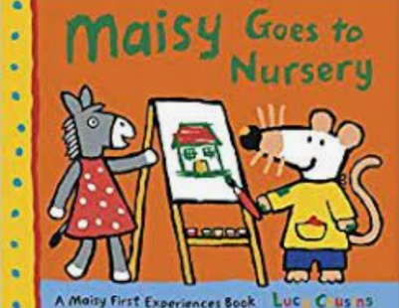

**Learning Through Talk (up to 3-4 Yrs)**

**-Find ways of managing transition from parent to keyworkers**

**-Play with increasing confidence on their own & with other children, knowing staff are near by**

**-Select & use activities & resources with help**

**- Ask for help when needed & recognise routines**

**-Begin to use the toilet independently**

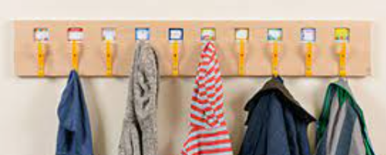

**Learning To Talk**

-Know that it is good to talk to others at school

-Know when it is time to listen

**Learning Through Talk (Reception)**

**-Manage their own needs: having a go for themselves**

**-Think about the perspectives of others**

**-Develop the skills they need to manage the school day (lining up & queuing, mealtimes, hygiene & toileting**



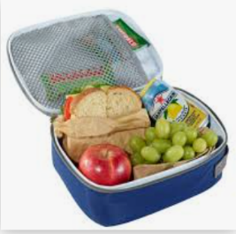

**Collections/Displays:**

Photos of staff, children & familiar places

**Real Experiences:** First School Visits

***Vocabulary***

***Teacher***

***Classroom***

***Listen***

***Quiet***

***Follow***

***Line Up***

***Outside***

***Snack/Lunch***

