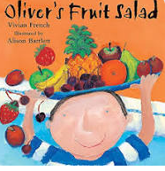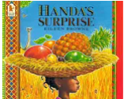

**Learning Through Talk (up to 3-4 Yrs)**

**-Use their senses in hands on exploration of natural materials & talk about what they see using a wide variety of vocabulary**

**- Know that fruits carry seeds which can grow into new plants**

**-Know that there are different countries in the world and that different things grow in different places**

**- Make healthy choices about food and know that fruit and vegetables are important to keep us healthy**

Term 4/4:

Food: Handa’s Surprise

**Vocabulary**

**Fruit / Vegetable**

**Healthy / Unhealthy**

**Climate**

**Life- Cycle**

**Seed**

**Variety**

**Learning Through Talk (Reception)**

**-Re-tell familiar stories in their own words, re-enacting or developing ideas through role play**

**-Compare & contrast different characters from stories**

**-Use their oracy skills to give simple instructions to others**

**-Recognise similarities & differences between life in this country & Africa.**

**-Know that there are different environments in different places around the world**

**-Know that we should eat a rainbow (7) of different fruits/vegetables**

**-Recognise emotions in story characters and discuss**

**-Recognise dangers in the kitchen**

**-**

**-**

**Learning To Talk**

Begin to use the sentence starters “I agree (or disagree) because….”

Recognise good talking behaviours in others

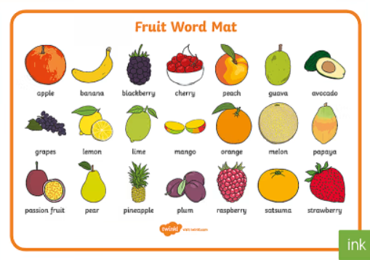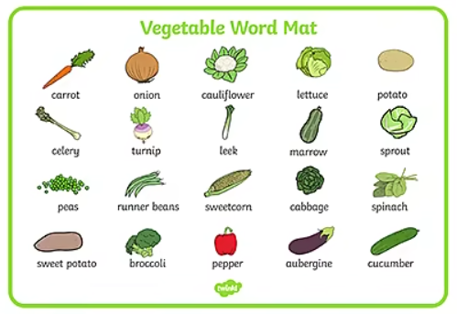

**Displays/ Real Experiences**

Making and tasting healthy snacks