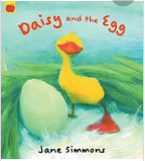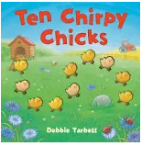

**Learning Through Talk (up to 3-4 Yrs)**

**-Use their senses in hands on exploration of natural materials & talk about what they see using a wide variety of vocabulary**

**- Make healthy choices about food and know that some food should be eaten in moderation**

**-Know that chocolate is bad for our teeth**

**-Explore some of the celebrations/traditions associated with Easter**

Term 4/5:

Easter & New Life

**Vocabulary**

**Life Cycle**

**Hatch**

**Fertilise**

**Patience**

**Spring**

**Easter**

**Displays/ Real Experiences**

**Making chocolate nests**

**Cooking & looking at eggs**

**Learning To Talk**

Begin to use the sentence starters “I agree (or disagree) because….”

Recognise good talking behaviours in others

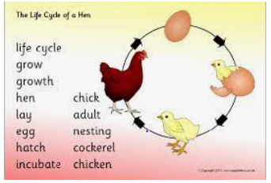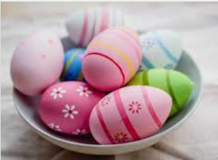

**Learning Through Talk (Reception)**

**-Know that many animals lay eggs to produce young and that these young grow up and lay more eggs**

**-Make close observations of chocolate and eggs to look for changes when heated and cooked.**

**-Use new vocabulary to talk about the changes they see**

**-Use their oracy skills to give simple instructions to others**

**-Know that Christians celebrate Easter and that it is a celebration of new life**

**-**

**-**