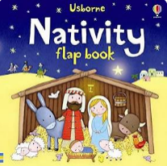

Term 2/6&7:

Celebrating Christmas

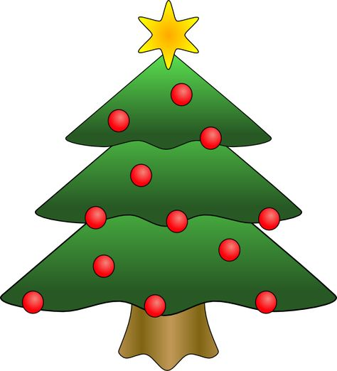

**Learning Through Talk (up to 3-4 Yrs)**

**-**Make comparisons between objects relating to size, length, weight

Talk about and identify the patterns around them.

Extend and create ABAB patterns

Play instruments with increasing control to express their feelings and ideas.

Talk about and identify the patterns around them.

Begin to describe a sequence of events, real or fictional, using words such as ‘first’, ‘then...’

Play instruments with increasing control to express their feelings and ideas.

**Learning To Talk**

Use a loud voice when speaking so that everyone can hear me

**Collections/Displays:**

**Shiny materials- gold & silver**

**Christmas traditions/objects**

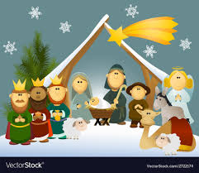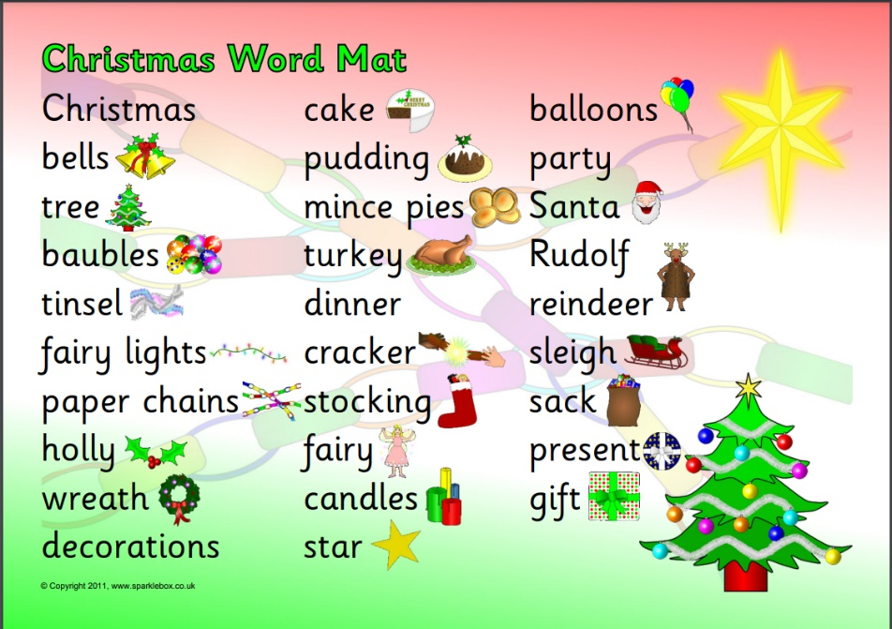

***Vocabulary***

***Nativity***

***Jesus/Mary/Joseph***

***Celebrate***

***Perform***

***Audience***

**Learning Through Talk (Reception)**

**-**Listen to and talk about stories to build familiarity and understanding.

Continue, copy and create repeating patterns.

-Explore & talk about 3D shapes

**-**Watch and talk about dance and performance art, expressing their feelings and responses

Sing in a group or on their own, increasingly matching the pitch and following the melody.