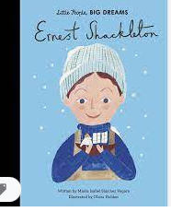

**Learning Through Talk (up to 3-4 Yrs)**

**- Use all their senses in hands on exploration of natural materials**

**-Talk about what they see using new vocabulary**

**- Know that there are different countries in the world & talk about the differences they have seen in photos**

**-Understand & follow simple 2 step instructions**

**-Talk about changes they notice when exploring snow & ice**

Term 3/2:

Snow & Ice: Cold Places

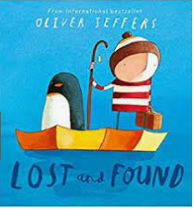

**Learning Through Talk (Reception)**

**-Recognise some environments are different to the one in which they live**

**-Recognise similarities & differences between life in this country & life in other countries**

**-Draw information from a simple map of the world**

**-Compare & contrast the explorations of Ernest Shakleton with explorers today**

**- Compare & contrast keeping warm in the past with keeping warm today**

**-Develop familiar storylines through their pretend play**

**Displays/Experiences**

Exploring snow & ice! Making ice Lollies.

Books & photos of cold places

Real investigations with snow & ice

**Learning To Talk**

Talking in a small group

Listening to what others say!

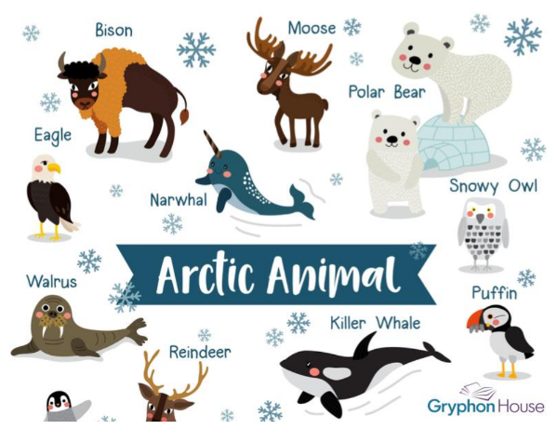

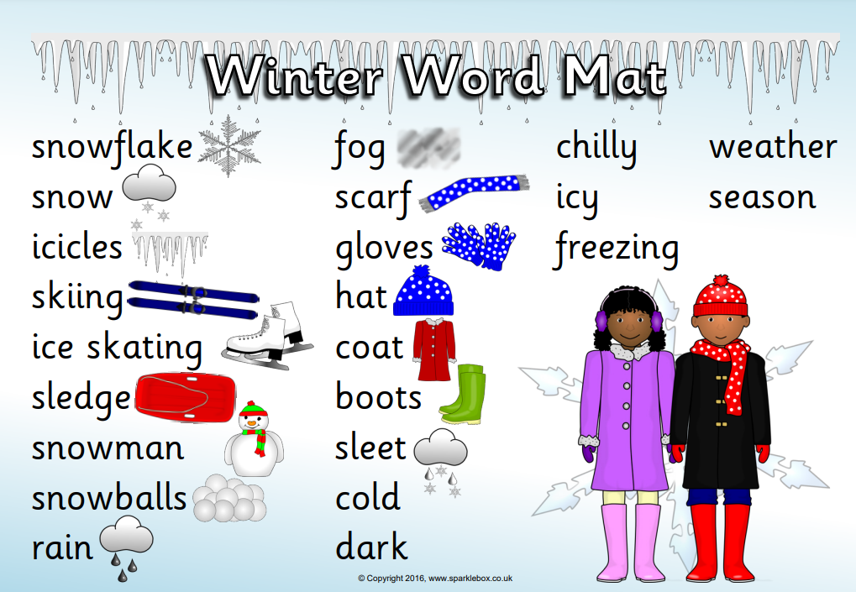

***Vocabulary***

***Freeze***

***Thaw***

***Snow***

***Ice***

***Icicle***

***Polar***

***Climate***

***Insulate***