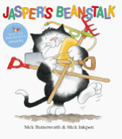

Term 5/2:

Jasper’s Beanstalk

**Learning Through Talk (up to 3-4 Yrs)**

**Talk about what they see using a wide vocabulary**

**Understand the key features of a life cycle of a plant**

**Plant seeds, understanding the need to respect & care for living things**

**Talk about changes they notice**

**Learning Through Talk (Reception)**

**-Make close observations of the caterpillars to look for changes as they grow.**

**-Use new vocabulary to talk about the changes they see**

**-Explore the natural world around them and describe what they see, hear & feel outside**

**-Recognise signs of spring in the environment outside**

**Know that plants need water and light to grow**

**-**

**-**

**Displays/ Real Experiences**

Plant beans and seeds and watch the changes that occur over time

**Learning To Talk**

Recognise good talking behaviours in others

Join a conversation in a small group

