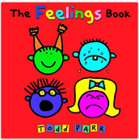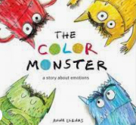

Term 1/2:

All About Me/Feelings

**Learning Through Talk (up to 3-4 Yrs)**

**-Know that I am listening when I hear stories, talk to others, play and explore**

**-Show an awareness of sounds in my environment**

**-Listen to short stories 1:1 & in a small group**

**-Talk about and name feelings**

**-Recognise feelings & know what emotions look like**

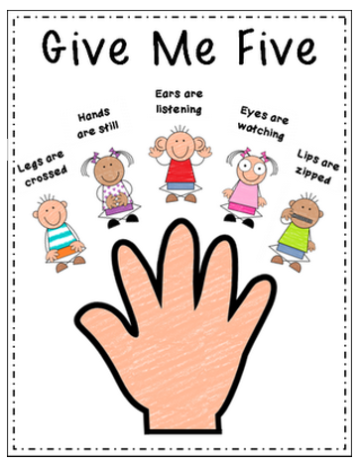

**Learning Through Talk (Reception)**

**-Know why it is important to listen**

**-Recognise good/bad listening behaviours**

**-Listen & respond to stories in a group setting**

**-Identify & express their feelings & begin to recognise how others are feeling**

**-See themselves as a valuable individual**

**Learning To Talk**

-Know what good listening looks like (listening guidelines)

**Collections/Displays:**

Photos of Staff & Children

**Real Experiences:** Taking Photos

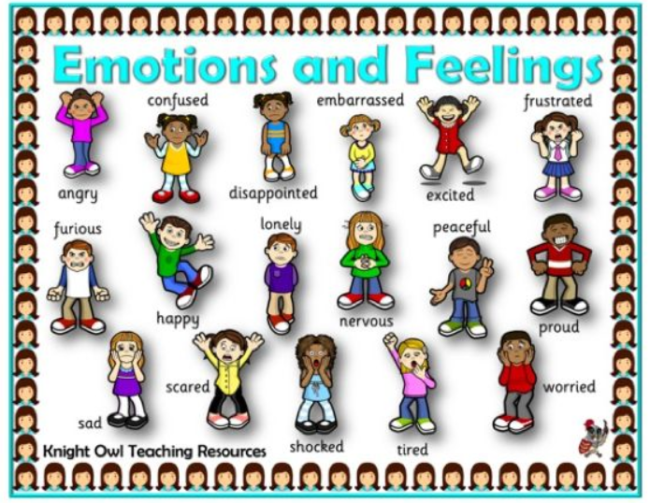

***Vocabulary***

***Feeling***

***Emotion***

***Expression***

***Choose***

***Taking Turns***

***Friend***

***Independent***

***Listen***