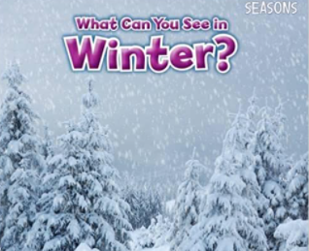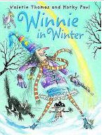

**Learning Through Talk (up to 3-4 Yrs)**

**- Use all their senses in hands on exploration of natural materials**

**-Talk about what they see using new vocabulary**

**-Name different parts of a book**

**-Know that non-fiction texts can tell us new information**

**-Understand & follow simple 2 step instructions**

Term 3/2:

Seasons-Winter

**Displays/Experiences**

Exploring snow & ice!

Collections of winter pictures/scenes

**Learning Through Talk (Reception)**

**-Measure time in simple ways using calendars**

**-Know the order of the different seasons & months of the year**

**-Describe what they see, hear & feel outside**

**-Understand the effect of changing seasons on the natural world around them**

**-Recognise the features of a non-fiction text**

**-Begin to understand how to use a non-fiction text to obtain new knowledge and answer questions**

**Learning To Talk**

Talking in a small group

Using eye contact & taking turns

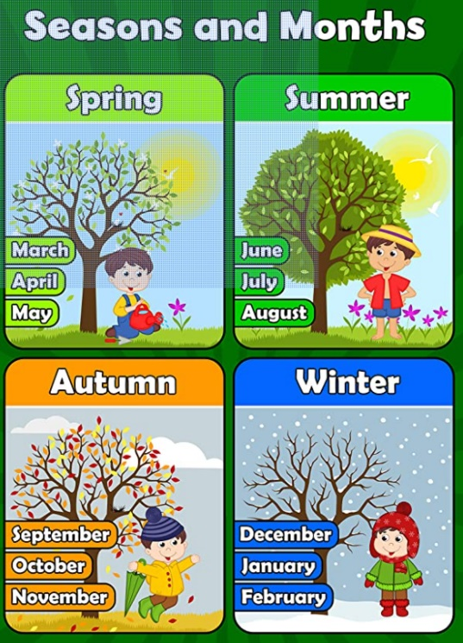

***Vocabulary***

***Season***

***Change***

***Nature***

***Winter***

***Weather***

***Freeze***

***Thaw***

***Snow/ Ice/ Icicle***

