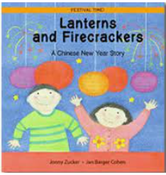

Term 3/3:

Chinese New Year

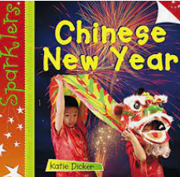

**Learning To Talk**

Introducing talk partners

Making eye contact & listening

**Learning Through Talk (up to 3-4 Yrs)**

**-Develop positive attitudes about the differences between people and communities**

**-Talk about what they see using a wide vocabulary**

**- Know that there are different countries in the world**

**-Understand gradually how others might be feeling using the key texts**

**-Explore different materials freely to develop their ideas about how to use them and what to make (focus on fabric/material)**

**-Talk about the differences between materials & the changes they notice (noodles)**

**-Play instruments with increasing control**

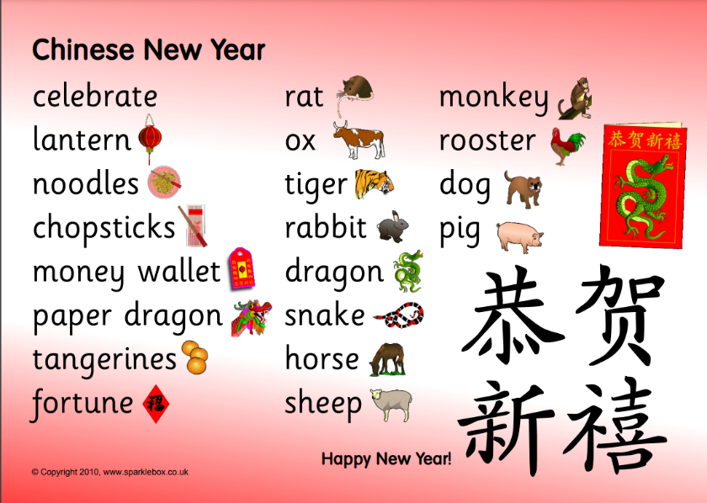

Celebration

Hard/Soft

Smooth/Crunchy

Fabric

Sound

Culture

**Learning Through Talk (Reception)**

**-Draw information from a simple map**

**-Understand that people have different beliefs and celebrate special times in different ways**

**-Create collaboratively, sharing ideas, resources & skills**

**- Move to and talk about music, expressing their feelings & responses**

**-Watch & talk about dance & performance art (Dragon dances)**

**-Explore & engage in music making & dance, performing in a group**

**-**

**Displays/ Real Experiences**

Chinese Celebration Day!

Cooking noodles & trying Chinese food

