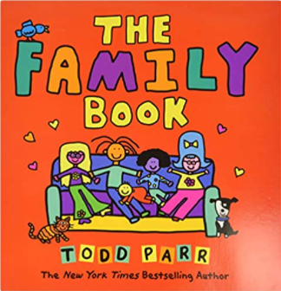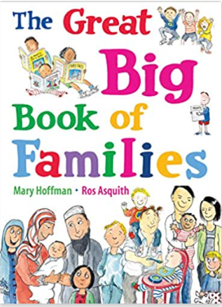

Term 1/3:

My Family

**Learning Through Talk (up to 3-4 Yrs)**

**-Begin to make sense of their own life story and their place in the family**

**-Recognise simple similarities & differences between families**

**-Name familiar people in their family**

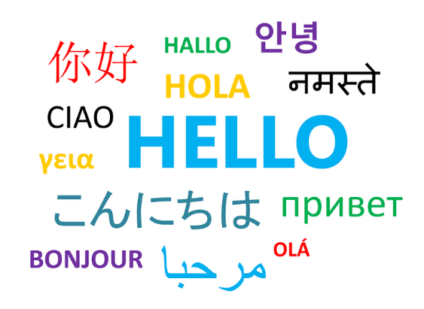

**Learning Through Talk (Reception)**

**-Know that families may come from different countries**

**-Develop a sense of identity and family history**

**-Show interest in others’ families & respect for difference**

**-Name & describe their family members**

**Learning To Talk**

-Listen to others as they talk, demonstrating good listening

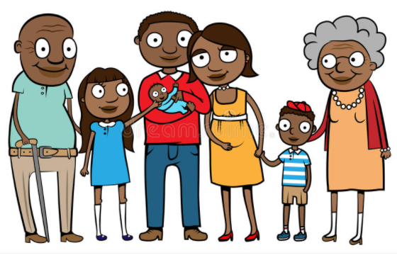

**Collections/Displays:**

Photos of Families, home countries & cultures

**Real Experiences:**

***Vocabulary***

***Parent***

***Family***

***Grandparent***

***Love***

***Care***

***Family***

***Past***

