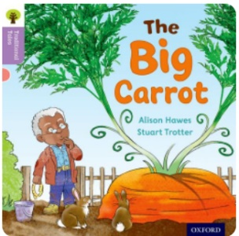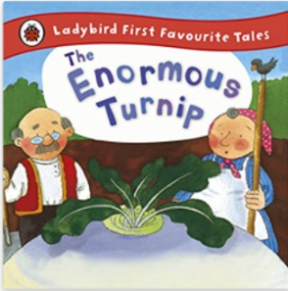

Term 5/3:

The Enormous Turnip

**Learning Through Talk (up to 3-4 Yrs)**

**Talk about what they see using a wide vocabulary**

**Understand the key features of a life cycle (plants)**

**Understand the need to respect & care for living things**

**Talk about changes they notice**

**Handle tools and equipment with some control and purpose**

**Learning Through Talk (Reception)**

**-Make close observations of the seedlings & plants to look for changes as they grow.**

**-Use new vocabulary to talk about the changes they see**

**-Explore the natural world around them and describe what they see, hear & feel outside**

**-Compare and contrast different plants, looking for similarities and differences in features**

**- Measure and compare the height of plants as they grow**

**-**

**-**

**Learning To Talk**

Recognise good talking behaviours in others

Join a conversation in a small group

**Displays/ Real Experiences**

Looking after growing plants

Gardening & tasting vegetables

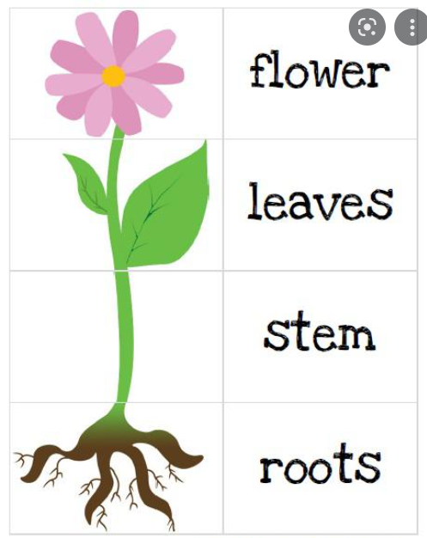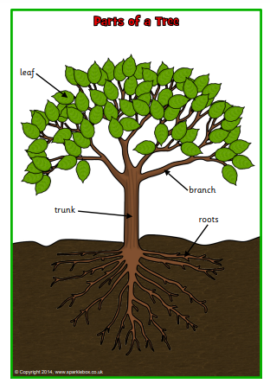

Vegetable Spade Sow

Underground Dig Weed

Soil Grow Harvest

Trowel Tend Water