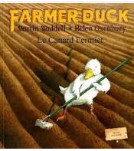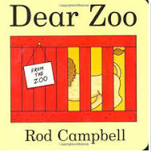

**Learning Through Talk (up to 3-4 Yrs)**

**Talk about what they see using a wide vocabulary**

**Understand the need to respect & care for living things**

**Show interest and curiosity in the natural world**

**Be confident enough to try new things and achieve a new goal (getting close to animals)**

**Understand and respond to simple questions**

**Begin to understand how others might be feeling by exploring simple stories**

Term 5/5:

Animals- Characteristics and features

**Displays/ Real Experiences**

Farm Visit/ Animal Experience

**Learning To Talk**

Begin to use expression and intonation when re-telling stories

Listen carefully to others and respond appropriately

Fur

Scales

Feathers

Fins

Tails

Wild

Pet

**Learning Through Talk (Reception)**

**-Make close observations of animals and talk about the features they see**

**-Use new vocabulary to talk about the similarities and differences they see when observing animals using new vocabulary**

**- Measure and compare the height of plants as they grow using newly taught vocabulary**

**-Compare and contrast characters from stories and figures from the past**

**-Explore different ways to group and classify animals based on their appearance/features**

**-Consider the feelings of others when exploring familiar stories**

**-**

**-**

