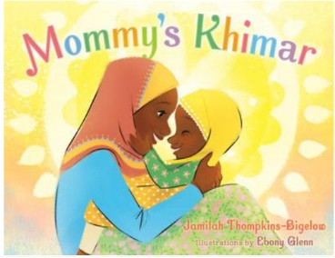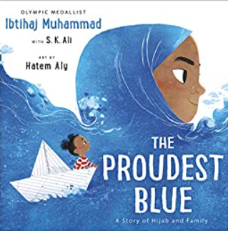

Term 3/4:

Exploring Clothes/Cultures

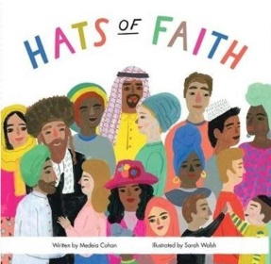

**Learning Through Talk (up to 3-4 Yrs)**

**-Develop positive attitudes about the differences between people and communities**

**-Talk about what they see using a wide vocabulary**

**-Understand how others might be feeling using the key texts**

**-Explore different materials freely to develop their ideas about how to use them and what to make (focus on fabric/material)**

**-Explore collections of materials with similar/different properties**

**-Explore different textures through collage & art**

**-Take part in simple pretend play, using an object to represent something else**

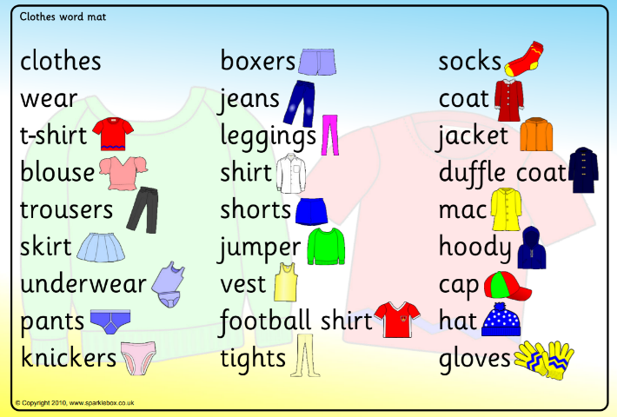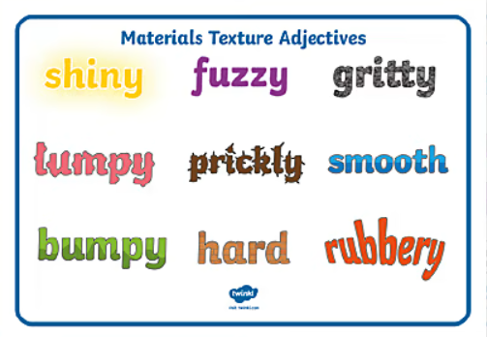

**Learning To Talk**

Introducing talk partners

Using new vocabulary to describe and articulate

**Displays/ Real Experiences**

Exploring different types of fabric and cloth, imaginative play

Clothing & textures display

Clothing

Warm/Cool/Waterproof

Insulate

Fabric

Comunity

**Learning Through Talk (Reception)**

**-Understand that people have different beliefs and celebrate special times in different ways**

**-Talk about resilience and perseverance in the face of challenge**

**-Support their own health/wellbeing by making appropriate choices about clothing**

**-Understand that some objects and places are special to members of a community**

**-Comment on images of clothing in the past & clothing worn in other climates**