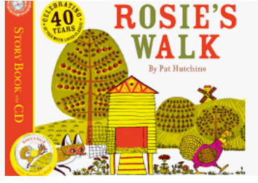

Term 5/6:

Animals- Prepositions

**Learning Through Talk (Reception)**

-**Develop their use of prepositional language**

**-Draw information from a simple map**

**-Develop their own storylines in pretend play based on the book**

**Learning To Talk**

-Describe events in some detail

-Choose vocabulary carefully to support listener (directions)

***Vocabulary***

***Route***

***Direction***

***Position***

***Life Cycle***

***Locate***

***Map***

**Collections/Displays/Real:**

Farm Animals

**Experiences:** Trip To The farm

