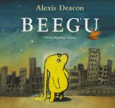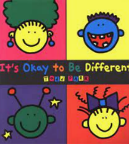

Term 1/6:

We Are All Different!

**Learning Through Talk (up to 3-4 Yrs)**

**-Develop positive attitudes about the differences between people**

**-Begin to make detailed observations of what they see sorting people by simple observable differences**

**-Use all their senses in hands on exploration of natural autumnal materials**

**-Make comparisons between objects relating to capacity, using natural materials**

**Learning To Talk**

Use new and exciting words to talk about familiar things around them

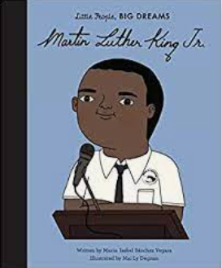

**Learning Through Talk (Reception)**

**-Use talk to describe people who are familiar**

**-Compare similarities and differences, demonstrating respect & interest in difference**

**-Understand the effect of changing seasons on the natural world around them**

**-Make observations of their environment and the features associated with Autumn**

**-Use talk to compare containers and explore capacity**

**-Explore colour mixing (leaves/skin tones)**

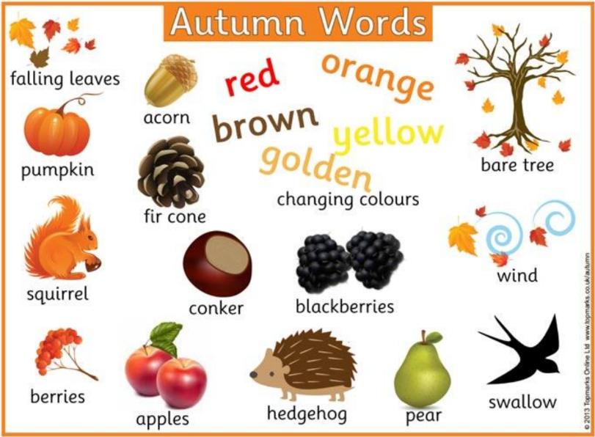

**Collections/Displays:**

**Autumnal Collections**

**Daily Colour Tables- objects**

***Vocabulary***

***Same***

***Different***

***Similar***

***Respect***

***Season***

***Shade***

***Mix***

***Container***

***Full/Empty***