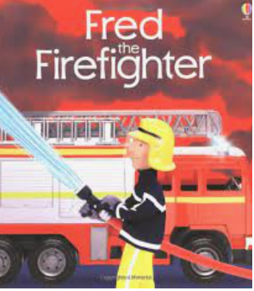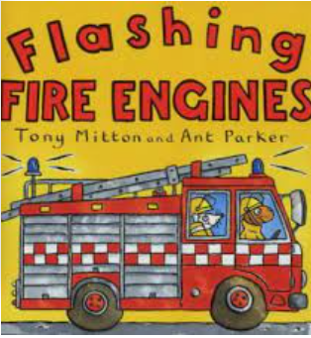

Term 2/2:

Our Community- Firefighters

**Collections/Displays/Experiences**

**Trip to the Fire Station/ visiting fire officer**

**Fire Station Role Play**

**Learning To Talk**

Use a loud voice when speaking so that everyone can hear me.

**Learning Through Talk (up to 3-4 Yrs)**

**-Talk about and explore 2D shapes (for example, circles, rectangles, triangles) using informal and mathematical language: ‘sides’, ‘corners’; ‘straight’, ‘flat’, ‘round’**

**-Recognise squares and rectangles in the environment**

**-Become more outgoing with unfamiliar people within the safe context of their setting**

**-Show interest in different occupations**

**Learning Through Talk (Reception)**

**-Describe people who are familiar to them**

**-Comment on images of familiar situations in the past**

**-Draw information from a simple map and make their own maps**

**-Know how to dial 999 if they need help**

**-Know some simple fire safety precautions**

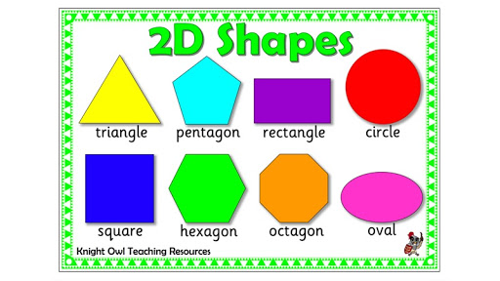

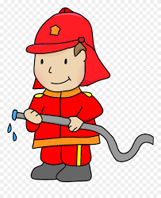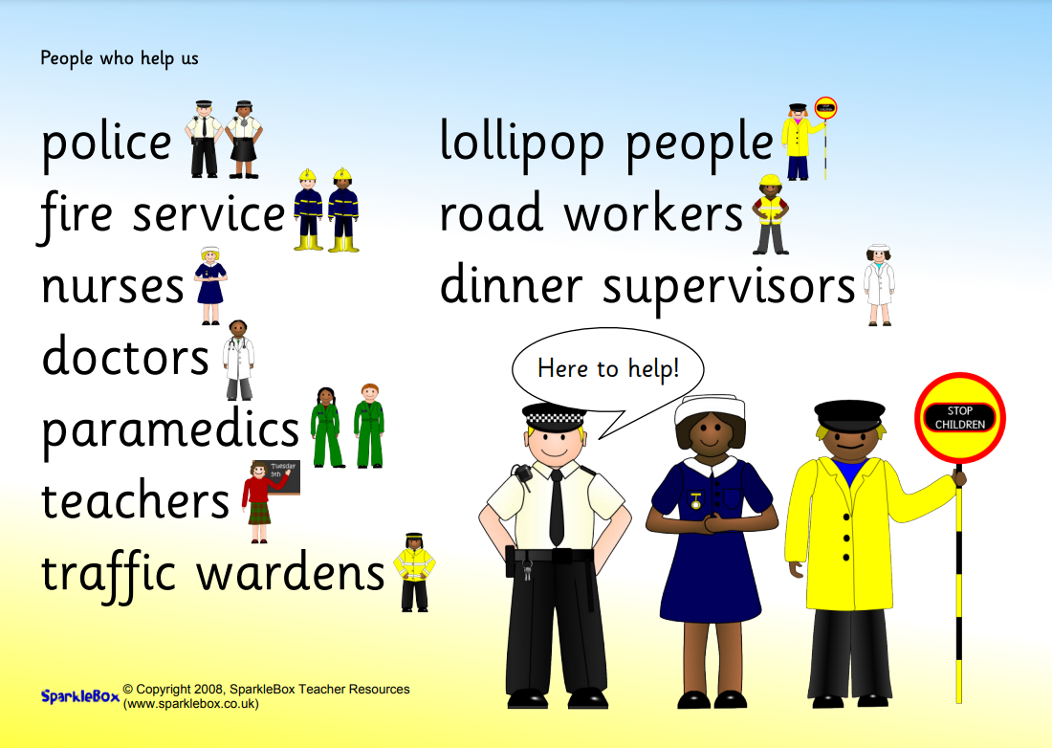

***Vocabulary***

***Safety***

***Emergency***

***Support***

***Past***

***Directions***

***Job/Occupation***

***2D/Flat shape***