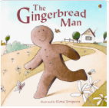

Term 4/3:

Food: The Gingerbread Man

**Learning Through Talk (up to 3-4 Yrs)**

**-Talk about what they see using a wide variety of vocabulary**

**-Talk about the differences between foods and the changes they notice as food is prepared**

**-Take part in simple pretend play using objects & props to represent other things**

**- Explore different ways to join materials when designing & making (directed activities-cutlery)**

**Learning Through Talk (Reception)**

**-Re-tell familiar stories in their own words, re-enacting or developing ideas through role play**

**-Use their oracy skills to give simple instructions to others**

**-Understand the importance of following instructions step by step and ordering them appropriately**

**-Become familiar with the way that instructions are laid out & followed (Eg. Recipes)**

**-Recognise and discuss emotions in story characters**

**-**

**-**

**Vocabulary**

**Beginning/Middle/End**

**Character/Role**

**First /then / later/next/meanwhile**

**Finally**

**Learning To Talk**

Respond to others comments using appropriate actions

Recognise good talking behaviours in others

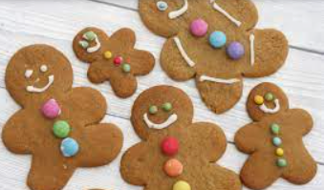

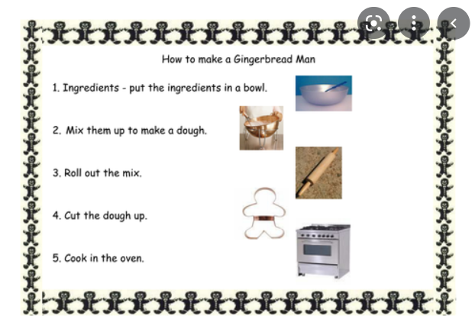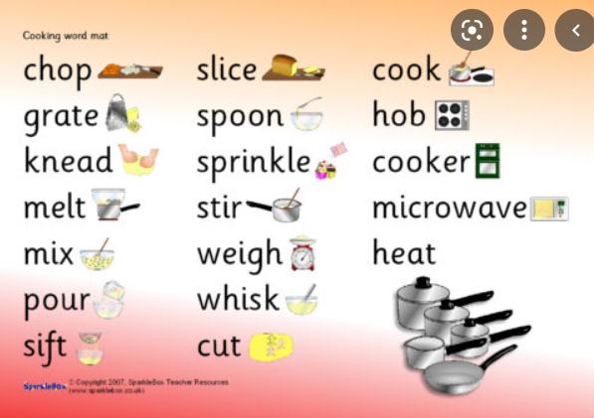

**Displays/ Real Experiences**

Making & Decorating Gingerbread men