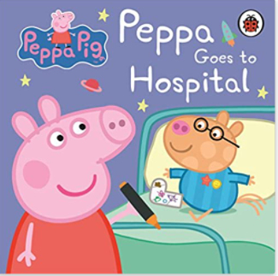

Term 2/3:

Our Community- Medical

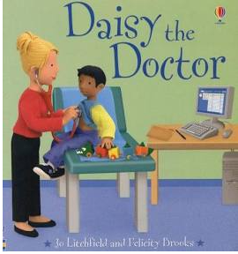

**Learning Through Talk (Reception)**

**-** Ask questions to find out more

- Learn about poppy day and Bonfire night

- Season of Autumn and changing seasons

-Learn about different people we have in our community

- How materials change when cooking, cooling and heating

**Collections/Displays:**

**Visit by school nurse**

**Looking at medical equipment**

**Learning To Talk**

Speak confidently to someone new. Use an audible voice.

**Learning Through Talk (up to 3-4 Yrs)**

**-** Become more outgoing with unfamiliar people, in the safe context of their setting.

-Show interest in different occupations

Show more confidence in new social situations.

Talk about and explore 2D and 3D shapes (for example, circles, rectangles, triangles and cuboids) using informal and mathematical language:

‘sides’, ‘corners’; ‘straight’, ‘flat’, ‘round’.

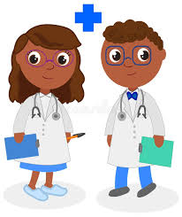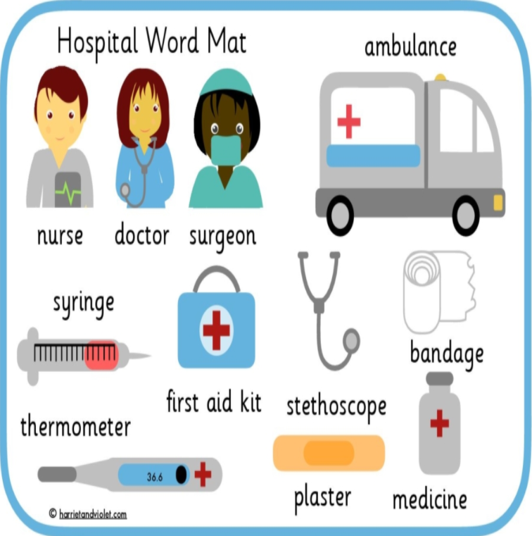

***Vocabulary***

***Same***

***Different***

***Similar***

***Respect***

***Season***

***Shade***

***Mix***

***Container***

***Full/Empty***