Welcome to EP Collier

Early Years Team

[](http://www.google.co.uk/url?sa=i&rct=j&q=&esrc=s&source=images&cd=&cad=rja&uact=8&ved=0CAcQjRw&url=http://cliparts.co/cartoon-pictures-for-children&ei=p8qGVZyMK-ip7AbF55PQBA&bvm=bv.96339352,d.ZGU&psig=AFQjCNFCe6tBMBRzT-PtEcnFvVhiFc7slA&ust=1434983362173479)

We hope you will be very happy at

EP Collier School

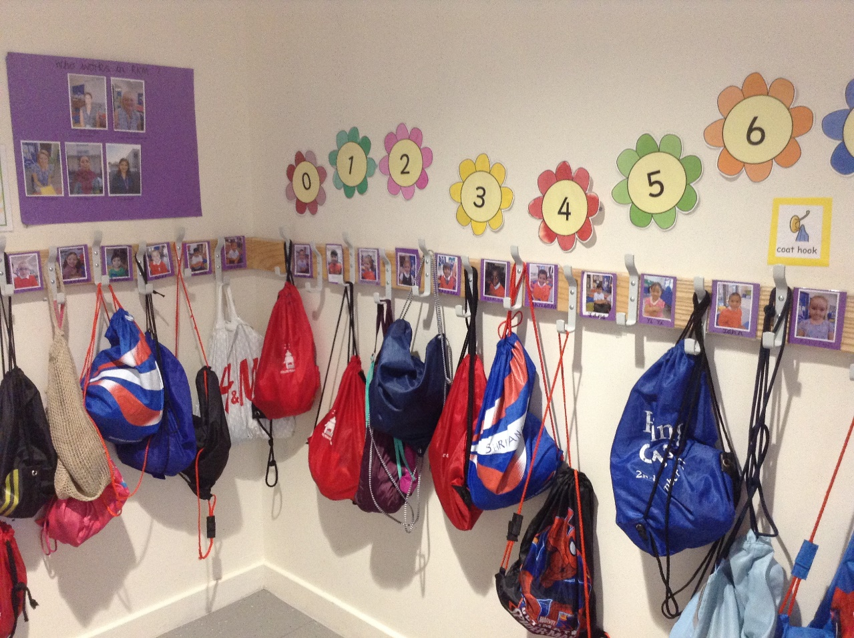Here is the cloakroom where I hang my coat, bag and PE kit.

My peg has my name on it.

I have my name on my drawer.

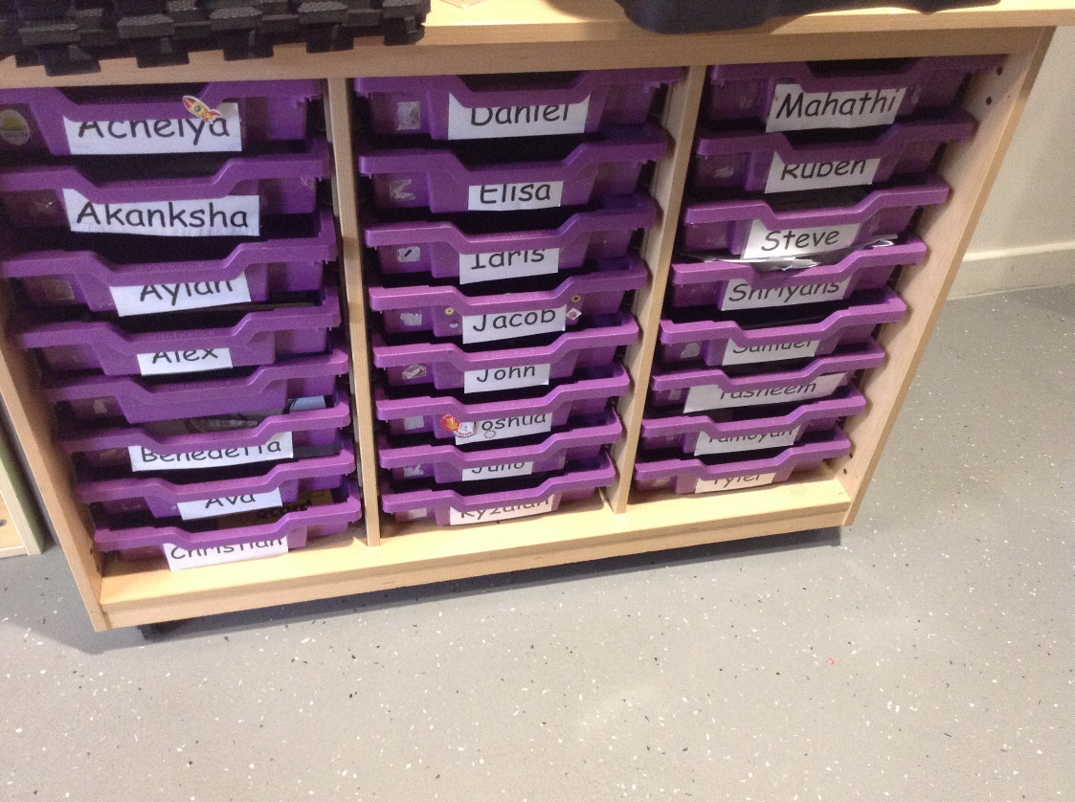

Here is one of my classrooms.

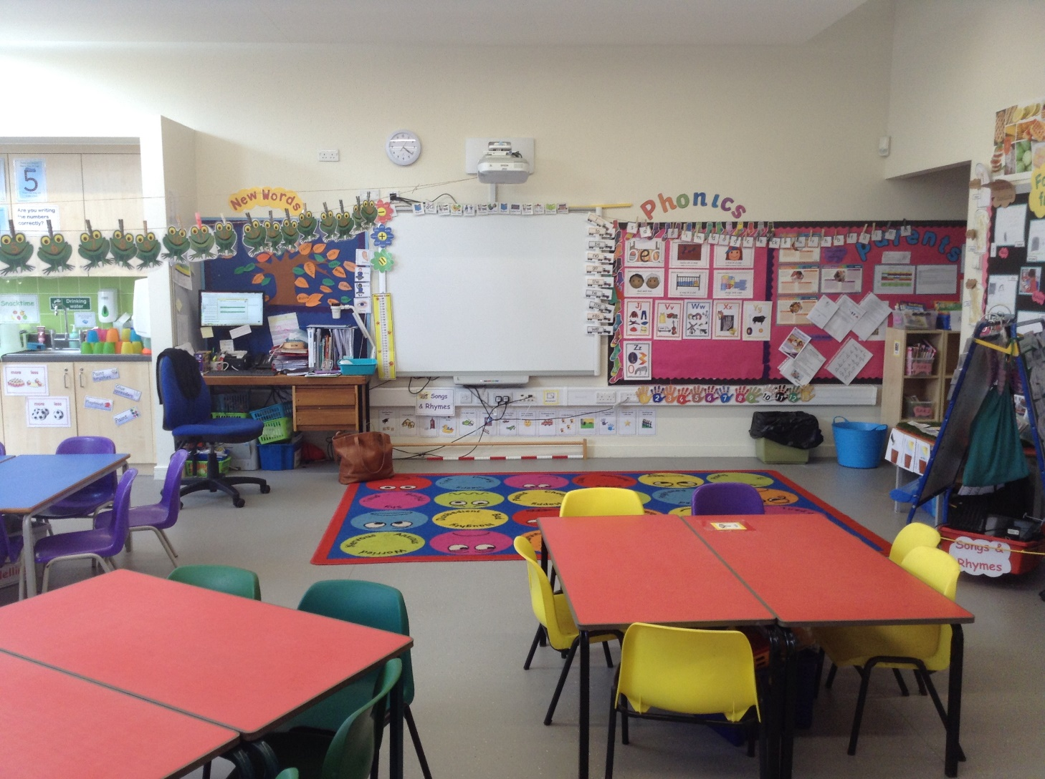

I can paint, draw, read stories, and play with my friends. The teachers at school help us.

Here are some of the people who work in Reception

Mrs Kayani

Miss Matthews

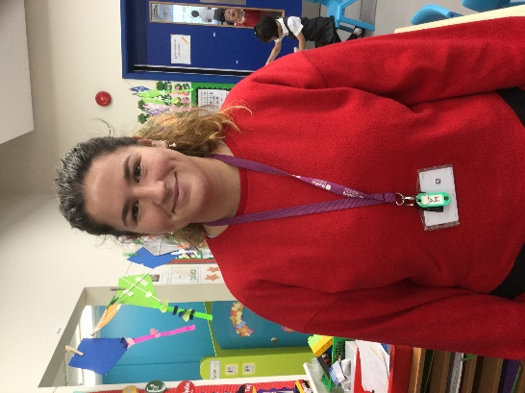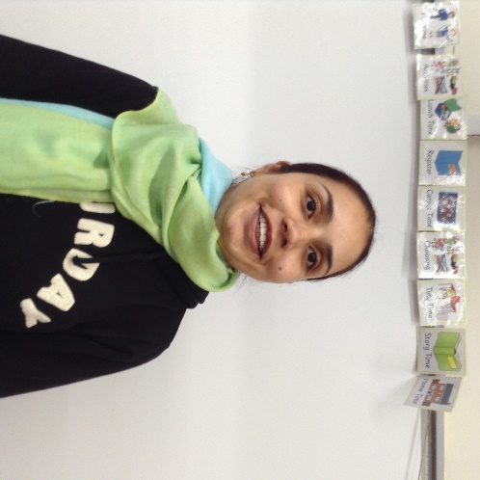

Mrs Stevenson

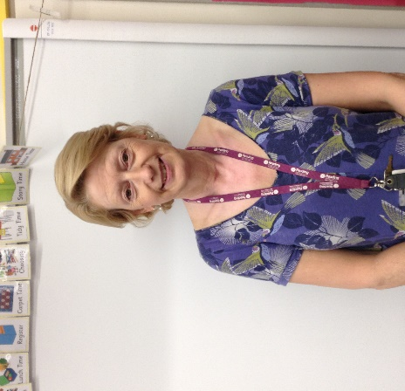 Mrs Mifflin

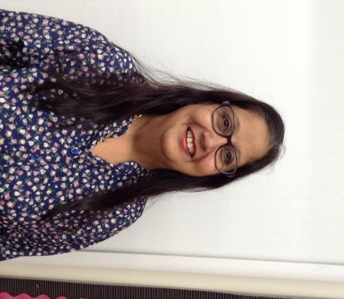

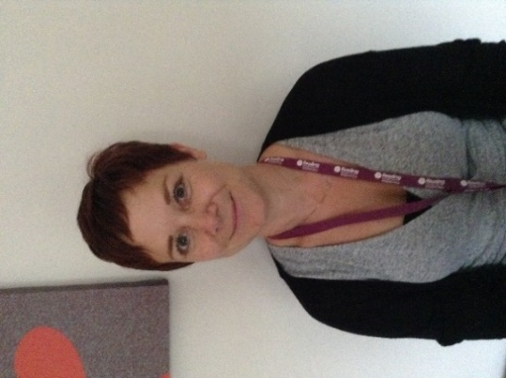

Mrs Chopra

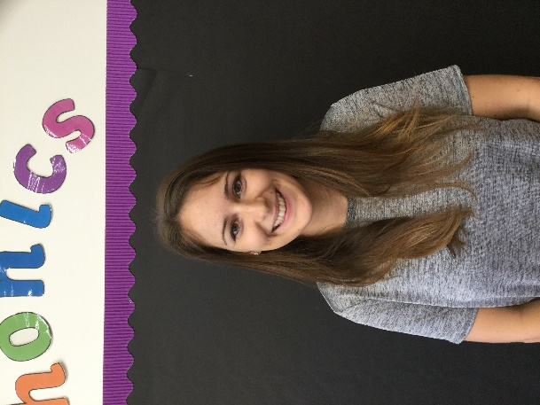

Miss Smith

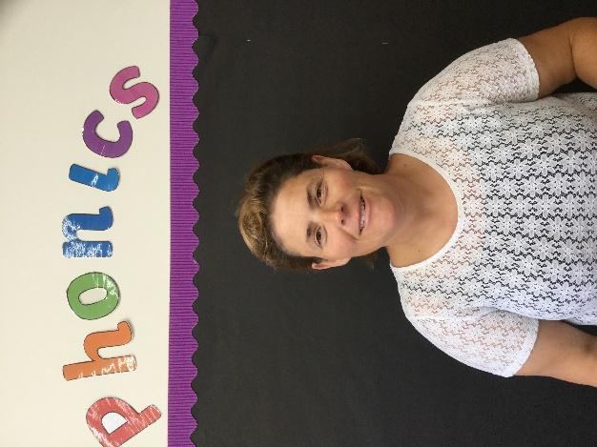

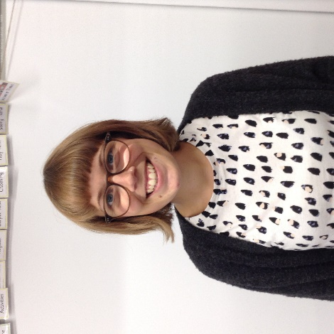

Miss Davis

Miss Knight

The teacher will give me a book to keep in my book bag.

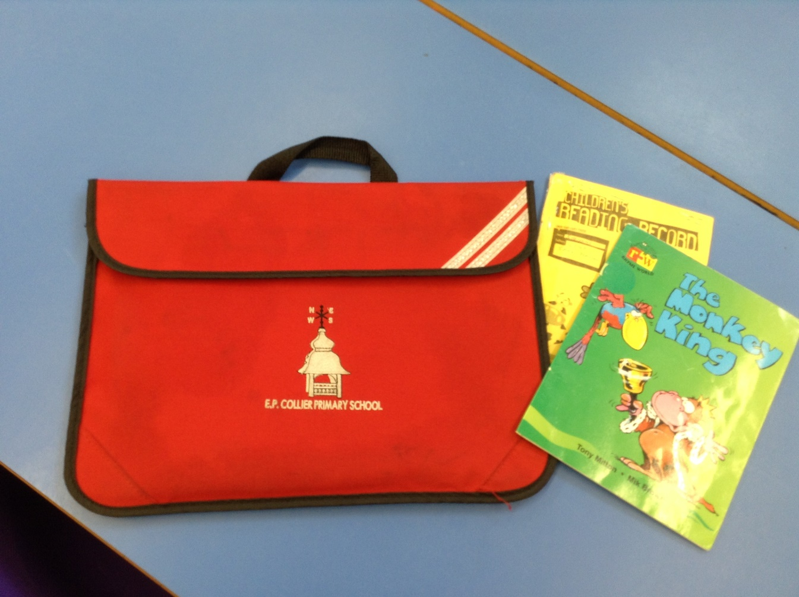I can take it home to read with my family .

Here are the toilets.

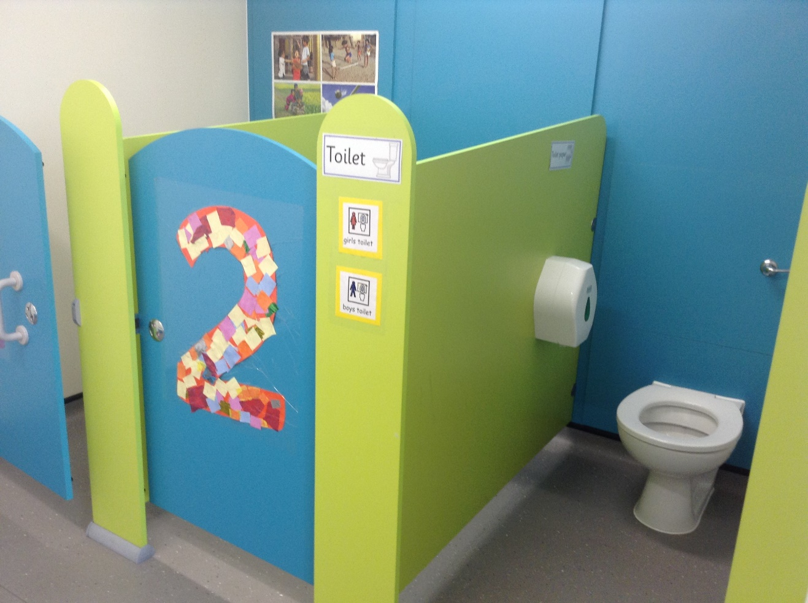

I can ask an adult if I need some help.

I wash my hands at the sinks.

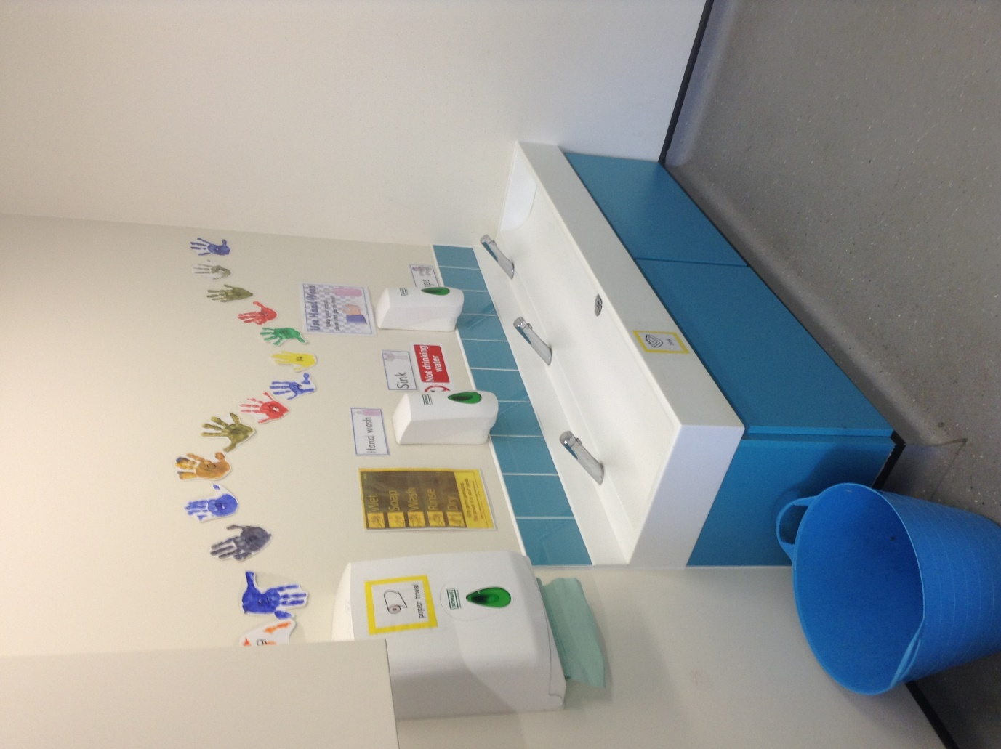

Here is the school hall where we do physical activities (PE).

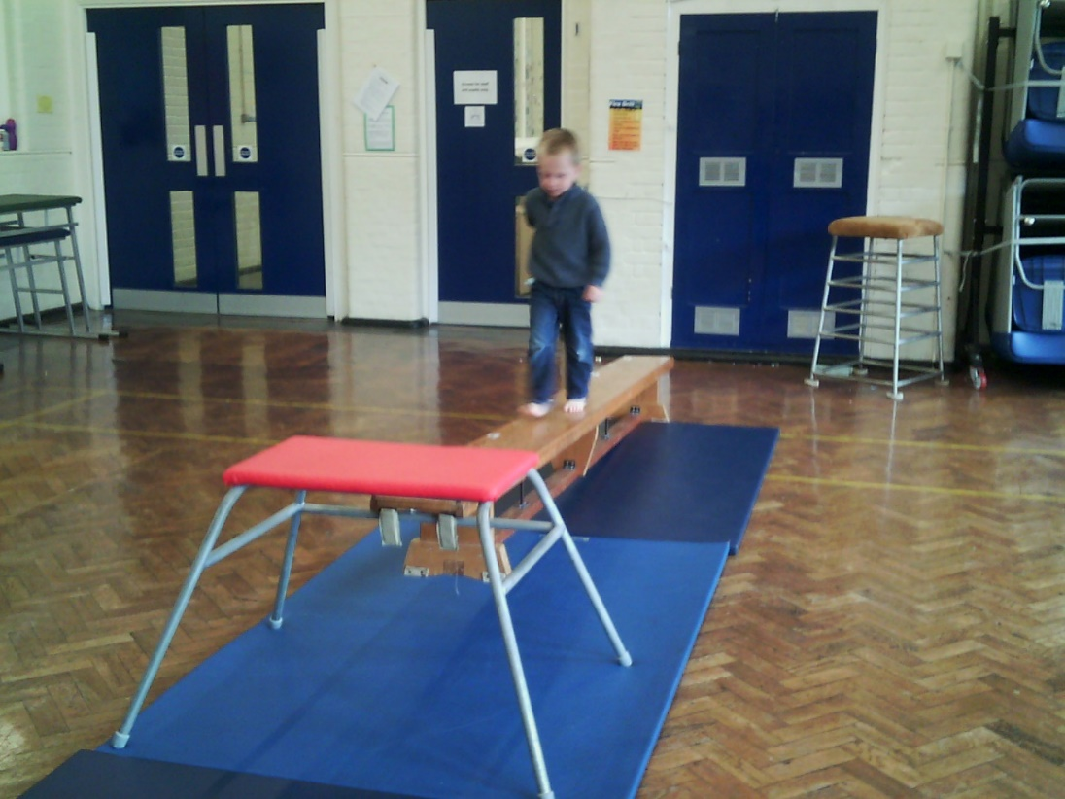

I can choose a school dinner

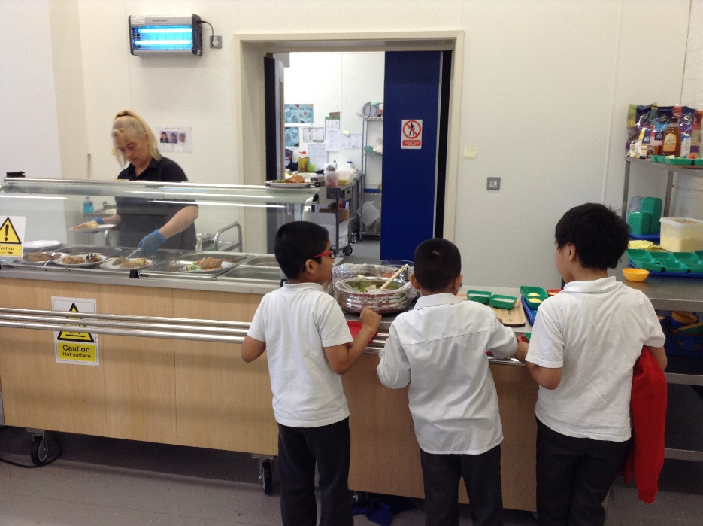

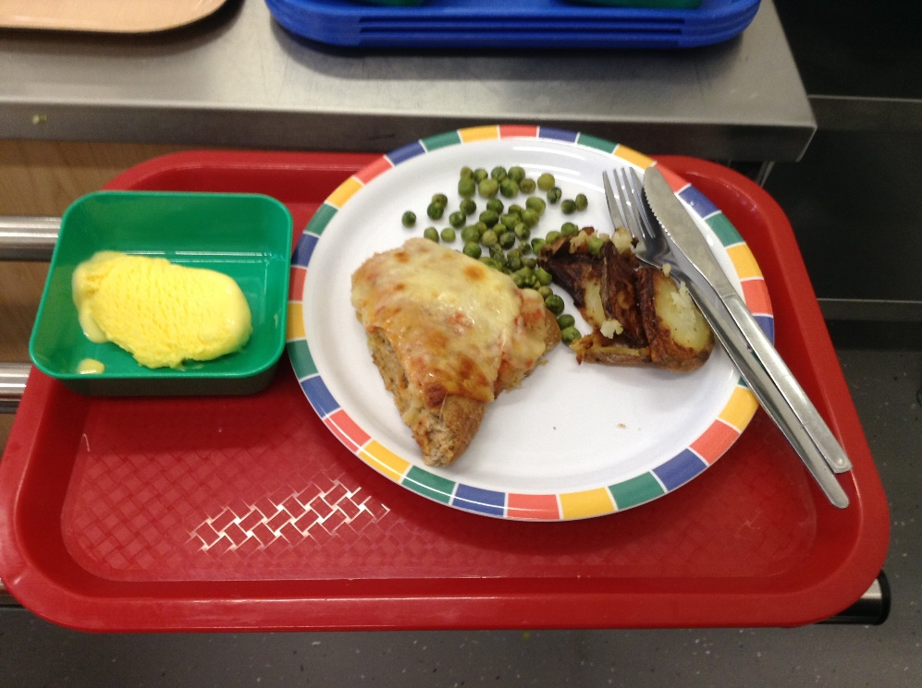

or I can bring a packed lunch from home.

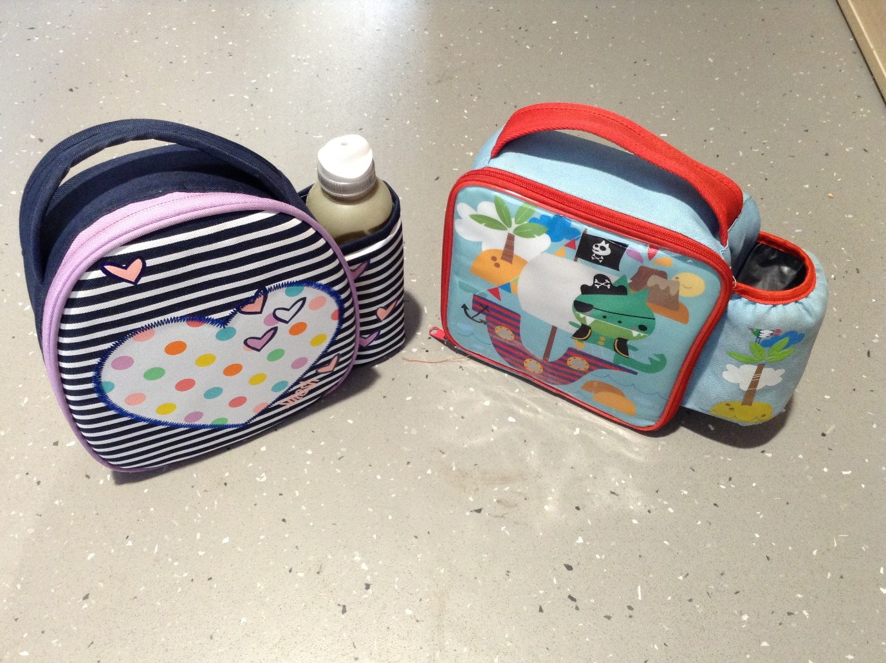

I get changed for physical activity, games and dance (P.E). I put my things in a basket.

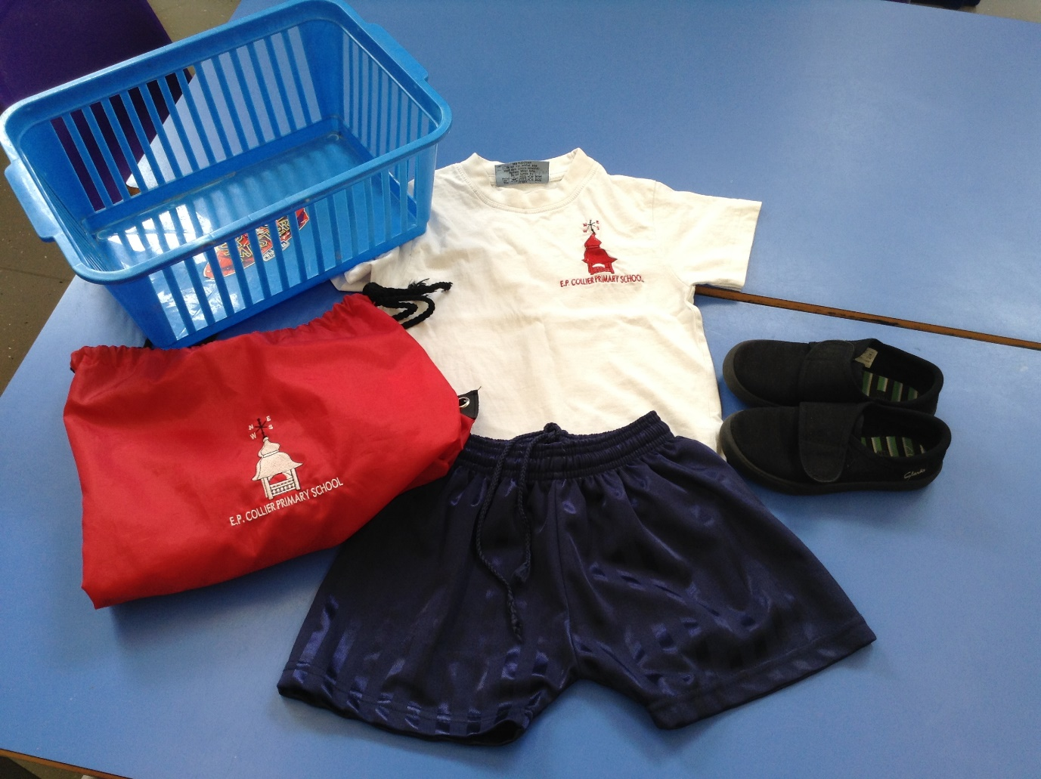

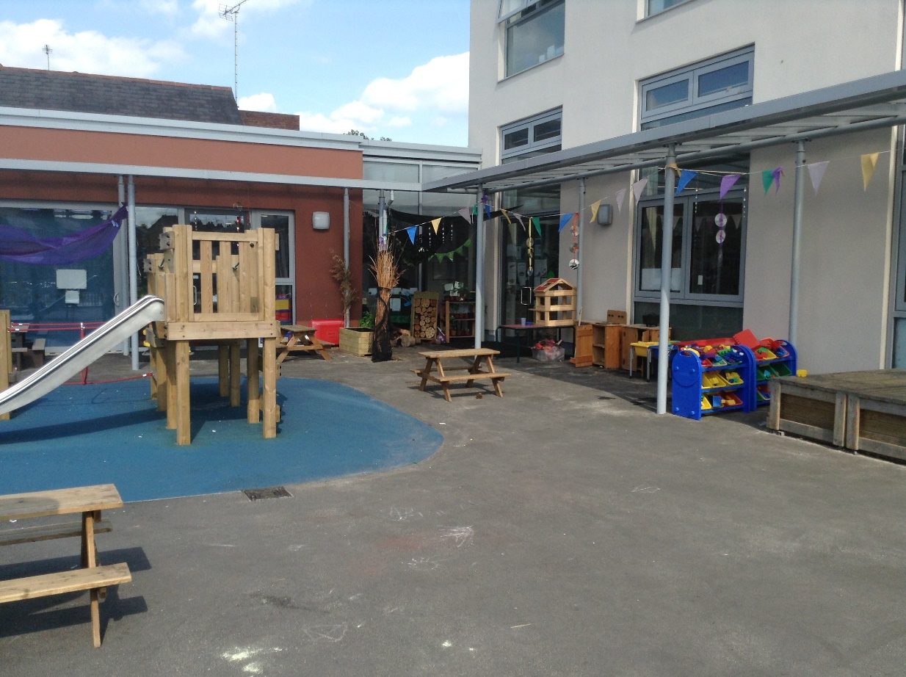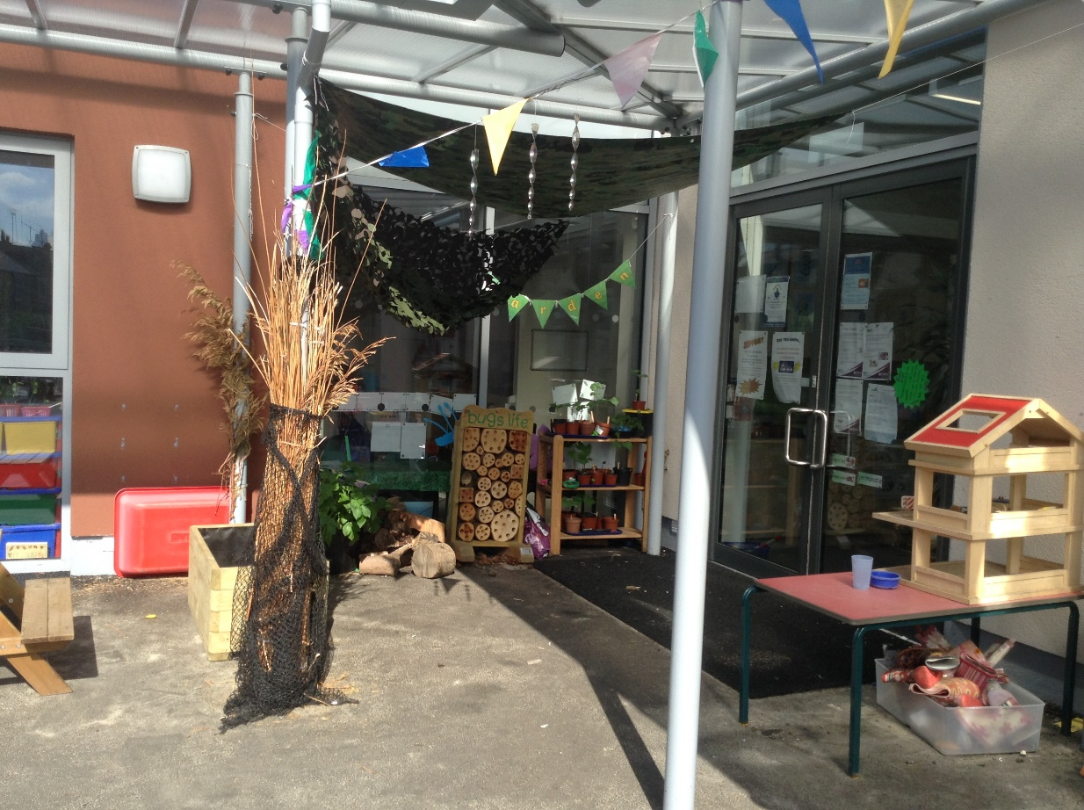Sometimes I play outside.

I go home at the end of the day, when somebody I know comes to collect me.



I am going to have fun at school and everybody is looking forward to meeting me!