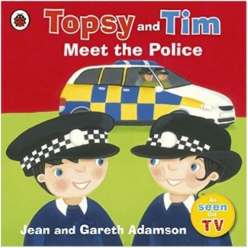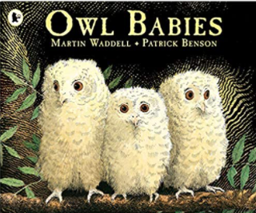

**Learning Through Talk (up to 3-4 Yrs)**

**- Become more outgoing with unfamiliar people within the safe context of their setting**

**-Show interest in different occupations**

**-Begin to describe a sequence of events, real or fictional, using words such as ‘first’, ‘then...’**

Term 2/4:

Our Community- Police

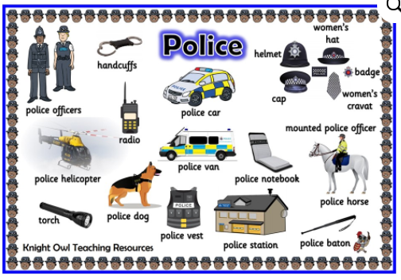

**Displays/Experiences**

**Meet a Police Officer**

**High Vis & Safety gear, helmets, road signs & warnings**

**Learning To Talk**

Speak confidently to someone new. Use an audible voice.

**Learning Through Talk (Reception)**

**-Know and talk about the different factors that support their overall health and wellbeing (being a safe pedestrian and having a good sleep routine)**

**-Ask questions to find out more**

**-Order key events in their daily routines**

**Use language to describe when things happen**

**-Measure time in simple ways**

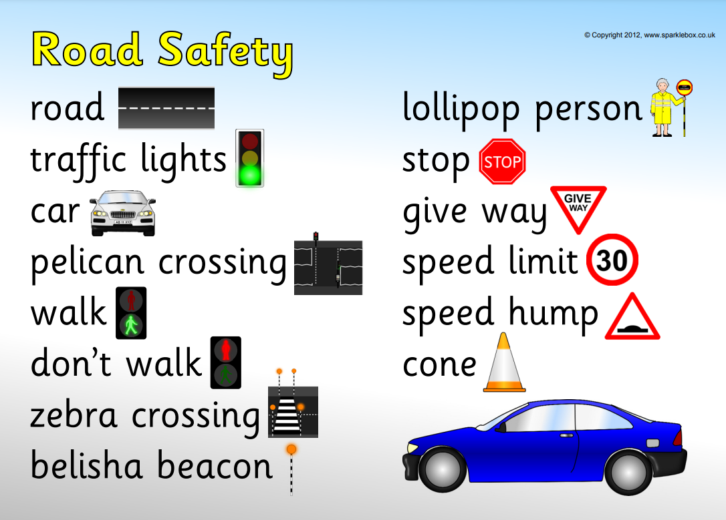

***Vocabulary***

***Time***

***Day/Night***

***Today***

***Yesterday***

***Tomorrow***

***Next***

***Before/After***

***Safety***

***Danger***