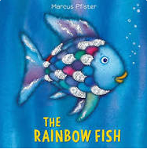

Term 2/5:

Celebrating: Hannukah & Advent

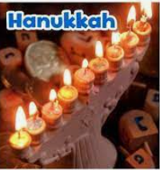

**Learning Through Talk (up to 3-4 Yrs)**

Talk about and explore 3D shapes (for example, cuboids) using informal and mathematical language:

‘sides’, ‘corners’; ‘straight’, ‘flat’, ‘round’.

Continue developing positive attitudes about the differences between people.

Begin to build & recognise meaningful relationships with other children

**Learning Through Talk (Reception)**

Understand that some places are special to members of their community.

Recognise that people have different beliefs and celebrate special times in different ways.

Understand that some places are special to members of their community.

Recognise that people have different beliefs and celebrate special times in different ways.

Begin to understand what makes a good friend

**Learning To Talk**

Use simple sentence stems to make relevant contributions

Begin to share discussion in a small group

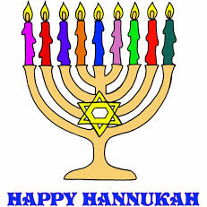

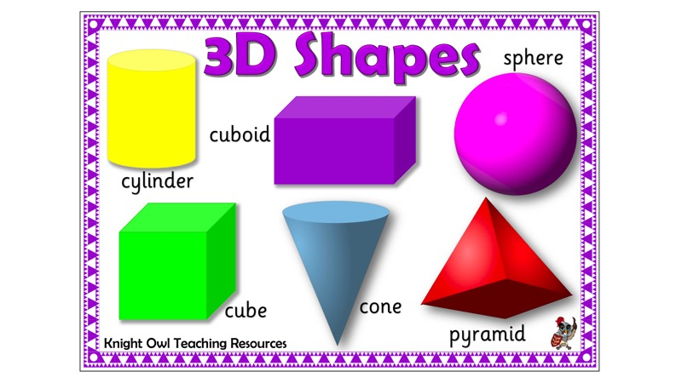

***Vocabulary***

***Celebrate***

***Hannukah / Advent***

***Synagogue***

***Jew***

***Solid shape***

***Face/Flat/Curved***

***Day***

***Week***

***Month***

**Collections/Displays:**

Shape Table with familiar objects. Sets of 3D shapes

Pictures of Jewish artefacts, synagogue etc

Advent calendar