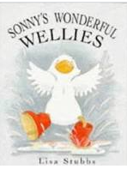

Term 3/3:

Weather: Rain, Wind & Storms

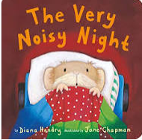

**Learning Through Talk (up to 3-4 Yrs)**

**- Use all their senses exploring natural materials**

**-Talk about the differences between materials Eg. Waterproof/Warm materials**

**-Explore collections of materials with different properties**

**-Talk about what they see using a wide vocabulary**

**- Know that there are different countries in the world & talk about the differences they have seen in photos**

**-Understand gradually how others might be be feeling using the key texts**

**-Talk about different forces they can feel (wind)**

**Displays/ Real Experiences**

Exploration with water.

Investigating waterproofing, insulation, floating & sinking

**Learning To Talk**

Talking in a small group

Listening to what others say!

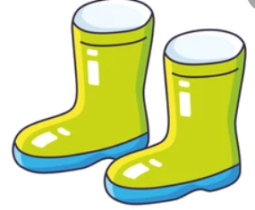

**Learning Through Talk (Reception)**

**-Recognise some environments are different to the one in which they live Eg. Rainforests**

**-Draw information from a simple map of the world**

**-Know that there are similarities and differences between different materials**

**- Describe what they see, hear and feel when outside**

**-Develop familiar storylines through their pretend play**

**-Consider the feelings of others using the key texts**

