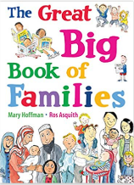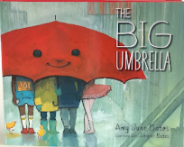

Term 1/4:

Being part of my Community: Home/School

**Learning Through Talk (up to 3-4 Yrs)**

**-Develop sense of responsibility & membership of a community**

**-Follow & understand simple rules**

**-Develop appropriate ways to be assertive**

**-Use talk to solve conflict**

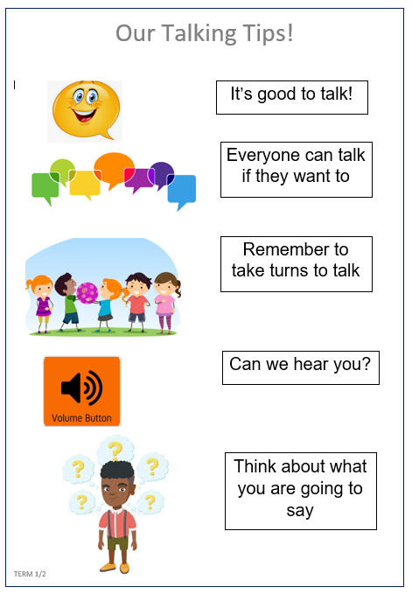

**Learning Through Talk (Reception)**

**-See themselves as a valuable individual within a community**

**-Begin to build constructive, respectful relationships**

**-Begin to think about the perspectives of others**

**-Talk about their role and responsibilities at home /school**

**-Locate resources in the classroom using positional language**

**Learning To Talk**

-Recognise the need for talk rules

*-*Devise class rules for good talking

***Talk Tips***

**Collections/Displays:**

**Real Experiences:** Walking around school, exploring, new people

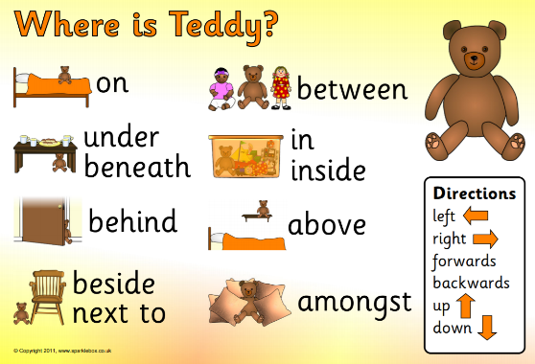

***Vocabulary***

***Respect***

***Support***

***Rules***

***TeamWork***

***Conversation***

***Share***

***Help***