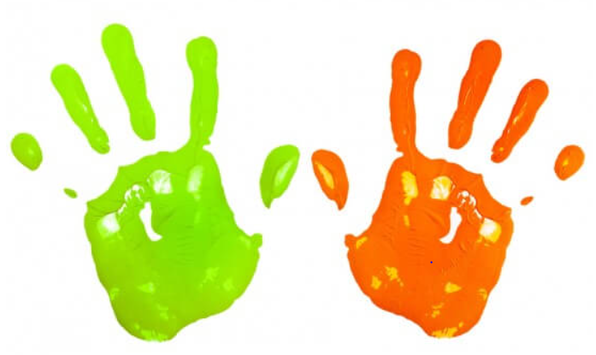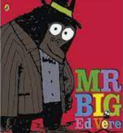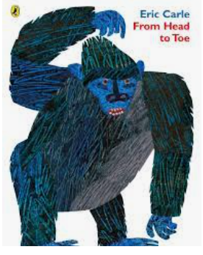

**Learning To Talk**

-Recognise the need for talk rules

***Talk Tips***

**Learning Through Talk (Reception)**

**-Talk about ways to keep their bodies healthy**

**- Talk about the importance of keeping their bodies safe *(Know that No means No* and that *Privates are private)***

***-*Compose and decompose familiar shapes, exploring size and position**

**-Explore colour**

Term 1/5:

My Body

**Learning Through Talk (up to 3-4 Yrs)**

**-Identify different parts of their body and explore ways to move and use their senses**

**-Know their bodies need exercise and to be kept clean**

**-Make comparisons between objects relating to size & length**

**-Build with and talk about 2D shapes using informal language**

**-Begin to use mathematical names for triangles and circles**



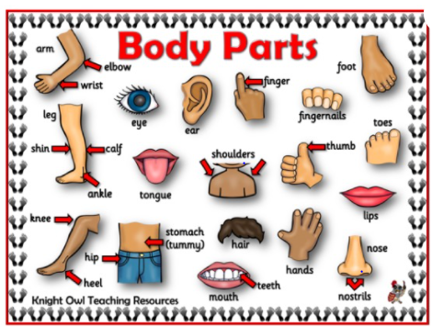

**Collections/Displays: Triangles & Circles/Kandinsky Art**

**Daily Colour Tables- objects**



***Vocabulary***

***Shape***

***Triangle***

***Circle***

***Round***

***Straight***

***Bigger***

***Smaller***

***Same***

***Flat***