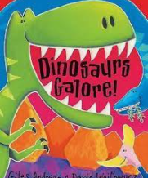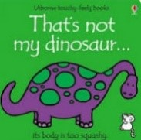

Term 3/4&5:

Dinosaurs: Describing & Sorting

**Learning Through Talk (up to 3-4 Yrs)**

**-Make comparisions between dinosaurs in terms of size, length, weight & appearance, sorting & ordering**

**-Talk about what they see using a wide vocabulary**

**-Develop their phonological awareness by spotting and suggesting rhymes**

**-Explore different materials freely to develop their ideas about how to use them and what to make (focus on fabric/material)**

**-Engage in extended conversations about stories learning new vocabulary**

**-Explore different textures through collage & art**

**-Draw with increasing complexity & detail**

**-Use print letter knowledge in their early writing**

**Displays/ Real Experiences**

Building large 3D dinosaurs together-inside & out

**Learning To Talk**

Working with talk partners talk partners

Using connectives to join statements when describing

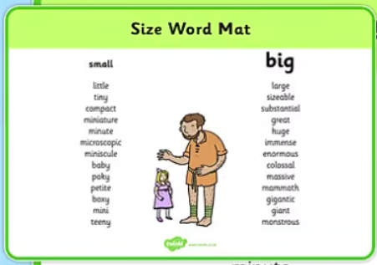

**Learning Through Talk (Reception)**

**- Re-read books to build up confidence, fluency, understanding and enjoyment**

**-Write short sentences with a capital letters and full stops.**

**-Create collaboratively, sharing resources & skills**

**-Develop their descriptive language, learning new vocabulary & connecting one idea to another**

**-**

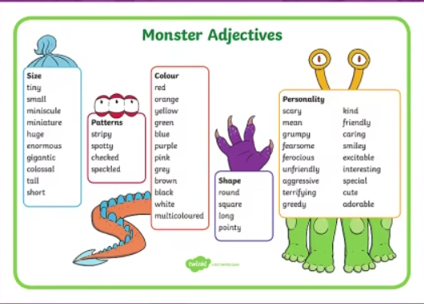

**Horns**

**Scales**

**Plates**

**Claws**

**Carnivore**

**Herbivore**