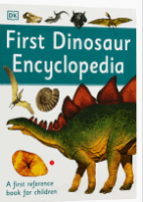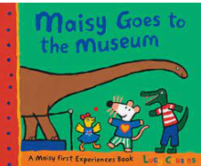

**Learning Through Talk (up to 3-4 Yrs)**

**-Make comparisons between dinosaurs in terms of size, length, weight & appearance, sorting & ordering**

**-Talk about what they see using a wide vocabulary**

**-Begin to be aware of, and show an interest in, life in the past**

**-Explore different textures through collage & art**

**-Draw with increasing complexity & detail**

**-Use print letter knowledge in their early writing**

Term 3/6 and Term 4/1:

Dinosaurs: Exploring the Past

**Learning Through Talk (Reception)**

**- Comment on images and facts about life in the past and present**

**-Write short sentences with capital letters and full stops.**

**-Create collaboratively, sharing resources & skills**

**-Explore large scale construction/sculpture and creative projects**

**-Use non fiction books as a way to find out about life in the past and develop their knowledge**

**Fossil**

**Prehistoric**

**Museum**

**Extinct**

**Non Fiction**

**Displays/ Real Experiences**

Making a class Museum!

**Learning To Talk**

Working with talk partners talk partners

Using connectives to join statements when describing

