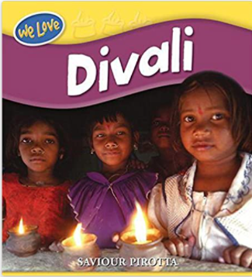

Term 2/1:

Divali/ Fireworks night

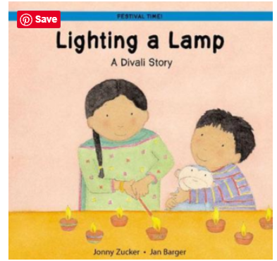

**Learning Through Talk (up to 3-4 Yrs)**

Continue developing positive attitudes about the differences between people.

Talk about members of their immediate family and community.

Increasingly follow rules, understanding why they are important.

Talk about and identify the patterns around them. Extend and create ABAB patterns – stick, leaf, stick, leaf.

**Collections/Displays/Experience**

Divali Interest Table

Divali Experience Day

Photos of fireworks

**Learning Through Talk (Reception)**

Compare and contrast characters from stories, including figures from the past.

Understand that some places are special to members of their community.

Recognise that people have different beliefs and celebrate special times in different ways.

|  |  |
| --- | --- |
| Describe what they see, hear and feel whilst outside. Try new things.  Talk about their feelings using words like ‘happy’, ‘excited” or “scared  Describe events in some detail  Continue, copy and create repeating patterns. |  |

**-**

**Learning To Talk**

Use new and exciting words to talk about familiar things around them

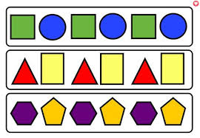



***Vocabulary***

***Diva***

***Celebrate***

***Mendhi***

***Candle***

***Hindu***

***Pattern***

***Repeating***

