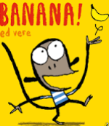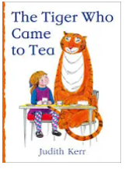

Term 4/2:

Food: Investigating Food & Shops

**Learning Through Talk (up to 3-4 Yrs)**

**-Use their senses to explore food textures and properties**

**-Talk about what they see using a wide variety of vocabulary**

**-Explore & sort collections of food with different properties**

**-Talk about the differences between foods and the changes they notice as food is prepared**

**-Explore familiar experiences of shops and shopping through imaginative role play**

**-Develop the use of cutlery to prepare and eat food**

**Learning Through Talk (Reception)**

**-Comment on familiar situations in the past Eg shops**

**-Draw information from a simple map & recognise that some environments are different from the one in which they live (origins of food)**

**-Talk about different sorts of shops in their locality & their experiences of shopping (inc online)**

**-Create imaginative small worlds with towns, shops and maps**

**-Explore different ways to join materials when designing & making (directed activities-cutlery)**

**Displays/ Real Experiences**

Investigating Food- making toast/jelly/pasta etc

Vocabulary

**Buy/Sell**

**Fruit / Vegetable**

**Meat**

**Dairy**

**Cash**

**Price**

**Learning To Talk**

Recognising good talking behaviours in others

Using connectives to join simple statements

