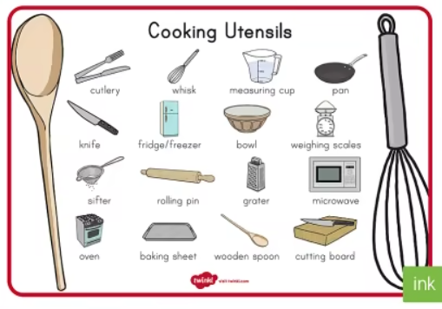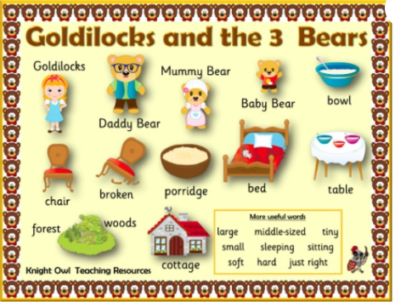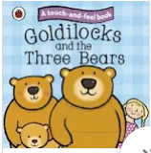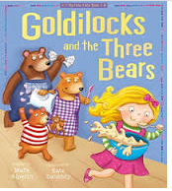

**Learning Through Talk (Reception)**

**-Compare & contrast characters from stories**

**-Think about the perspectives of others when discussing & role playing characters from stories**

**-Explore different ways to join materials when designing & making (directed activities-cutlery)**

**-Use story of Goldilocks to explore moral dilemmas/**

**problem solving through discussion & debate**

**-Explore what is meant by sequence, setting & character in a familiar story.**

**-Compare different versions of the same story**

**Learning Through Talk (up to 3-4 Yrs)**

**-Use their senses to explore food textures and properties**

**-Talk about what they see using a wide variety of vocabulary**

**-Engage in extended conversations about stories, learning new vocabulary**

**-Talk about the differences between foods and the changes they notice as food is prepared**

**-Explore story sequence through simple story maps**

**- Explore right & wrong through the story of Goldilocks**

**Displays/ Real Experiences**

Making & Tasting porridge- exploring texture

Vocabulary

**Texture**

Character

Sequence

Setting

Words to describe size

Beginning/Middle/End

**Learning To Talk**

Begin to learn how to agree/disagree by justifying ideas in discussion

Use the connective “because”

Explore different tones/volume when using their voices to speak

Term 4/2:

Food: Goldilocks & the 3 Bears