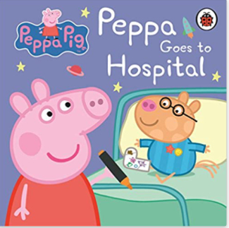

Term 2/3:

Our Community- Medical

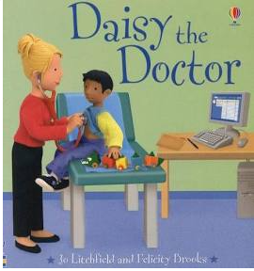

**Learning Through Talk (up to 3-4 Yrs)**

**-** Become more outgoing with unfamiliar people, in the safe context of their setting.

-Show interest in different occupations

Show more confidence in new social situations.

Talk about and explore 2D and 3D shapes (for example, circles, rectangles, triangles and cuboids) using informal and mathematical language:

‘sides’, ‘corners’; ‘straight’, ‘flat’, ‘round’.

**Learning To Talk**

Speak confidently to someone new. Use an audible voice.

**Learning Through Talk (Reception)**

**-** Ask questions to find out more

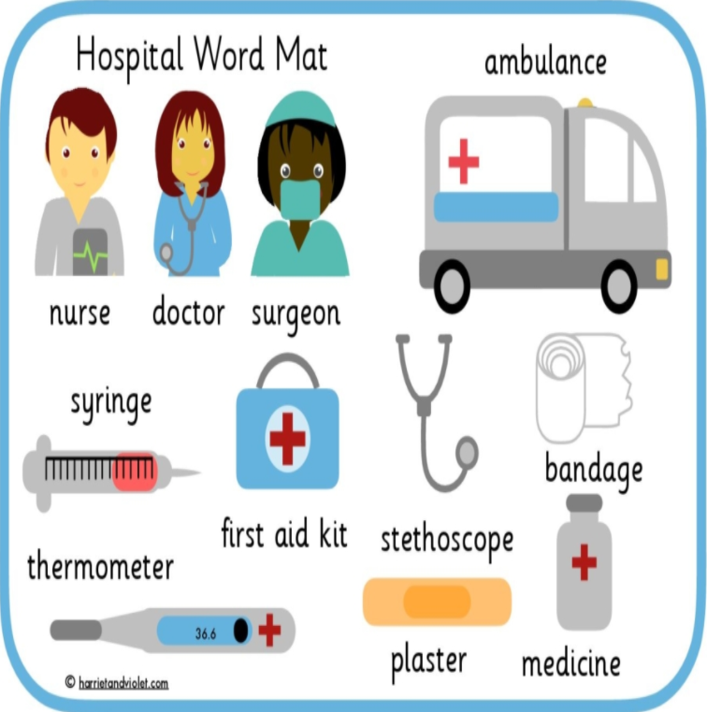

**Collections/Displays:**

**Autumnal Collections**

**Daily Colour Tables- objects**

***Vocabulary***

***Same***

***Different***

***Similar***

***Respect***

***Season***

***Shade***

***Mix***

***Container***

***Full/Empty***