EYFS: Curriculum Overview Term 1 Autumn 1
KEYTEXTS | 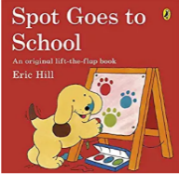  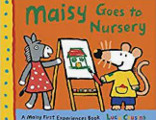 |  | 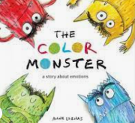  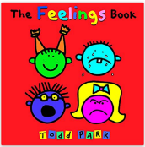 |  | 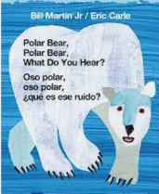  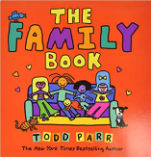 |  | 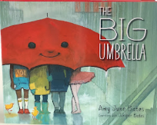  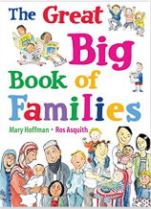 |  |  | 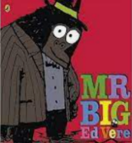  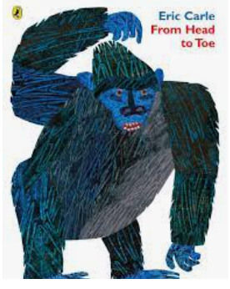 | 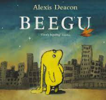  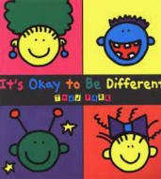
Theme |  | Settling In | All About me  Feelings |  | My Family |  | My Community  Home/School |  |  | My Body | Similarities & Differences
Real Experiences |  | Visiting School  Family Visits | Staying for lunch  Starting Full Time |  |  |  | Looking around School/ Meeting new people
Rhymes/Songs |  | Hello how are you song (with Makaton) | If you’re happy and you know it |  | The Wheels on the Bus |  | 10 Little Fingers  Wind the Bobbin |  |  | Heads Shoulders Knees and Toes | Rainbow Song
Communication Language |  |  | What is Listening?  Devising Listening Guidelines |  |  |  | It’s good to Talk!  Introducing Talk Guidelines
Phonics |  |  | Phase 1 Listening Activities |  |  |  | Nursery- Phase 1  Reception-Phase 1 & 2 (s,a,t,p,I,n)
Numeracy-Rec |  |  | Matching, sorting, comparing |  |  |  |  |  |  | Exploring 1,2,3- Represent, compare,
Measures, Space… |  |  | Spatial awareness/Positional |  |  |  |  | Size & Mass Capacity  Triangles & Circles
PE sessions |  |  |  |  | Visiting the hall & playground and exploring the space- games/dance
PD Focus (Gross) |  | Managing the school day- lining up, sitting down, mealtimes & snack  Managing stairs/steps Large arm movements & vertical surfaces Managing space safely-Running,Crawling, sliding, rolling-
PD Focus  (Fine) |  | - Holding a pencil Introducing Dough Disco  - Scissors skills- grip & snip Putting on coats  - Using glue sticks/spreaders Developing pincer grasp
PSED |  | Building Relationships & Leaving carers  Communicating feelings  Hygiene/Toileting Asking for Help |  | Developing self identity, learning names  Being a member of the class community- rules/tidying/helping  Making choices & directing own play Safeguarding-My Body is mine
UW |  |  |  |  |  | Developing positive attitudes about differences- Martin Luther King/Kandinsky
Music |  |  | Learning to Listen-identifying sounds |  |  |  | Listening Walks |  |  | Body Sounds
Dance |  |  | Moving to music- free dance, how does it make you feel? |  |  |  |  |  | Dancing with different body parts - actions
Art |  |  | Exploring collage and paint |  |  |  |  |  |  | Exploring & identifying colours  Exploring art with natural materials
EYFS: Curriculum Overview Term 2 Autumn 2
Week | 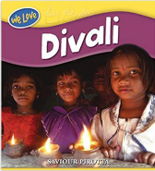  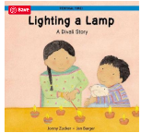 | 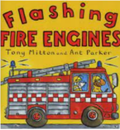  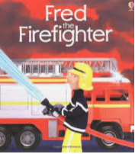  8.1 | 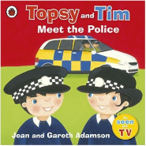  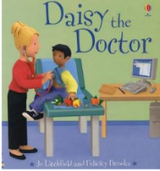 | 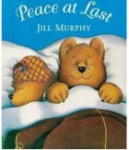  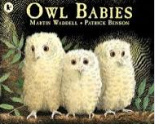 | 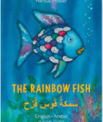  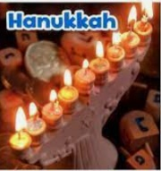  `29. | 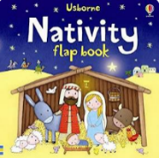 | 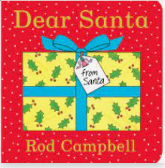
Theme | Divali  Firework Night | Our Community-FireFighters | Our Community- Medical/Polics |  | Celebrating Hannukah | Nativity | Celebrating Christmas
Real Experiences | Divali Celebration day | Trip to the Fire Station | Visit by Nurse/Doctor |  | Invite an older pupil to | Live Performances
Rhymes/Songs | Light A Diva | 5 Little Firefighters  London’s Burning | 5 Little Monkeys |  | Nativity songs | Nativity songs | Christmas Songs
Communication & Language | - Establishing Talk Guidelines Speaking Audibly  - Introducing Show nTell Making relevant contributions
Phonics | Nursery- Phase 1  Reception-Phase 1 & 2
Numeracy- Rec | Exploring 1,2,3… | Representing no.s to 5 |  |  | One more/one less
Measures,Space… | Pattern | Shapes with 4 Sides Time |  |  | 3D shapes Pattern cont.
PE sessions
PD Focus (Gross) | Balancing skills Travelling in different ways Simple sequences of movements Climbing
PD Focus (Fine) | - Scissor Skills- cutting in a straight line Introducing basic letter formation- copying over  - Exploring clay with hands Tracing  - Zips & Fastenings/ Changing shoes & Socks Stencils
PSED | Trying new things/ Making choices | Fire Safety  Explore Feelings | Keeping Well  Explore Friendships | Pedestrian Safety | Exploring Friendships | Exploring Feelings | Exploring Feelings
UW | Hindi culture-Gandhi | Different occupations/roles in our community Night/Day  Mother Theresa/Florence Nightingale |  |  | Special places & different celebrations in our community
Music | Introducing percussion Instruments- stop/start, playing with control
Dance
Art

EYFS: Curriculum Overview Term 3 Spring 1
Week |   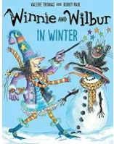 | 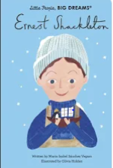  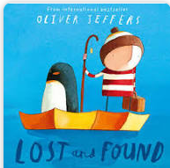 | 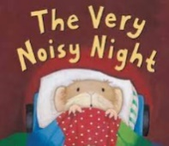  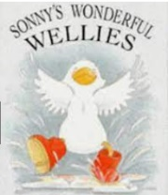 | 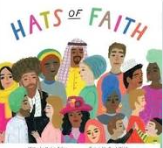  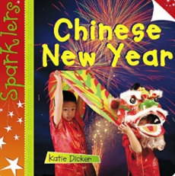 |  | 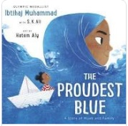  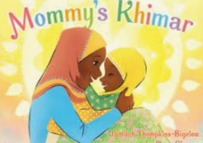 | 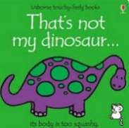  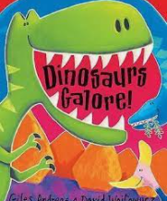 | 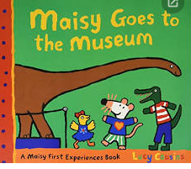
Real Experiences | Exploring Ice & Snow! | Real Investigations: Floating & Sinking  Freezing & Thawing  Waterproofing & Insulation |  | Chinese Celebrations! |  | Visitors to share traditional clothes | Large scale collaborative projects to build dinosaurs
Rhymes/Songs | 5 Little Snowmen  Im a Little Snowm | The Sun has got  In All Kinds of Weather | Rain, Rain Go Awa  I Hear Thunder
Communication & Language | Talking in a small group | Listening carefully to others  Responding to what others say |  | Sharing conversation with a talk partner |  |  | Beginning to use connectives to join simple sentences (describing)
Literacy | Exploring Non Fiction Texts |  | Re-telling stories in small groups | Using spaces to separate words modelled & shared writing |  |  | Labelling with single words  Writing simple captions  Descriptive vocabulary
Key Texts |  |  |  | Smartest Giant in Town |  |  | That’s Not
Numeracy-  (Woodpeckers) | Exploring Numbers to 5 | Exploring 6,7,8 |  |  | Pairs |  | Combining sets
(Puffins) | Exploring Numbers to 5 |  |  | Exploring 6,7,8 |  |  | Pairs
Measures, Space… | Time | Capacity |  | Weight |  |  | Length & height
PD Focus (Gross) | - Use basic body strength to slide on tummy, shuffle of their bottom, crawl & pull body along etc  - Balance on one foot, one hand and foot, large & small body parts etc  - String 2 or more movements together
PD Focus (Fine) | - Write recognisable letter shapes and begin to use anti clockwise direction and follow back over lines  - Effectively cut along lines and simple shapes  - Drawing with greater care and fewer inaccuracies/overlap
PSED | Responding to simple instructions |  | Recognising emotions in others | Showing a respect for others and an interest in cultures beyond their own
UW | Exploring seasons & change  Freezing/Thawing | Cold Places  Keeping warm past & present  Shackleton | Exploring materials: waterproofing | Festivals &  Cultural Dress, exploring tradition & culture. Clothes in past |  |  | Sorting similarities & Differences | Dinosaurs in the past- beyond living memory
Imagination | Exploring stories through role play and props  Making Umbrellas & Boats- directed |  |  | Creating own hats |  |  | Drawing details, using stencils & templates
Dance/Music |  | Exploring weather sounds – following picture scores |  | Chinese Dragon  Dances-watching & responding |  |  |  | Creating music and sounds for different dinosaurs
Art/Expression | Chalks  Patterns clothing | Explore colour mixing & rainbows | Effects of water  Water colour paint | Exploring different textures & fabrics |  |  | Drawing details, using stencils & templates

EYFS: Curriculum Overview Term 4 Spring 2
 | 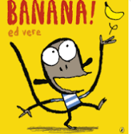  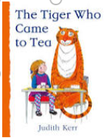 | 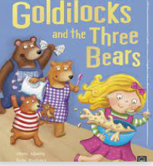 | 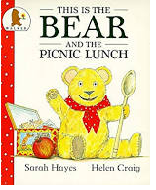  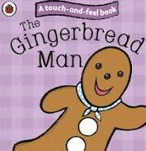 |  | 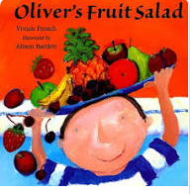  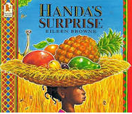 | 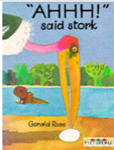  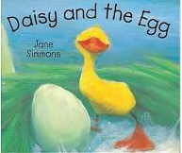 |  | 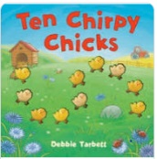  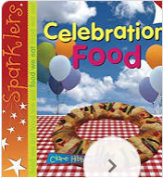
Theme | Food | Stories-Sizes |  |  | Healthy Eating | Dental Health |  | New Life/ Easter
Real Experiences | Investigating Food | Making Porridge | Cooking Activities  Visit from cook |  | Making healthy snacks | Investigating chocolate-changes |  | Exploring eggs-changes
Rhymes/Songs |  | When goldilocks… |  |  |  | Chick, chick, chicken |  | Hop Little Bunny
Communication & Language | - Develop back and forth conversations, acknowledge what others say  - Recognise good speaking behaviours in others  - Use talk partners effectively & speak in a small group, taking turns  - Begin to try out expression and vary tone/volume when speaking
Phonics
Numeracy- Rec | Exploring 9 & 10 |  |  | Comparing numbers to 10 |  |  | Numberbonds to 10
Measures, Space… | Shape-3D |  |  | Patterning |  |  | Weight
PE sessions
PD Focus (Gross)
PD Focus (Fine) | - Using cutlery and tools for cooking/eating  - Develop correct letter formation, anti clockwise directions etc  - Cutting simple shapes  - Developing drawing skills and effective use of one handed tools
PSED | Managing self, eating independently & organising own things |  | Developing awareness of healthy eating & safety in the kitchen |  |  | Working towards own goals and targets  Dental Health
 | Focus on recognising emotions in others & managing own feelings effectively
UW | Sorting & classifying foods.  Food/shops past & present & in different places  Where does our food come from? |  |  | Exploring changes in food, cooking & investigating different foods |  |  | Food for celebrating in different cultures/festivals  Celebrating easter-traditions
Music | Using percussion instruments to accompany songs and rhymes |  |  |  | Exploring rhythm and volume when playing with increasingcontrol
Dance
Art | Exploring ways to join materials (new resources/tools)  Explore texture in food | Following directed project: making utensils | Exploring pattern |  | Colour mixing, using shades  Observational drawing | Design projects for carrying/storing eggs  Make a basket
 |  | Role Play familiar stories

