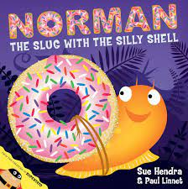

Term 5:

Living Things-Minibeasts

**Learning Through Talk (3-4 Yrs)**

-**Use all their senses in hands on exploration**

**-Explore collections of living things (real & pretend)**

**-Talk about what they see using a wide vocabulary**

**-Talk about & identify patterns around them**

**-Select shapes appropriately for activities (Eg circle for a snail)**

**-Combine shapes to make new ones**

**Supporting Texts:**

**Learning Through Talk (Reception)**

-**Explore the natural world around them**

**-Make observations and describe what they see**

**-Identify similarities & differences between living things**

**-Talk about & explore 2D shapes using informal & mathematical language to justify & describe**



**Learning To Talk**

-To use *“because”* to develop their ideas

-To ask questions

**Collections/Displays/Real Experiences:**

Minibeast Hunts. Spirals. Circles. Shells.

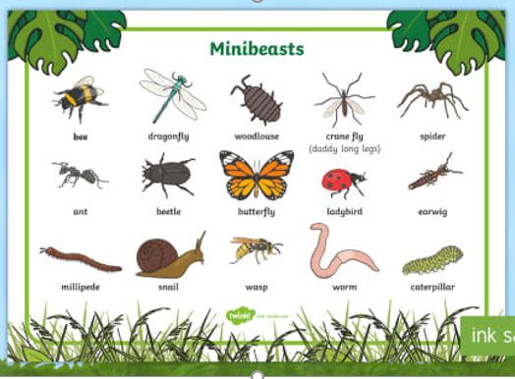

***Vocabulary***

***Same/Similar***

***Different***

***Detail***

***Observe***

***Compare***

***Spiral***

***Names of minibeasts (ladybird, spider…)***

***Features (legs, antennae…)***