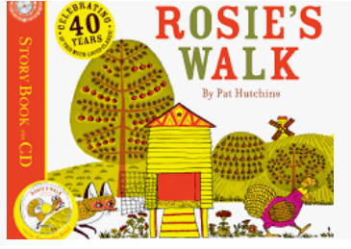

Term 6:

Animals- Prepositions, Routes & Story Telling

**Learning Through Talk (3-4 Yrs)**

-**Understand an instruction that has 2 parts**

**-Understand and follow prepositional language**

**-Engage in extended conversations about stories**

**-Develop stories using small world equipment (farm sets)**

**-Understand the key features of a life cycle**

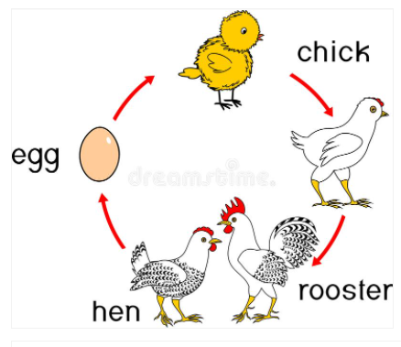

**Supporting Texts:**

*The Great Pet Sale*

*Rainbow Fish*

**Learning Through Talk (Reception)**

-**Develop their use of prepositional language**

**-Draw information from a simple map**

**-Develop their own storylines in pretend play based on the book**

**Learning To Talk**

-Describe events in some detail

-

**Collections/Displays/Real:** Farm Animals

**Experiences:** Trip To The farm

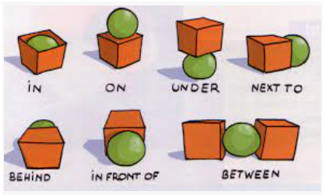

***Vocabulary***

***Route***

***Direction***

***Life Cycle***