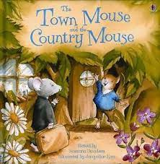

Term 6:

My World- Exploring habitats & different environments

**Learning Through Talk (3-4 Yrs)**

-Talk about what they see using a wide vocabulary

-Begin to understand the need to care for the natural environment

-Show interest in different occupations

**Supporting Texts:**

*The Shopping Basket*

**Learning Through Talk (Reception)**

-Recognise that some environments are different to the one they live in

-Discuss images of familiar places in the past

-Draw information from a simple map

-Discuss how we can care for the natural world

**Learning To Talk**

-

-

**Collections/Displays:** Maps, photos of local area past & present, Google Earth

**Real Experiences:** Walk around our local community

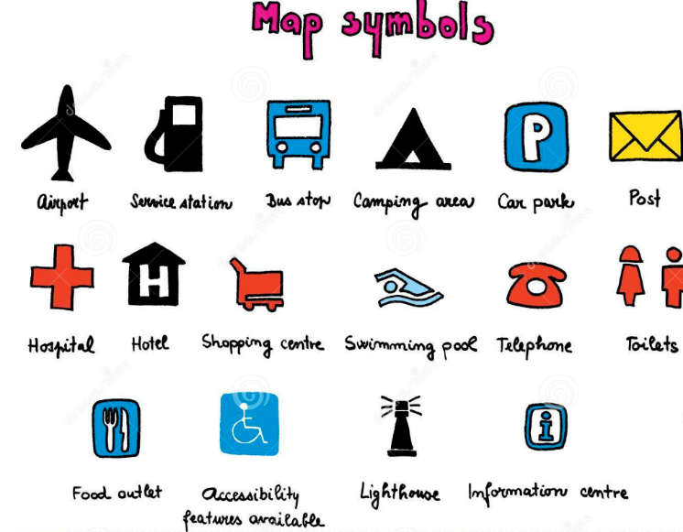

***Vocabulary***

***Town***

***Country***

***Feature***

***Route***

***Key***

***Direction***

***Respect***

***Pollution***

***Re-cycle***

***Environment***

